

IE4727 Web Application Design - Project Report

**Design project group number:** *F35-DG16*

**Team members:** Lim Jing Han, Jacia Lee

**Project Title:** A web portal for booking cinema tickets/theatre shows

# Abstract:

*This project is a web-based application for customers to purchase movie tickets and food & beverages. It would allow customers to browse through the available movies with description, movie timings, locations and other items. Once the booking is confirmed, the application would send an acknowledgement and e-ticket via email. Additionally, admin would be able to use this web application to modify and update various field in the webpage for better accessibility. Hence, aiming to provide a user-friendly interface for the users.*

# Table of Contents

Abstract: 1

Table of Contents 2

1. Application Requirements and Specifications 4

2. Functional Requirements and Specifications 6

3. Design of the web application 24

4. Implementation: 25

5. Testing of web application 26

6. Summary of Modern Enhancements (optional) 27

7. Conclusion 28

Appendices 28

**List of Figures**

Figure 1: Search Filter 6

Figure 2: Movie Homepage 6

Figure 3: Movie Details 7

Figure 4: Movie Showtimes 7

Figure 5: Accessibility Seating Rules 8

Figure 6: Movie Seat Selection 8

Figure 7: Seat Reservation Countdown Timer 9

Figure 8: F&B page before adding tickets to cart 9

Figure 9: F&B page after adding tickets to cart 10

Figure 10: F&B section in checkout page 10

Figure 11: Linking food items to tickets 11

Figure 12: Checkout Cart 12

Figure 13: Order Summary 13

Figure 14: E-Ticket 14

Figure 15: Email Notifications 15

Figure 16: Enter Booking Reference 15

Figure 17: View My E-Ticket Feature 16

Figure 18: Contact Us 17

Figure 19: Career Opportunities 17

Figure 20: Email Acknowledgement 18

Figure 18: Admin Authorization 18

Figure 21: Admin Panel 19

Figure 22: Movie Management 19

Figure 23: Showtime Scheduling 20

Figure 24: F&B Management 21

Figure 25: Contact Us Submissions 22

Figure 26: Job Applications Submissions 22

# Application Requirements and Specifications

**R1 – Usability:** The application should come with a user-friendly interface with consistent layouts allowing users to navigate through the web seamlessly, with clear error messages and simple workflows.

**Navigation & Layout**

It comes with a fixed sidebar navigation allowing easy access to all pages. With a consistent color scheme, providing a good contrast with clear visual hierarchies for the various headers, contents, and buttons.

**User Interface**

Dropdown options for various fields comes with hover effects for clear visual clarity. Tooltips and visual states will provide interactive feedback showing if a tab is hovered upon or active.

**Concurrent User Support**

Seat selection interface is also color-coded with the legend to show it status, accompanied by a reservation countdown timer. This would allow multiple users to browse and book tickets simultaneously. When 1 user selects the seats, the system will automatically reserve the seats and reflect it on the webpage, preventing other users from booking the same seats while allowing them to browse for their seats too.

**R2 – Responsiveness**: Having an interface that can scale accordingly to the device that is being used (E.g. Mobile phones, Tablets, PCs) ensuring smooth rendering.

This application uses custom CSS with flexbox and grid to apply responsive behavior across the pages, adjusting the layout on various devices for better user experience.

**R3 – Security:** Our application has a security-conscious approach where there is session-based access control, hashed password storage in the database, SQL injection prevention statements and only authenticated admin would be able to access the admin management features.

**Password Security**

Admin passwords are secured using SHA-256 hashing before storing in the database ensuring that plaintext is never stored in the database for higher security. During login, the entered password would be hashed with the same algorithm to compare with the stored password for authentication.

**SQL Injection Prevention**

By using parameterized statements - “$stmt->bind_param( )”, the application prevents SQL injection attacks, ensuring that the inputs are properly sanitized before any database operations.

**Session**

The application also relies on sessions to maintain user state through “session_start( )”, sessions are all destroyed on logout to prevent any session hijacking.

**R4 – Scalability:** Our application also exhibits good scalability through the implementation of the admin panel, which provides various features for modifications and further development.

**Admin Panel**

With the admin panel, administrators can now access the movie management, showtime scheduling, F&B management, customers feedback and career opportunities tab, allowing them to make view and modify from the web application seamlessly without having to access and modify the database manually. This would help to enhance scalability when the business grows larger, reducing the need for a larger overhead and workload while keeping the process less complex and efficient.

**R5 – Maintainability**: Ensures code is done efficiently, with proper documentation and coding standards, eliminating the need for major modifications/redevelopment when a change must be made. For example, having a sidebar.php and footer.php instead of adding them manually on every page, allowing it to be included across the pages to save time and for better efficiency.

**R6 – Accessibility:** Our webpage also incorporates some accessibility features to enhance user experience. For example, the forms include proper labelled elements with red asterisks for visual identification. When it is not filled up accurately, error message will be displayed through the client-side validation. Additionally, the visual design is intentionally done by using high contrast color combinations to allow better user interaction, allowing users to identify various elements on the page clearly, especially for users with color vision deficiency.

# Functional Requirements and Specifications

**F1: Search Filter** – Allow users to filter by date, movies or cinemas to view available shows based on the filters.

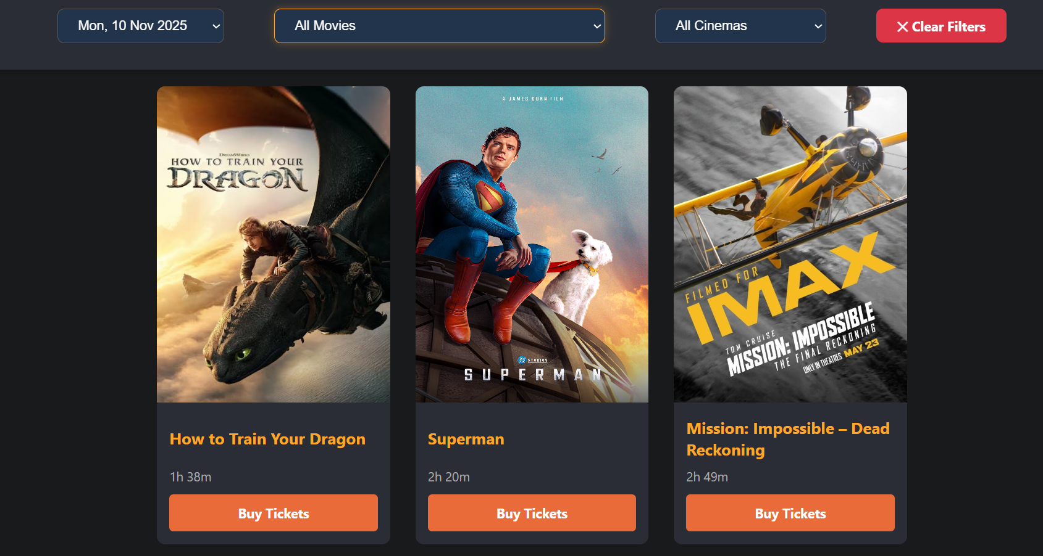

Figure 1: Search Filter

**F2: Movie Listings (homepage)** – The homepage will display all available movies in a grid layout with brief information about the movie.

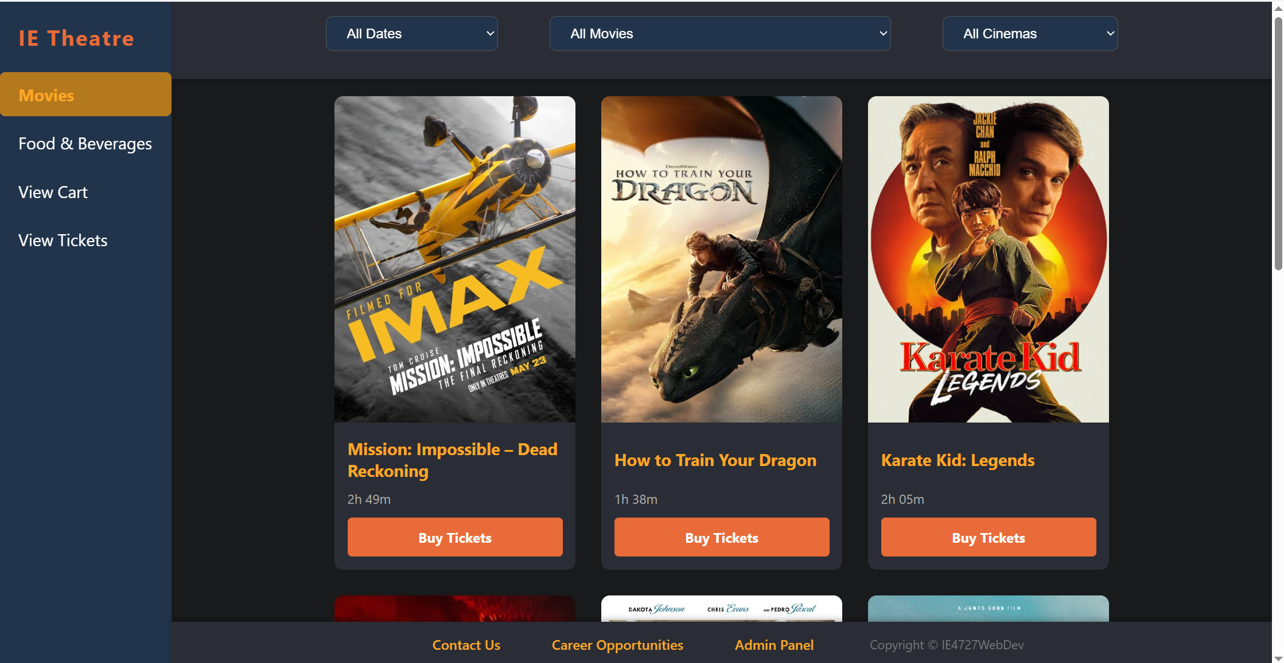

Figure 2: Movie Homepage

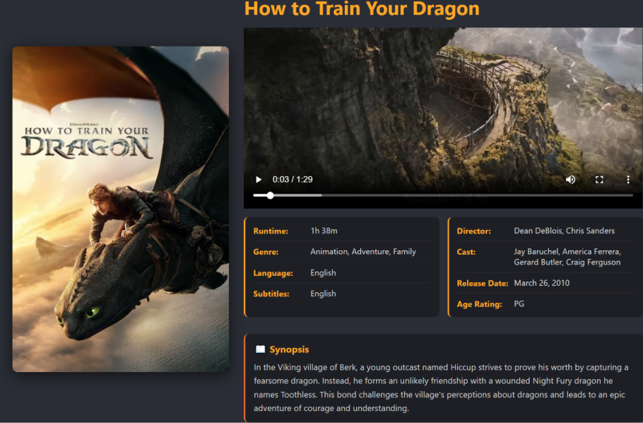**F3: Movie selection, Location and Showtimes** - Includes comprehensive details such as title, synopsis, genre, duration, cast, subtitles and others. Allowing users to select the date and time of the movie of their choice. The system will automatically filter out showtimes based on current time, ensuring that only upcoming movies can be booked.

Figure 3: Movie Details

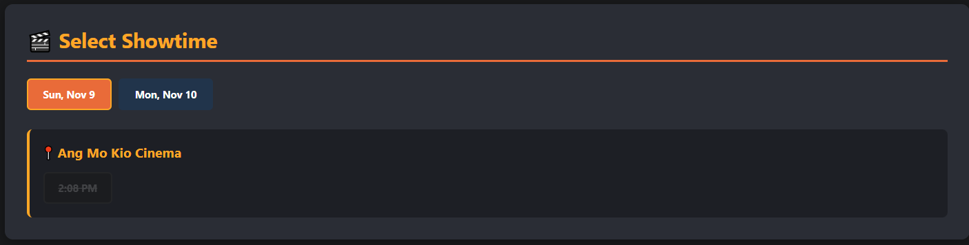

Figure 4: Movie Showtimes

**F4: Seat selection** - Display seating chart for each movie, with the legends displayed. Allowing users to select their preferred seats. There will also be a reservation feature to block out seats (10 mins) that have been added to the cart, preventing a double booking of the same seats. The seat selection will also have accessibility seating rules where no gaps between selected seats are allowed.

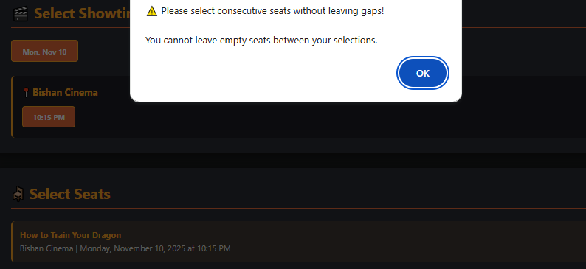

Figure 5: Accessibility Seating Rules

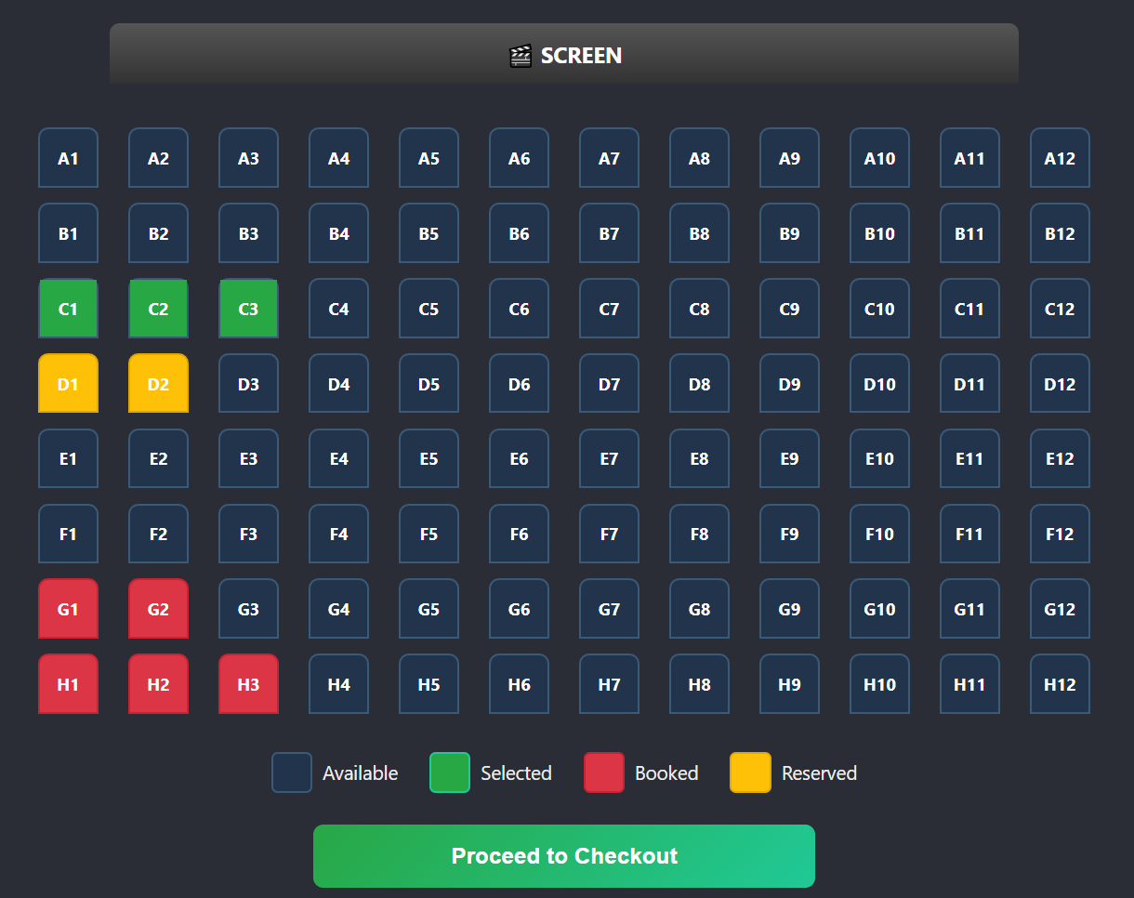

Figure 6: Movie Seat Selection

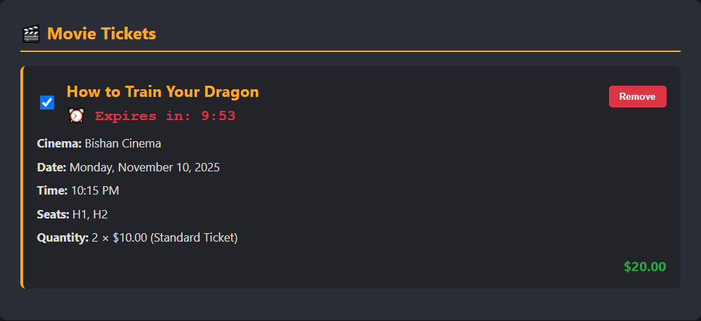

Figure 7: Seat Reservation Countdown Timer

**F5: Browse for food and drinks** - Users can browse the F&B menu to enhance their movie experience. This can be done on our F&B page or in the cart after tickets have been added. This system requires a mandatory ticket validation where food items are exclusively available for customers who have added at least one movie ticket to their cart, linking them to the movie ticket for collection. This feature allows F&B items to be specially discounted for customers and ensures that food is prioritized for ticket holders, thus preventing non-moviegoers from depleting F&B inventory and causing delays in services.

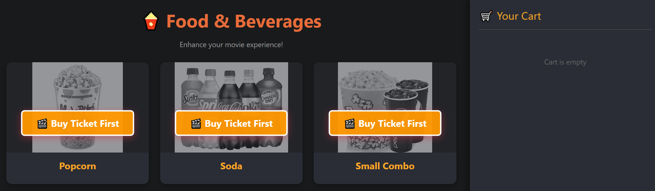

Figure 8: F&B page before adding tickets to cart

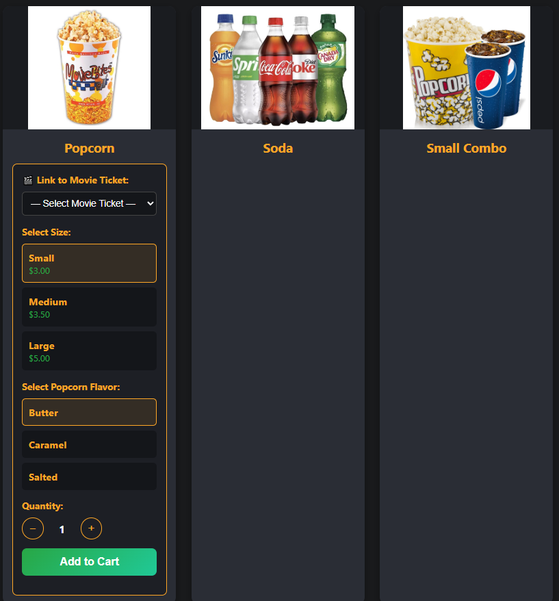

Figure 9: F&B page after adding tickets to cart

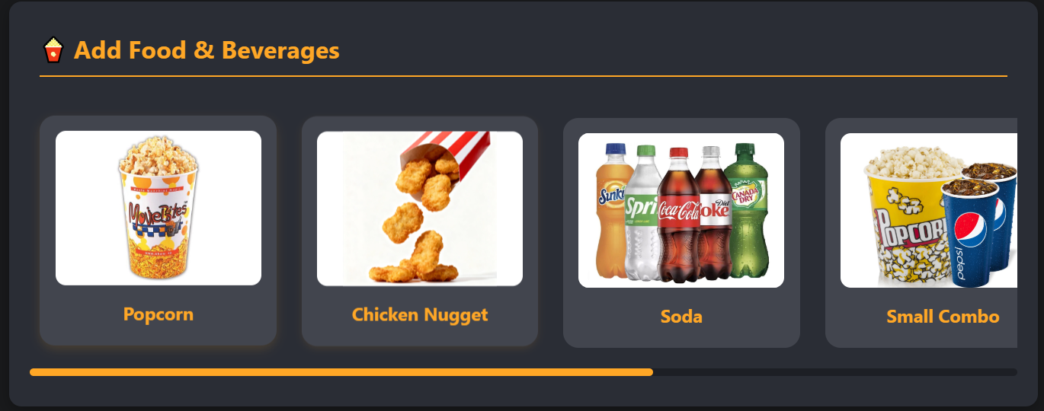

Figure 10: F&B section in checkout page

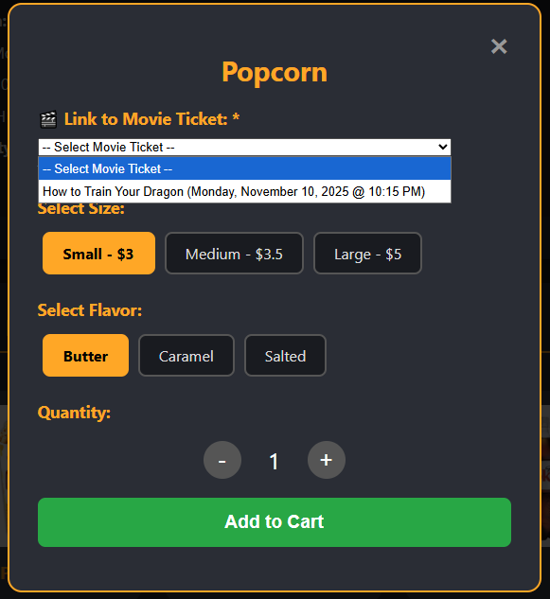

Figure 11: Linking food items to tickets

**F6: Payment and checkout** – This feature handles collection of customer details and payment confirmation. It will calculate the total cost including booking fee, F&B items and the tickets with different pricing for weekday and weekend. After validating the customer’s details, it will process the orders and update the reservations accordingly.

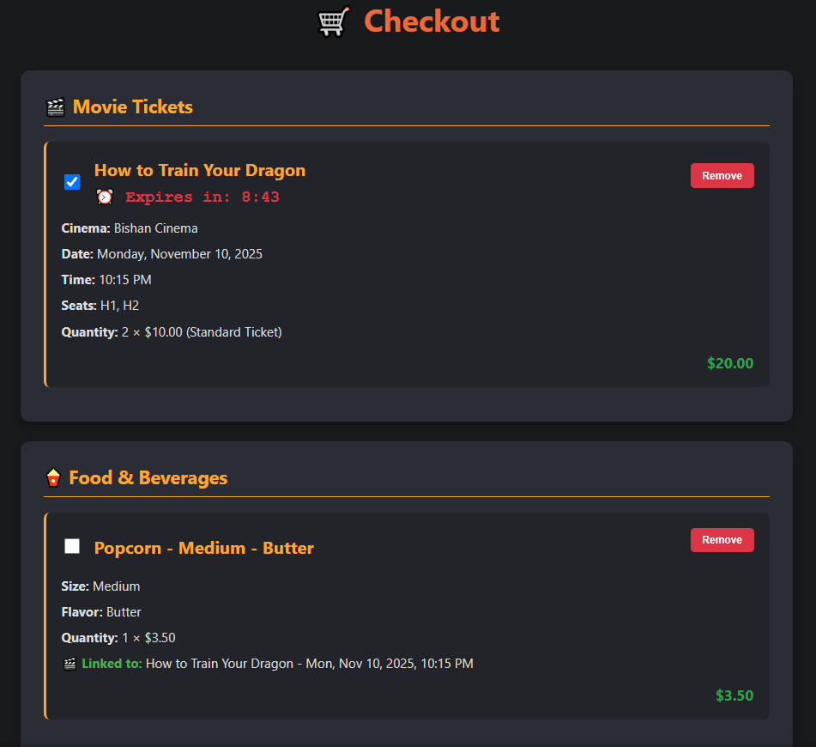

Figure 12: Checkout Cart

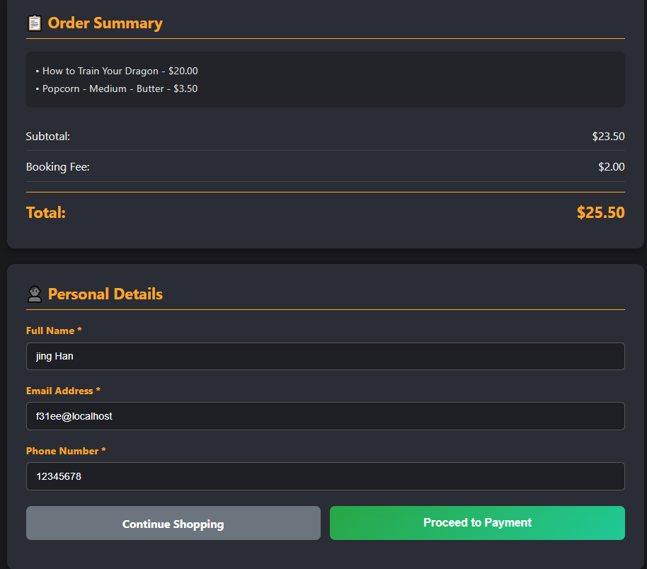

Figure 13: Order Summary

**F7: Ticketing confirmation and notification** – Upon purchasing, there would be an email confirmation, sending the users the E-ticket for verification at the cinema.

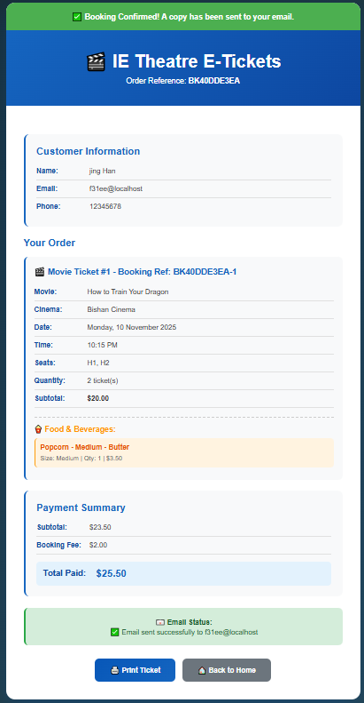

Figure 14: E-Ticket

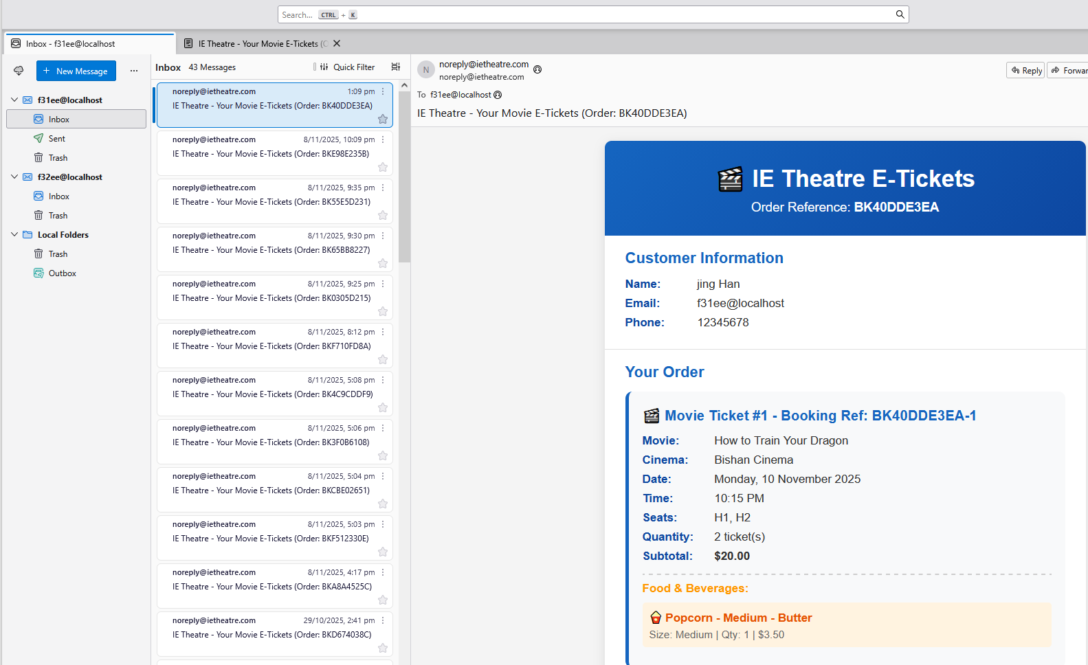

Figure 15: Email Notifications

**F8: View E-Ticket** – This feature also allows customers to retrieve and display their e-ticket using their booking reference on the webpage as an alternative rather than retrieving it from their email.

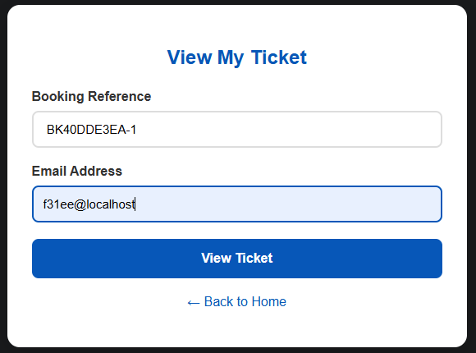

Figure 16: Enter Booking Reference

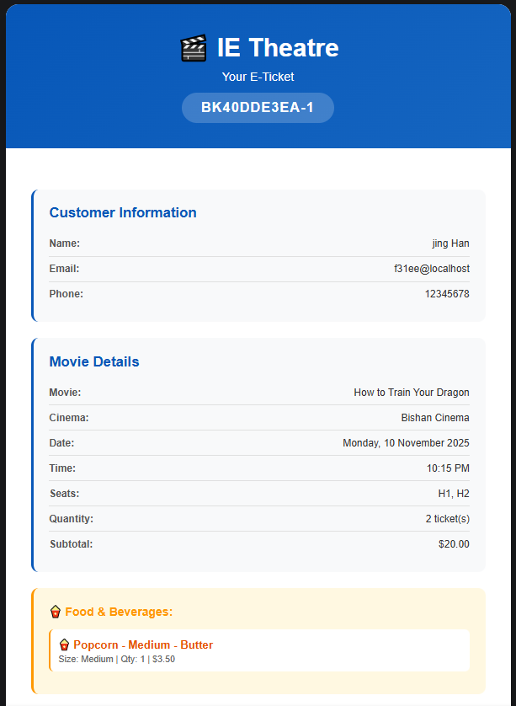

Figure 17: View My E-Ticket

**F9: Contact Us & Career Opportunities** – These pages allow customers to write to us if they have any feedback or send in an application for career opportunities with us. After submitting, an acknowledgment email would be sent to the sender.

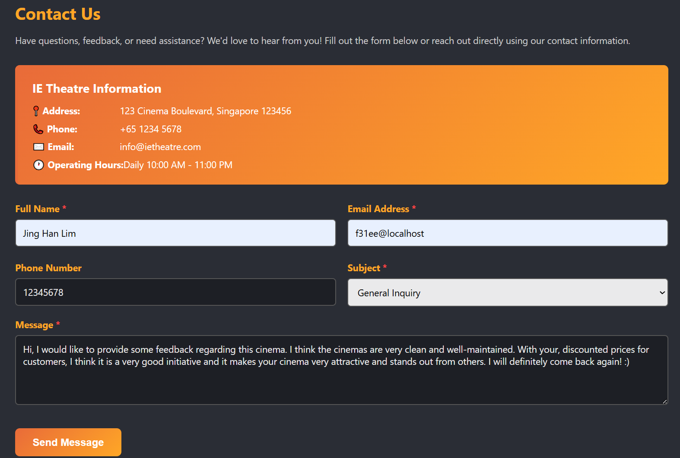

Figure 18: Contact Us

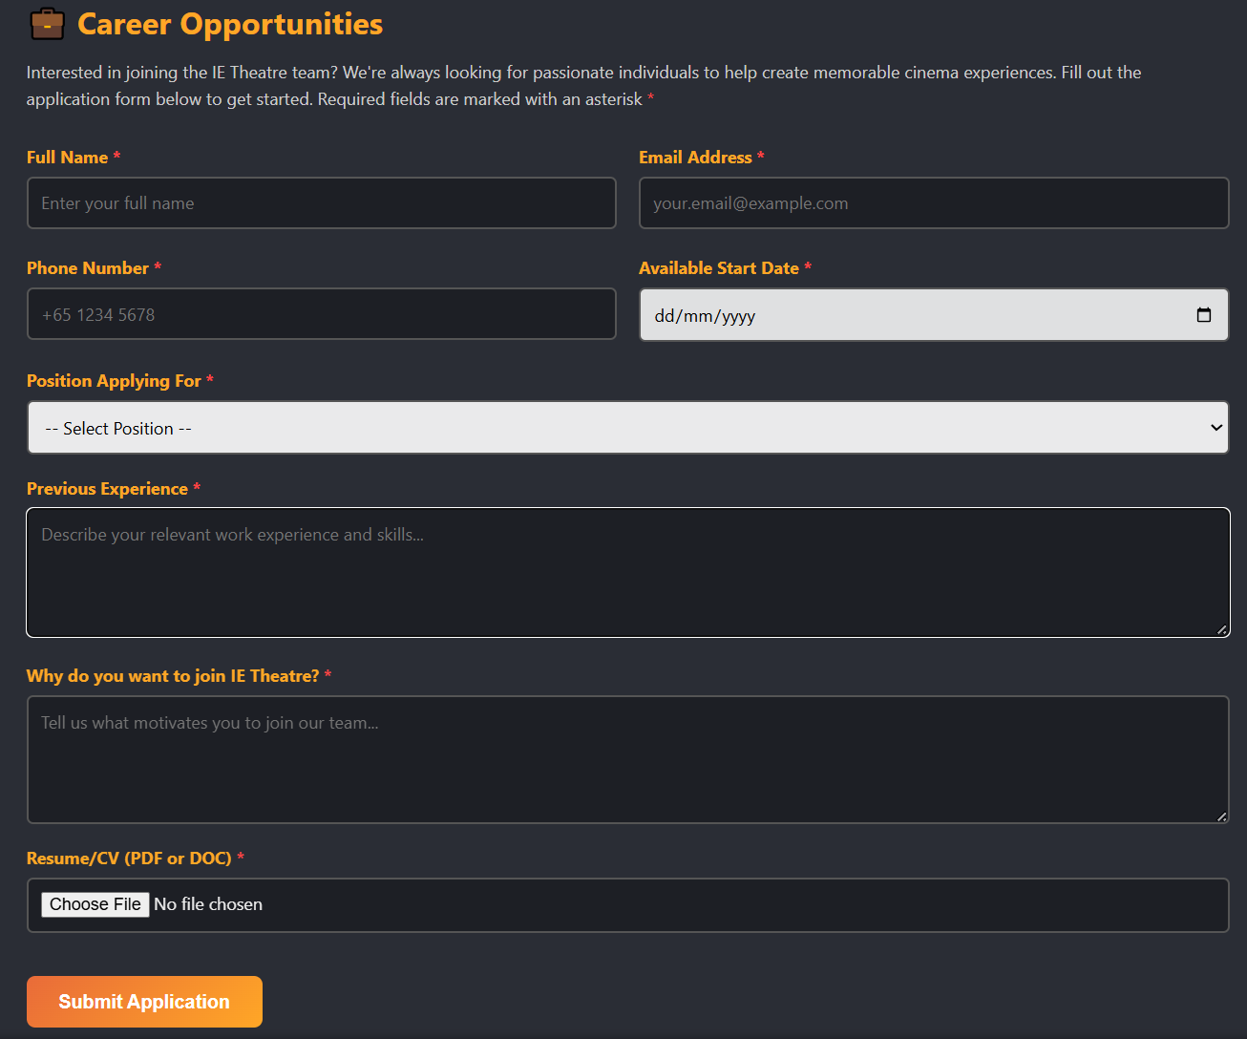

Figure 19: Career Opportunities

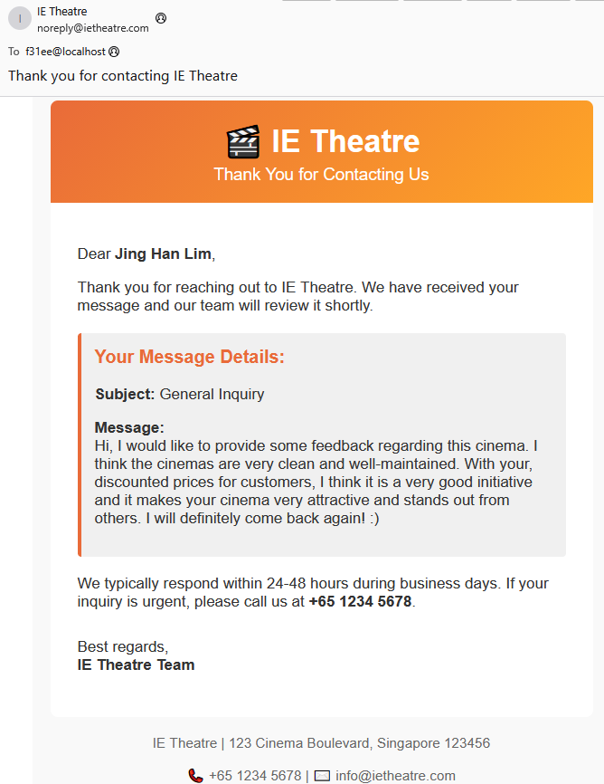

Figure 20: Email Acknowledgement

**F10: User Authentication (admin)** – Login feature for administrators to be authorized and granted access to the admin panel.

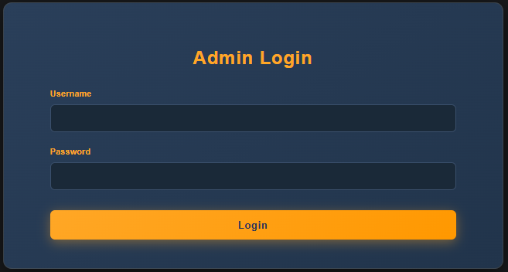

Figure 21: Admin Authorization

**F11: Admin panel** – Provide authorized administrator to manage, add or edit movies, showtime, F&B items, customer feedback and job applications. This feature would simplify admins’ jobs, making the workflow simpler and more efficient.

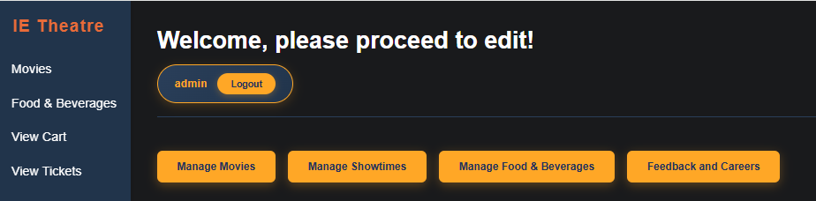

Figure 22: Admin Panel

The movie management panel allows admins to add, remove or edit movies from the database. Making the changes here will write into the database and update it, displaying the updated movies details on the movie webpage.

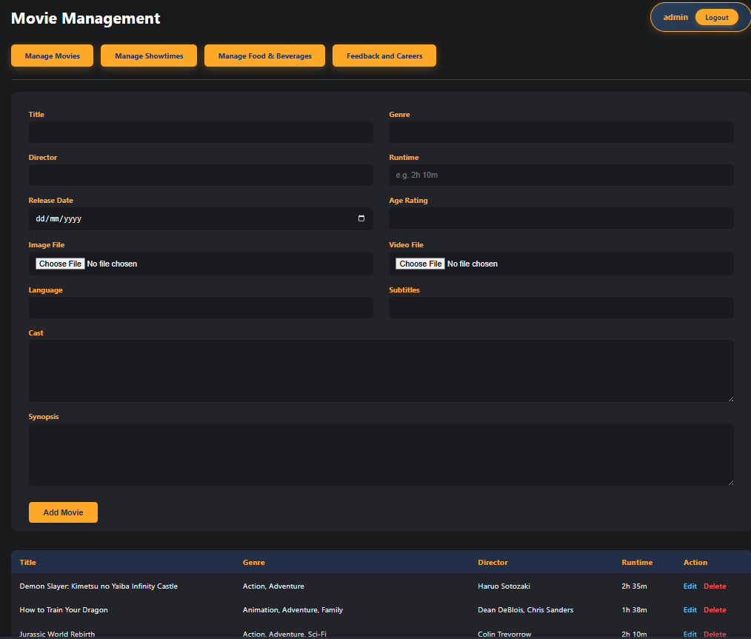Figure 23: Movie Management

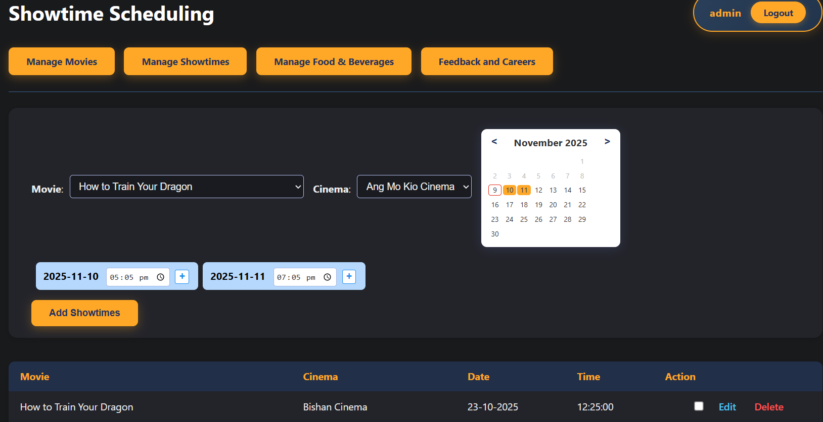The showtime management here will also updates the database, admins can edit and add new showtimes which will reflect on webpage accordingly.

Figure 24: Showtime Scheduling

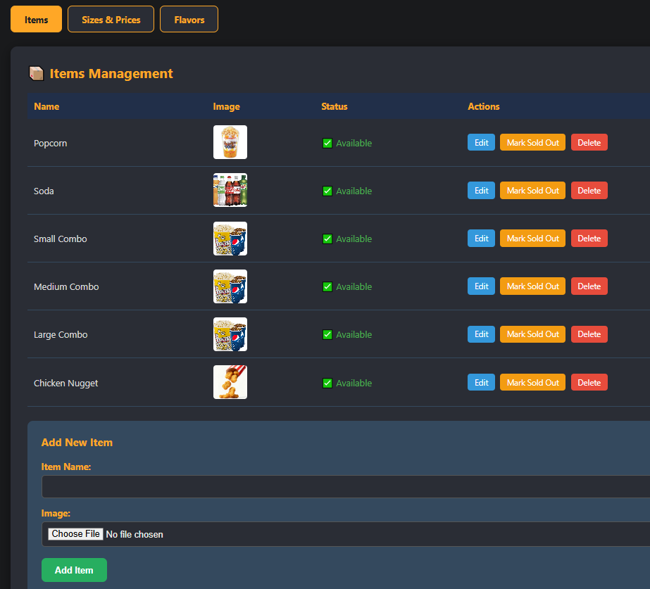The F&B management here allows admins to edit food items and mark them as sold out when any items are unavailable. Hence, reflecting the changes and preventing customers from selecting items that are unavailable.

Figure 25: F&B Management

The feedback and careers page consist of 2 tabs, contact submissions and job applications. From the tab, admins would be able to view all submissions and change their status accordingly after reviewing it.

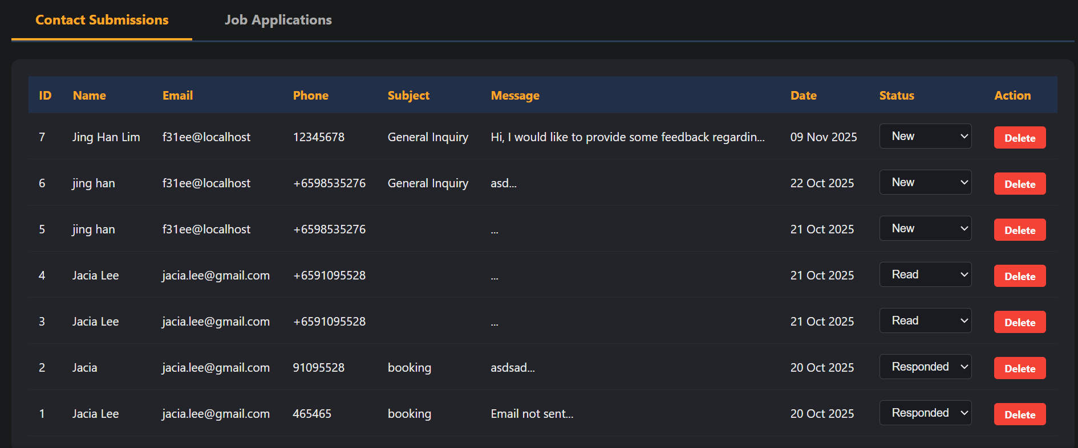

Figure 26: Contact Us Submissions

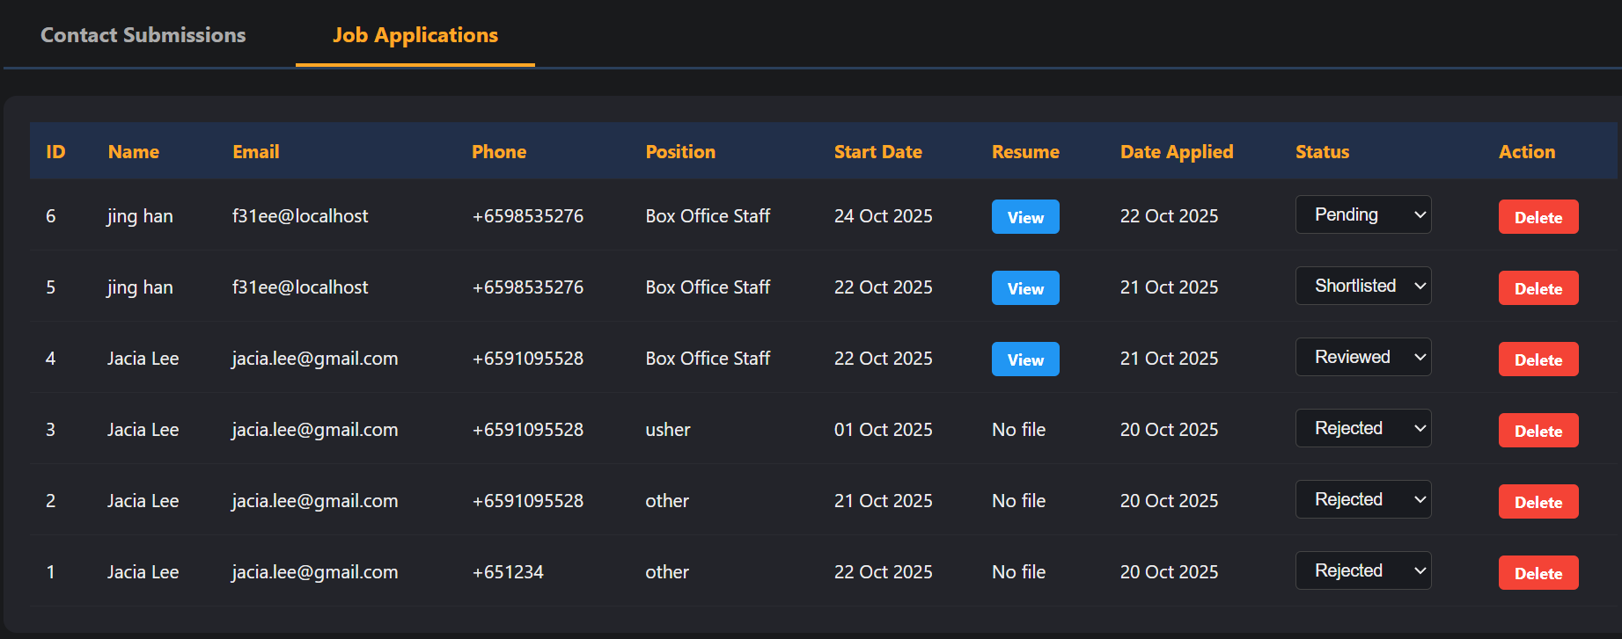

Figure 27: Job Applications Submissions

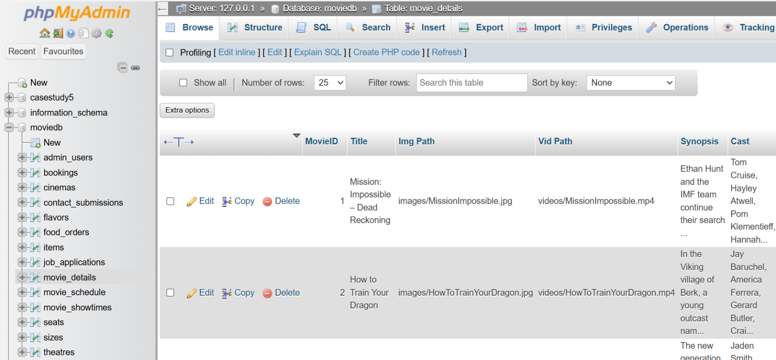**F12: MySQL Database** – This web application also utilized a MySQL database for all the features mentioned above to work, a database (moviedb) would be required to store, write and retrieve all the data. This includes multiple tables such as the movie_details for movie information, movie_showtimes for scheduling and many other tables that are linked through foreign keys, enabling querying across the entire workflow. This database supports the Create, Read, Update and Delete operations that help the webpage to work efficiently.

Figure 28: MySQL Database

# Design of the web application

Describe your overall structure of the web sites and the task workflows with reference to section 2.

Site Map Story Board

Design your page layouts for all the pages Wireframe

Design of the database tables and explain the designs Database

# Implementation:

Provide A Summary

Fill up the form in Appendix 2 **(To be printed for DEMO evaluation)**

Description of the coding of ONE to THREE Application Requirements

Select one to three that are most impressive, and you wish to highlight. Talk about the coding of web page template, pages and functions pertaining to each Application Requirement

**Seat selection with reservation timer**

This feature displays an interactive seat map for users after selecting a particular showtime, allowing users to view seats that are available, selected, booked or reserved real-time with it being color-coded. When the user selects a seat, it will be marked as selected, adding it to cart will change the status of that seat to be reserved temporarily while a countdown timer will start counting down from 10 minutes. Removing it from cart or when the time limit is up, the reserved seat would be released and be available for others to select again. Lastly, making a payment would change it to “booked” as shown in the image below. This implementation would prevent double-booking and prevent conflicts from happening.

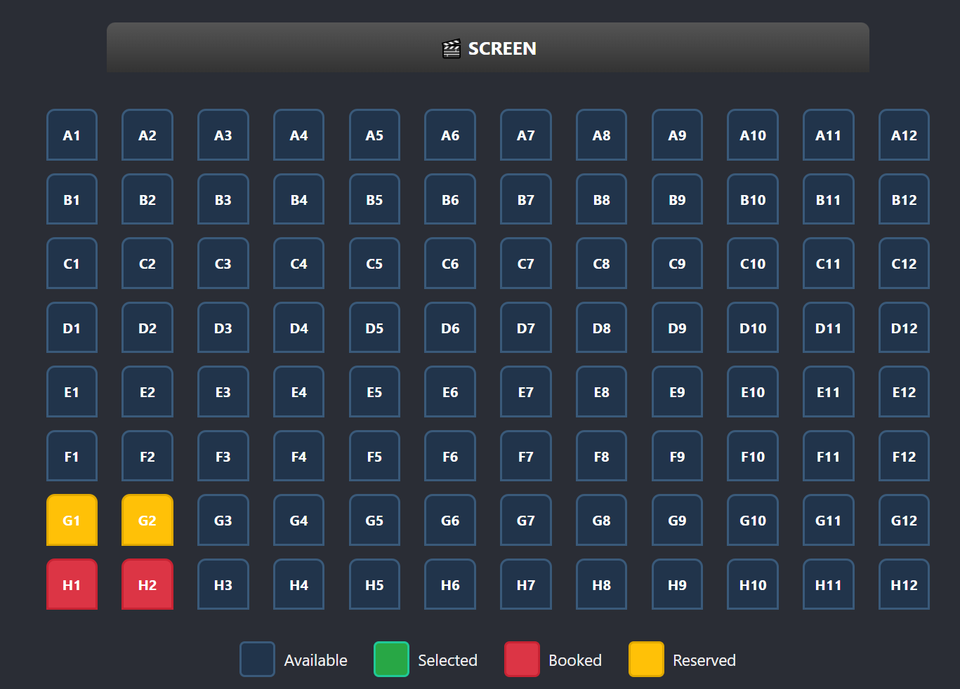

Figure 29: Movie Seat Map

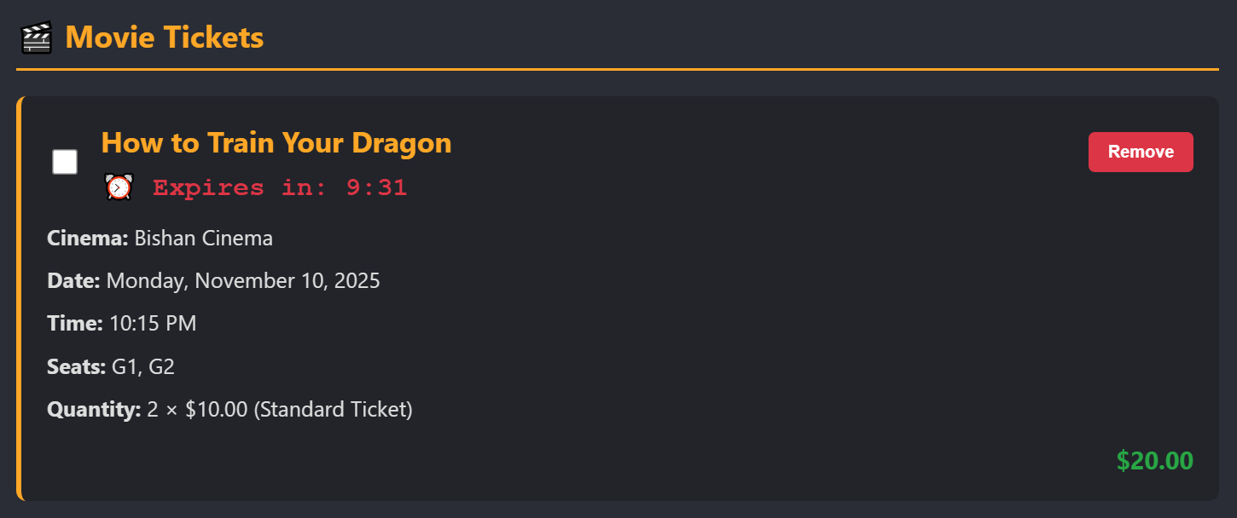

Figure 30: 10 Mins Countdown Timer

Based on the code below, if there are seats selected after pressing the add to cart button, a 10-minute countdown timer would be created and temporarily reserve the seats in the database.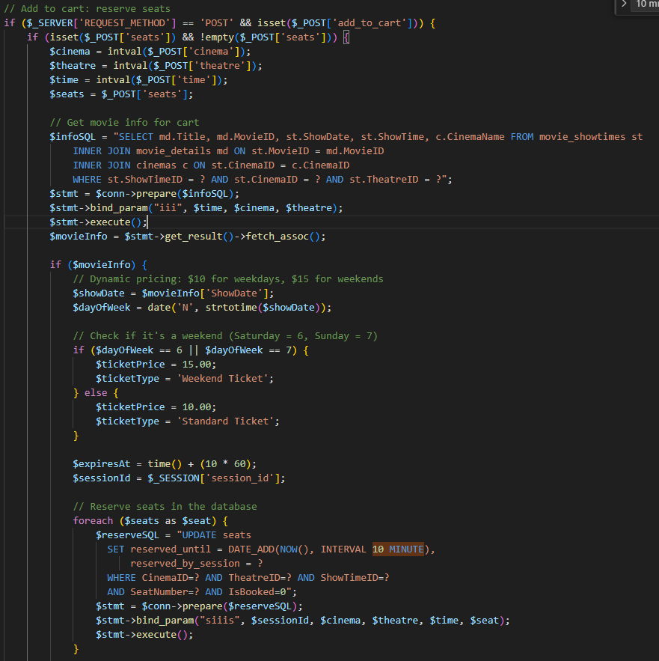

Figure 31: Temporarily Reserve Seats

After reserving the seats, when the user heads back to the same movie showtime, the code will clean up the database and remove all expired seat reservations, using the query shown below.

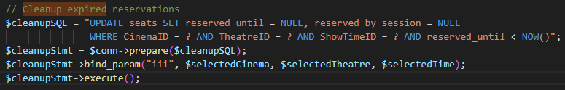

Figure 32: Cleanup Expired Request

The code will then query to sort the seats according to their row and seat number using the SUBSTRING and display the updated seat map indicating the status of each seat.   
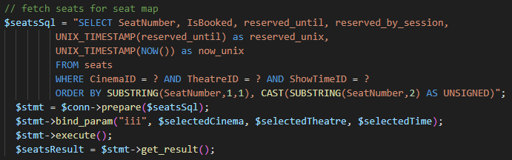

Figure 33: Fetch and Sort Seats According in Order

Next, a while loop is implemented to build an array of each seat’s status for display of the updated seat map. 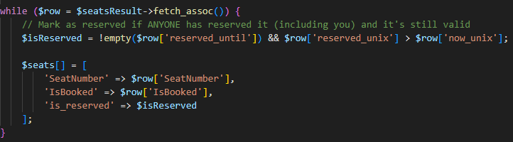

Figure 34: Array of Seat Status

Once the array is created, the code will loop through the seats in the array to display different colored seats by using the various CSS classes based on the seat status. If seats are not booked or reserved, it will allow it to be clickable by using checkbox. Else, no checkbox will be used to ensure that the seats would not be able to be selected by others to prevent double booking.

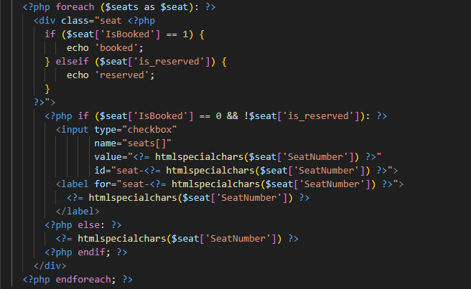

Figure 35: Display Seats Status

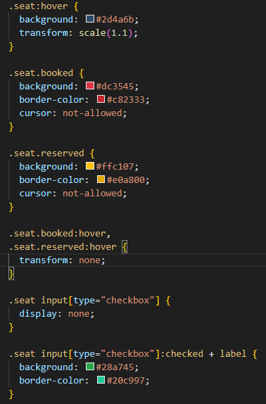

Figure 36: CSS for Seat Status

**Linking Food Items to Movie Tickets**

When users add F&B items into their cart, they will be prompted to link it to a movie via a dropdown based on the movies available in their cart thus, ensuring that all items is paired with the movie ticket for collection.

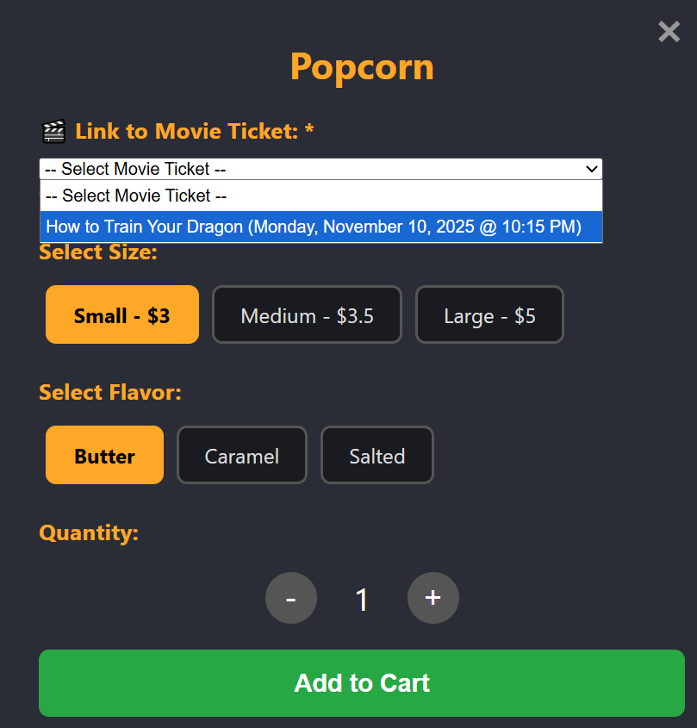

Figure 37: Dropdown to link F&B items to movie

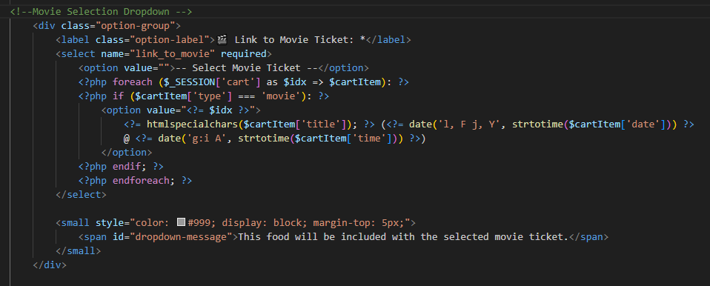

Figure 38: Code to link F&B Items to Movie

After adding to cart, the PHP code will process the food items and link it to the selected movie ticket. When the post method is used and add_food button is pressed, the code will capture all the details on the food items and linked movie. It then proceeds to display the names with the selected options followed by a ‘- ‘ for a more user friendly interface and added to the session-based cart.  
  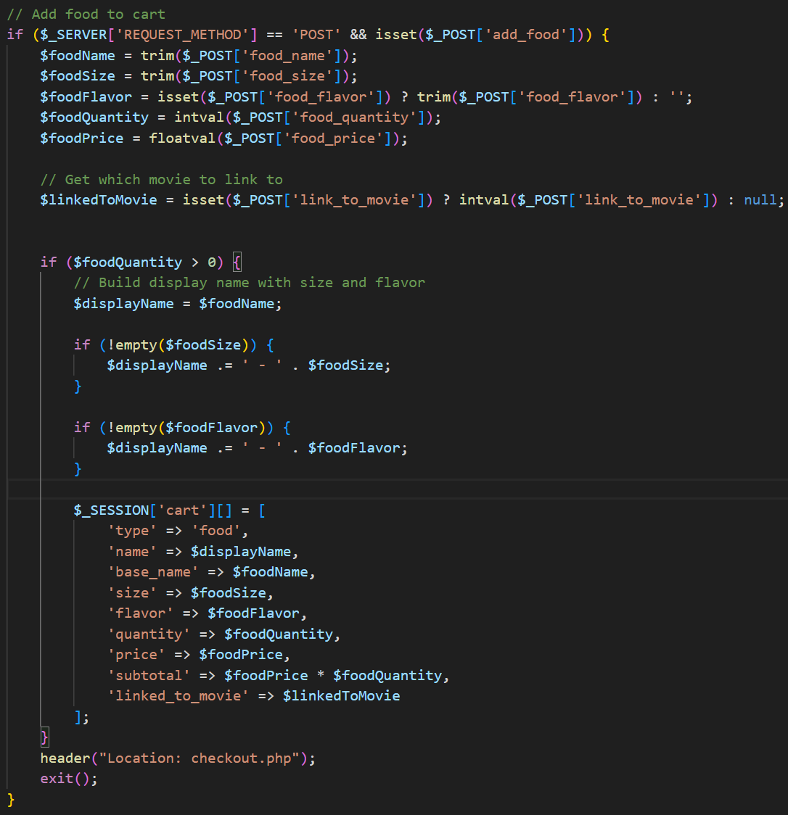

Figure 39: Display linked Food Items in Session-Based Cart

The code then checks if there is a link to movie and the food is accessible in the cart. If the conditions are met, it will display the food items along with the linked movie in the checkout summary.

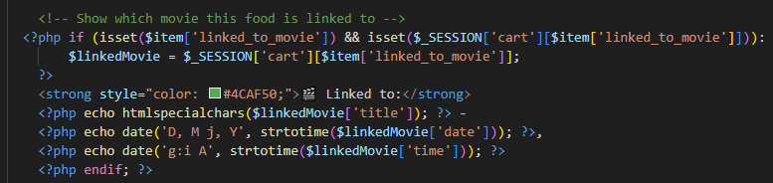

Figure 40: Display Food with Linked Movies

Upon payment, payment.php will insert this into the database with the linked movie reference which will be used to display on the receipt.   
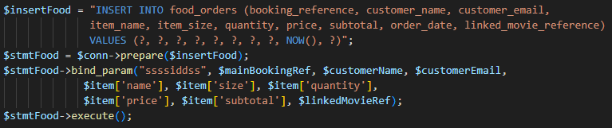

Figure 41: Insert into Database

After payment, an email will be sent to the customer showing its purchase details.  
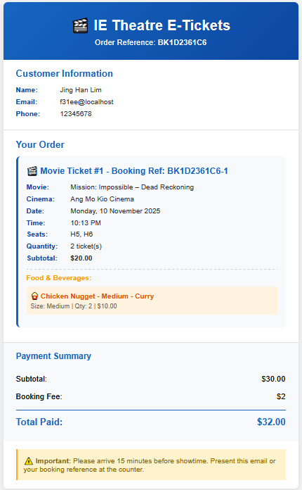

Figure 42: Email Notification of Receipt

**Admin Panel**

To make the workflow more efficient for cinema staff, we also implemented the admin panel. Firstly, a session is created to track logged-in users, the code would compare the credentials keyed in by admin against the data in the admin_users table. If the username matches with any rows in the table, it will hash the entered password to verify against the hashed password stored in the table. Once successful, user will be logged in with a session being set and be re-directed to the admin dashboard. Lastly, session would be destroyed after logging out.

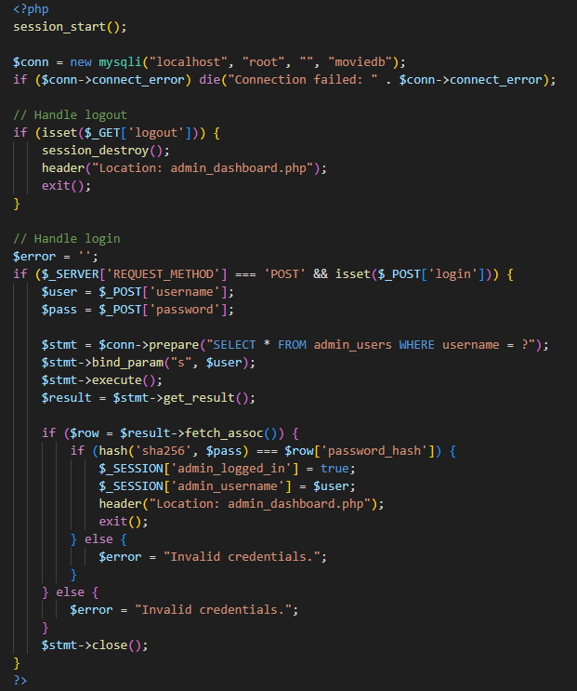

Figure 43: Admin Login Authentication

In the dashboard, there are various tabs to make changes to the webpage, but they all follow the same concept with the CRUD operations. Each button will link admin to the respective pages for further updates.

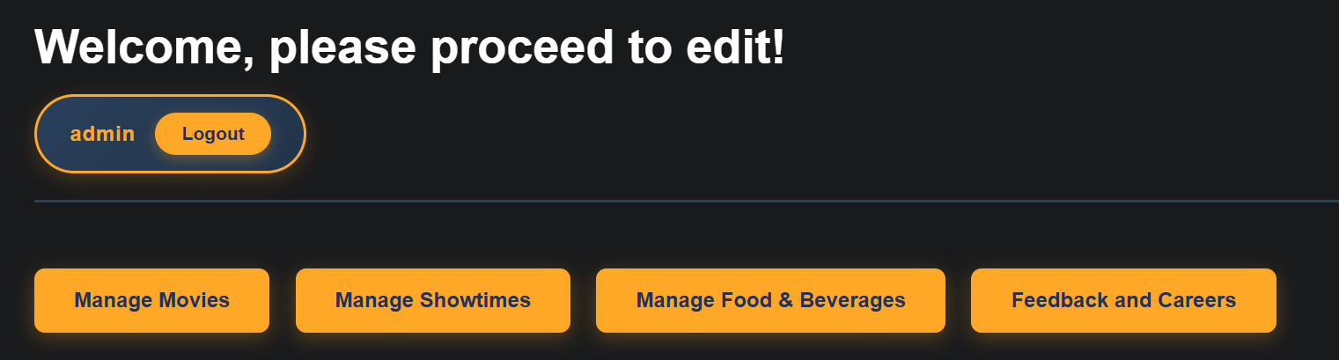

Figure 44: Admin Panel Home

Taking the mange movie as an example, it allows admin to easily add, edit or delete data from the database, following the same concept as the other tabs.

This function is used to check if a file is uploaded with no errors, it will retrieve it from PHP’s temporarily file path and move it to the targetpath, allowing admin to upload items into the folder directly from the webpage.  
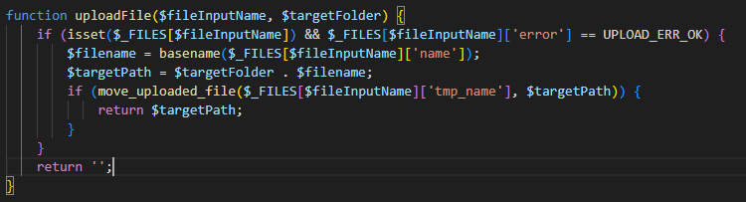

Figure 45: Upload Files Function

If the add button is clicked, the code will add all the fields from the form into the database table using the insert statement.

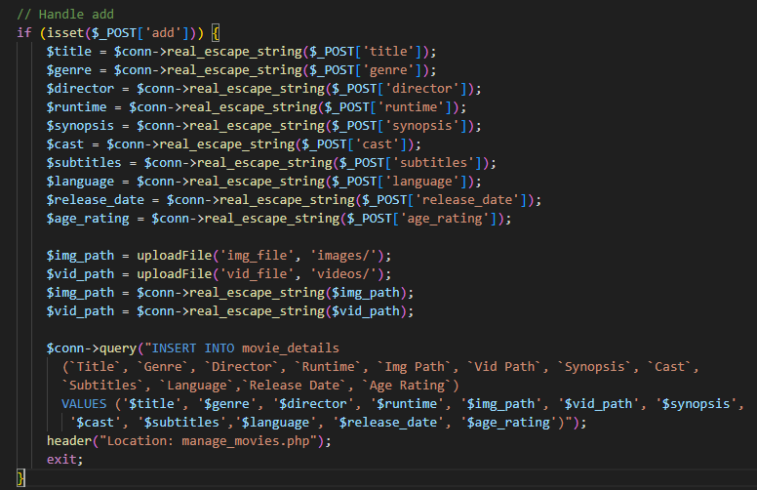

Figure 46: Admin Add Feature

The code here fetches the movie current details when the edit button is pressed. This way, the form would be pre-filled, and admins can make minimal changes.

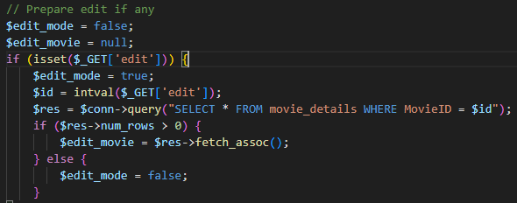

Figure 47: Edit Feature

Similarly, if the update button is pressed, it will retrieve all the data from the form submitted. It also retrieves the existing file paths which would be kept the same if no new file is uploaded. After that, the update query would be used to update the data in the movie_details table.  
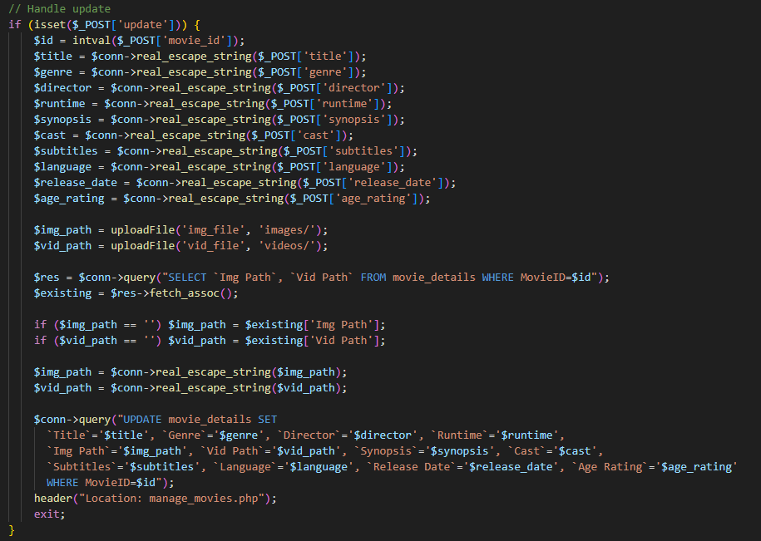

Figure 48: Admin Update Feature

Lastly, the delete logic will remove a movie from the database if the delete button is pressed for that movie ID.

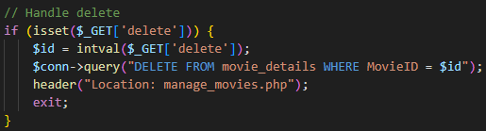

# Testing of web application

Describe the tests performed and the results for each Application Requirement. A test case is a specific scenario or condition used to verify that the application behaves as expected. Test cases include: Input data; Expected Output; Test Method; Test Results. Make use of the table below. For each row, put in the description and result of each test case pertaining to an Application Requirement.

|  |  |  |
| --- | --- | --- |
| Application Requirement | Description of Test Case | Result (If a visual needs to be shown, place the figure below this table and label with a figure number) |
| R1. xxx |  |  |
| R1. xxx |  |  |
|  |  |  |

# Summary of Modern Enhancements (optional)

Clearly describe each modern technique or tool you added to your project beyond the traditional base version. Provide a rationale (justification) for each enhancement—explaining why you chose to implement it, and how it improves your project.

# Conclusion

Summarize what has been achieved and what has been deferred in the current stage.

# Appendices

Appendix 1: Source Codes **with proper comments for evaluation**

Appendix 2 **(To be printed for DEMO evaluation):** Contribution to the project by each team member shown in a table (see Table A2.1 and A2.2).

Appendix 3: Contribution to the report by each team member shown in a table (see Table A3).

**Appendix 1 – Source Codes**

**Index.php**

<?php

$conn = new mysqli('localhost', 'root', '', 'moviedb');

if ($conn->connect_error) die("Connection failed: " . $conn->connect_error);

// Get filter values from GET parameters

$date = isset($_GET['date']) ? $_GET['date'] : '';

$movieId = isset($_GET['movie_id']) ? intval($_GET['movie_id']) : 0;

$cinemaId = isset($_GET['cinema_id']) ? intval($_GET['cinema_id']) : 0;

// Get all movies for dropdown

$moviesSql = "SELECT DISTINCT MovieID, Title FROM movie_details ORDER BY Title";

$moviesResult = $conn->query($moviesSql);

// Get all cinemas for dropdown

$cinemasSql = "SELECT DISTINCT CinemaID, CinemaName FROM cinemas ORDER BY CinemaName";

$cinemasResult = $conn->query($cinemasSql);

// Get available dates

$datesSql = "SELECT DISTINCT ShowDate FROM movie_showtimes WHERE ShowDate >= CURDATE() ORDER BY ShowDate LIMIT 7";

$datesResult = $conn->query($datesSql);

// Build filtered query

if ($date || $movieId || $cinemaId) {

    $sql = "SELECT DISTINCT md.* FROM movie_details md

            INNER JOIN movie_showtimes st ON md.MovieID = st.MovieID

            WHERE 1=1";

    if ($date) {

        $sql .= " AND st.ShowDate = '" . $conn->real_escape_string($date) . "'";

    }

    if ($movieId) {

        $sql .= " AND md.MovieID = $movieId";

    }

    if ($cinemaId) {

        $sql .= " AND st.CinemaID = $cinemaId";

    }

} else {

//show all movies if no filters

    $sql = "SELECT * FROM movie_details";

}

$result = $conn->query($sql);

include 'sidebar.php';

?>

<!DOCTYPE html>

<html lang="en">

<head>

  <title>IE Theatre | Movies</title>

  <meta charset="utf-8">

  <meta name="viewport" content="width=device-width, initial-scale=1">

  <!-- Link to Combined External CSS -->

  <link rel="stylesheet" href="sidebarandfooter.css">

  <style>

    body {

      background: #191a1c;

      margin: 0;

      font-family: 'Segoe UI', Arial, sans-serif;

      color: #eee;

      padding-bottom: 70px;

      padding-top: 70px;

      padding-left: 200px;

    }

    .filter-bar {

      position: fixed;

      top: 0;

      left: 200px;

      right: 0;

      background: #2a2d35;

      padding: 15px 20px;

      display: flex;

      justify-content: center;

      align-items: center;

      box-shadow: 0 2px 8px rgba(0,0,0,0.3);

      z-index: 5;

      height: 60px;

    }

       .filter-bar form {

      display: flex;

      gap: 60px;

      align-items: center;

      justify-content: center;

    }

    .filter-bar select {

      padding: 10px 20px;

      background: #21344b;

      color: #fff;

      border: 1px solid #555;

      border-radius: 8px;

      font-size: 1em;

      cursor: pointer;

      min-width: 200px; /* ✅ Wider dropdowns */

      transition: all 0.3s ease;

    }

    .filter-bar select:hover {

      border-color: #e96b39;

      transform: translateY(-2px);

    }

    .filter-bar select:focus {

      outline: none;

      border-color: #ffa726;

      box-shadow: 0 0 10px rgba(255, 167, 38, 0.3);

    }

    /* Clear Filters Button */

    .clear-btn {

      padding: 10px 25px;

      background: #dc3545;

      color: white;

      border: none;

      border-radius: 8px;

      font-size: 1em;

      font-weight: bold;

      cursor: pointer;

      transition: all 0.3s ease;

      text-decoration: none;

      display: inline-block;

    }

       .clear-btn:hover {

      background: #c82333;

      transform: translateY(-2px);

      box-shadow: 0 4px 12px rgba(220, 53, 69, 0.4);

    }

    #content {

      min-height: calc(100vh - 140px);

    }

    .movies-grid {

      display: flex;

      flex-wrap: wrap;

      gap: 30px;

      padding: 40px;

      max-width: 1600px;

      margin: 0 auto;

      justify-content: center;

    }

    .movie-card {

      background: #2a2d35;

      border-radius: 10px;

      overflow: hidden;

      transition: transform 0.2s, box-shadow 0.2s;

      width: 280px;

      flex-shrink: 0;

    }

    .movie-card:hover {

      transform: translateY(-5px);

      box-shadow: 0 8px 20px rgba(233, 107, 57, 0.3);

    }

    .movie-card img {

      width: 100%;

      height: 380px;

      object-fit: cover;

    }

    .movie-info {

      padding: 15px;

    }

    .movie-title {

      font-size: 1.2em;

      font-weight: bold;

      color: #ffa726;

      margin: 0 0 8px 0;

      min-height: 55px;

      display: flex;

      align-items: center;

    }

    .movie-runtime {

      color: #aaa;

      font-size: 0.95em;

      margin-bottom: 12px;

    }

    .buy-btn {

      display: block;

      background: #e96b39;

      color: white;

      padding: 12px 20px;

      border-radius: 5px;

      text-decoration: none;

      font-weight: bold;

      transition: background 0.2s;

      border: none;

      cursor: pointer;

      text-align: center;

    }

    .buy-btn:hover {

      background: #d55a28;

    }

    .no-results {

      width: 100%;

      color: #faa726;

      font-size: 1.3em;

      text-align: center;

      padding: 60px 20px;

    }

      .filter-bar {

        left: 0;

        height: auto;

        padding: 15px;

      }

      .filter-bar form {

        flex-direction: column;

        width: 100%;

        gap: 12px;

      }

      .filter-bar select,

      .clear-btn {

        width: 100%;

        min-width: auto;

      }

           .movies-grid {

        padding: 20px;

        gap: 20px;

      }

      .movie-card {

        width: 100%;

        max-width: 320px;

      }

    }

  </style>

</head>

<body>

<div id="content">

  <!--

  <div class="filter-bar">

    <form id="filter-form" method="GET" action="index.php">

      <select id="date-filter" name="date" onchange="this.form.submit()">

        <option value="">All Dates</option>

        <?php

        $datesResult->data_seek(0);

        while ($dateRow = $datesResult->fetch_assoc()):

        ?>

          <option value="<?= $dateRow['ShowDate'] ?>"

              <?= ($date == $dateRow['ShowDate']) ? 'selected' : '' ?>>

            <?= date('D, d M Y', strtotime($dateRow['ShowDate'])) ?>

          </option>

        <?php endwhile; ?>

      </select>

 <select id="movie-filter" name="movie_id" onchange="this.form.submit()">

        <option value="">All Movies</option>

        <?php

        $moviesResult->data_seek(0);

        while ($movieRow = $moviesResult->fetch_assoc()):

        ?>

          <option value="<?= $movieRow['MovieID'] ?>"

              <?= ($movieId == $movieRow['MovieID']) ? 'selected' : '' ?>>

            <?= htmlspecialchars($movieRow['Title']) ?>

          </option>

        <?php endwhile; ?>

      </select>

<select id="cinema-filter" name="cinema_id" onchange="this.form.submit()">

        <option value="">All Cinemas</option>

        <?php

        $cinemasResult->data_seek(0);

        while ($cinemaRow = $cinemasResult->fetch_assoc()):

        ?>

          <option value="<?= $cinemaRow['CinemaID'] ?>"

              <?= ($cinemaId == $cinemaRow['CinemaID']) ? 'selected' : '' ?>>

            <?= htmlspecialchars($cinemaRow['CinemaName']) ?>

          </option>

        <?php endwhile; ?>

</select>

      <!-- CLEAR FILTERS BUTTON -->

      <?php if ($date || $movieId || $cinemaId): ?>

      <a href="index.php" class="clear-btn">✕ Clear Filters</a>

      <?php endif; ?>

    </form>

  </div>

  <!-- Movies Grid -->

  <div class="movies-grid">

    <?php

    if ($result && $result->num_rows > 0) {

      while ($row = $result->fetch_assoc()) {

        echo "<div class='movie-card'>";

        echo "<img src='" . htmlspecialchars($row["Img Path"]) . "' alt='" . htmlspecialchars($row["Title"]) . "'>";

        echo "<div class='movie-info'>";

        echo "<div class='movie-title'>" . htmlspecialchars($row["Title"]) . "</div>";

        echo "<div class='movie-runtime'>" . htmlspecialchars($row["Runtime"]) . "</div>";

        echo "<a href='movie.php?movie_id=" . $row['MovieID'] . "' class='buy-btn'>Buy Tickets</a>";

        echo "</div>";

        echo "</div>";

      }

    } else {

      echo "<div class='no-results'>No movies found. <a href='index.php' style='color:#e96b39; text-decoration:underline;'>Clear filters</a></div>";

    }

    ?>

  </div>

</div>

<?php include 'footer.php'; ?>

<script>

window.addEventListener('DOMContentLoaded', function() {

    console.log('Index page loaded - Filter system active');

});

</script>

</body>

</html>

<?php $conn->close(); ?>

**Sidebar.php**

<style>

      #sidebar {

      position: fixed;

      top: 0;

      left: 0;

      width: 200px;

      height: 100vh;

      background: #21344b;

      padding-top: 24px;

      box-shadow: 2px 0 8px rgba(0,0,0,0.08);

      z-index: 10;

    }

    .sidebar-title {

      font-weight: bold;

      color: #e96b39;

      font-size: 1.6em;

      margin: 0 0 24px 0;

      padding-left: 22px;

      letter-spacing: 1.5px;

    }

    #sidebar ul {

      list-style: none;

      padding: 0;

      margin: 0;

    }

    #sidebar li a {

      display: block;

      color: #ffffff;

      font-size: 1.2em;

      text-decoration: none;

      padding: 13px;

      border-radius: 7px;

      transition: background 0.1s, color 0.1s;

      margin: auto;

    }

    #sidebar li a.active,

    #sidebar li a:hover {

      background: #e08d0fc5;

      color: #ffa726;

      font-weight: bold;

      cursor: pointer;

    }

</style>

<div id="sidebar">

  <div class="sidebar-title">IE Theatre</div>

  <ul>

    <li>

      <a href="index.php"

         <?php if(basename($_SERVER['PHP_SELF']) == 'index.php') echo 'class="active"'; ?>>

        Movies

      </a>

    </li>

    <li><a href="FnB.php">Food & Beverages</a></li>

    <li><a href="checkout.php">View Cart</a></li>

    <li><a href="view_ticket.php">View Tickets</a></li>

  </ul>

</div>

**Footer.php**

<div id="footer">

  <span><a href="contact_careers.php#contact-us">Contact Us</a></span>

  <span><a href="contact_careers.php#career-opportunities">Career Opportunities</a></span>

  <span><a href="admin_dashboard.php">Admin Panel</a></span>

  <div class="cr">Copyright &copy; IE4727WebDev</div>

</div>

**Sidebarandfooter.css**

#sidebar {

  position: fixed;

  top: 0;

  left: 0;

  width: 200px;

  height: 100vh;

  background: #21344b;

  padding-top: 24px;

  box-shadow: 2px 0 8px rgba(0, 0, 0, 0.08);

  z-index: 10;

}

.sidebar-title {

  font-weight: bold;

  color: #e96b39;

  font-size: 1.6em;

  margin: 0 0 24px 0;

  padding-left: 22px;

  letter-spacing: 1.5px;

}

#sidebar ul {

  list-style: none;

  padding: 0;

  margin: 0;

}

#sidebar li a {

  display: block;

  color: #ffffff;

  font-size: 1.2em;

  text-decoration: none;

  padding: 13px 22px;

  border-radius: 7px;

  transition: background 0.1s, color 0.1s;

  margin: 5px auto;

}

#sidebar li a.active,

#sidebar li a:hover {

  background: rgba(224, 141, 15, 0.77);

  color: #ffa726;

  font-weight: bold;

  cursor: pointer;

}

#footer {

  position: fixed;

  bottom: 0;

  left: 200px;

  right: 0;

  background: #2a2d35;

  color: #aaa;

  padding: 15px 20px;

  text-align: center;

  box-shadow: 0 -2px 8px rgba(0, 0, 0, 0.3);

  z-index: 100;

  display: flex;

  justify-content: center;

  align-items: center;

  gap: 30px;

  flex-wrap: wrap;

}

#footer span {

  margin: 0 15px;

}

#footer a {

  color: #ffa726;

  text-decoration: none;

  font-weight: 500;

  transition: color 0.2s;

}

#footer a:hover {

  color: #e96b39;

  text-decoration: underline;

}

#footer .cr {

  color: #777;

  font-size: 0.9em;

  margin-left: 20px;

}

/* MOBILE RESPONSIVE */

@media (max-width: 768px) {

  #sidebar {

    width: 100%;

    height: auto;

    position: relative;

  }

  #footer {

    left: 0;

    flex-direction: column;

    gap: 10px;

    padding: 12px 10px;

  }

  #footer span {

    margin: 5px 0;

  }

  #footer .cr {

    margin-left: 0;

    margin-top: 5px;

  }

}

**Movie.php**

<?php

session_start();

date_default_timezone_set('Asia/Singapore'); // Set timezone

$conn = new mysqli('localhost', 'root', '', 'moviedb');

if ($conn->connect_error) {

    die("Connection failed: " . $conn->connect_error);

}

$movieId = isset($_GET['movie_id']) ? intval($_GET['movie_id']) : 0;

$selectedDate = isset($_GET['date']) ? $_GET['date'] : '';

$selectedCinema = isset($_GET['cinema']) ? intval($_GET['cinema']) : 0;

$selectedTheatre = isset($_GET['theatre']) ? intval($_GET['theatre']) : 0;

$selectedTime = isset($_GET['time']) ? intval($_GET['time']) : 0;

if ($movieId == 0) {

    header("Location: index.php");

    exit();

}

$sql = "SELECT * FROM movie_details WHERE MovieID = ?";

$stmt = $conn->prepare($sql);

$stmt->bind_param("i", $movieId);

$stmt->execute();

$movie = $stmt->get_result()->fetch_assoc();

if (!$movie) {

    header("Location: index.php");

    exit();

}

$datesSql = "SELECT DISTINCT ShowDate FROM movie_showtimes WHERE MovieID = ? AND ShowDate >= CURDATE() ORDER BY ShowDate LIMIT 7";

$stmt = $conn->prepare($datesSql);

$stmt->bind_param("i", $movieId);

$stmt->execute();

$datesResult = $stmt->get_result();

$availableDates = [];

while ($row = $datesResult->fetch_assoc()) {

    $availableDates[] = $row['ShowDate'];

}

if (empty($selectedDate) && !empty($availableDates)) {

    $selectedDate = $availableDates[0];

}

$showtimes = [];

if (!empty($selectedDate)) {

    $showtimesSql = "SELECT st.ShowTimeID, st.ShowTime, st.CinemaID, st.TheatreID, c.CinemaName

                     FROM movie_showtimes st

                     INNER JOIN cinemas c ON st.CinemaID = c.CinemaID

                     WHERE st.MovieID = ? AND st.ShowDate = ?

                     ORDER BY c.CinemaName, st.ShowTime";

    $stmt = $conn->prepare($showtimesSql);

    $stmt->bind_param("is", $movieId, $selectedDate);

    $stmt->execute();

    $showtimesResult = $stmt->get_result();

    while ($row = $showtimesResult->fetch_assoc()) {

        $showtimes[] = $row;

    }

}

$seats = [];

$showtimeInfo = null;

if ($selectedCinema > 0 && $selectedTheatre > 0 && $selectedTime > 0) {

    $showtimeInfoSql = "SELECT st.ShowTime, st.ShowDate, c.CinemaName

                        FROM movie_showtimes st

                        INNER JOIN cinemas c ON st.CinemaID = c.CinemaID

                        WHERE st.ShowTimeID = ? AND st.CinemaID = ? AND st.TheatreID = ?";

    $stmt = $conn->prepare($showtimeInfoSql);

    $stmt->bind_param("iii", $selectedTime, $selectedCinema, $selectedTheatre);

    $stmt->execute();

    $showtimeInfo = $stmt->get_result()->fetch_assoc();

    // Cleanup expired reservations

    $cleanupSQL = "UPDATE seats SET reserved_until = NULL, reserved_by_session = NULL

                   WHERE CinemaID = ? AND TheatreID = ? AND ShowTimeID = ? AND reserved_until < NOW()";

    $cleanupStmt = $conn->prepare($cleanupSQL);

    $cleanupStmt->bind_param("iii", $selectedCinema, $selectedTheatre, $selectedTime);

    $cleanupStmt->execute();

// Fetch seats for seat map

    $seatsSql = "SELECT SeatNumber, IsBooked, reserved_until, reserved_by_session,

             UNIX_TIMESTAMP(reserved_until) as reserved_unix,

             UNIX_TIMESTAMP(NOW()) as now_unix

             FROM seats

             WHERE CinemaID = ? AND TheatreID = ? AND ShowTimeID = ?

             ORDER BY SUBSTRING(SeatNumber,1,1), CAST(SUBSTRING(SeatNumber,2) AS UNSIGNED)";

$stmt = $conn->prepare($seatsSql);

$stmt->bind_param("iii", $selectedCinema, $selectedTheatre, $selectedTime);

$stmt->execute();

$seatsResult = $stmt->get_result();

while ($row = $seatsResult->fetch_assoc()) {

    // Mark as reserved if ANYONE has reserved it (including you) and it's still valid

    $isReserved = !empty($row['reserved_until']) && $row['reserved_unix'] > $row['now_unix'];

    $seats[] = [

        'SeatNumber' => $row['SeatNumber'],

        'IsBooked' => $row['IsBooked'],

        'is_reserved' => $isReserved

    ];

}

}

include 'sidebar.php';

?>

<!DOCTYPE html>

<html lang="en">

<head>

  <title><?= htmlspecialchars($movie['Title']) ?> - IE Theatre</title>

  <meta charset="utf-8">

  <meta name="viewport" content="width=device-width, initial-scale=1">

  <link rel="stylesheet" href="sidebarandfooter.css">

  <style>

    body {

      background: #191a1c;

      margin: 0;

      font-family: 'Segoe UI', Arial, sans-serif;

      color: #eee;

      padding-bottom: 70px;

      padding-left: 200px;

      padding-top: 20px;

    }

    .movie-container {

      max-width: 1400px;

      margin: 20px auto;

      padding: 20px;

    }

    .movie-header {

      display: flex;

      gap: 25px;

      margin-bottom: 40px;

      background: #2a2d35;

      padding: 28px;

      border-radius: 12px;

      box-shadow: 0 4px 20px rgba(0,0,0,0.4);

      align-items: center;

    }

    .movie-poster {

      flex-shrink: 0;

      width: 360px;

    }

    .movie-poster img {

      width: 100%;

      height: 540px;

      object-fit: cover;

      border-radius: 8px;

      box-shadow: 0 6px 25px rgba(0,0,0,0.6);

    }

    .movie-info {

      flex: 1;

      display: flex;

      flex-direction: column;

      max-width: 850px;

    }

    .movie-title {

      font-size: 2em;

      color: #ffa726;

      margin: 0 0 15px 0;

      font-weight: bold;

      line-height: 1.2;

    }

    .trailer-section video {

        width: 100%;

        height: 300px;

        display: block;

        object-fit: cover;

    }

    .details-grid {

      display: grid;

      grid-template-columns: 1fr 1fr;

      gap: 14px;

      margin: 14px 0;

    }

    .details-column {

      background: rgba(0,0,0,0.3);

      padding: 13px;

      border-radius: 8px;

      border-left: 3px solid #ffa726;

    }

    .details-row {

      display: flex;

      margin-bottom: 8px;

      padding-bottom: 8px;

      border-bottom: 1px solid rgba(255,167,38,0.12);

    }

    .details-row:last-child {

      border-bottom: none;

      margin-bottom: 0;

      padding-bottom: 0;

    }

    .detail-label {

      color: #ffa726;

      font-weight: bold;

      font-size: 0.85em;

      min-width: 95px;

      flex-shrink: 0;

    }

    .detail-value {

      color: #ddd;

      font-size: 0.85em;

      line-height: 1.3;

    }

    .synopsis-section {

      margin-top: 14px;

      padding: 14px;

      background: rgba(0,0,0,0.3);

      border-radius: 8px;

      border-left: 3px solid #e96b39;

    }

    .synopsis-title {

      color: #ffa726;

      font-size: 1em;

      font-weight: bold;

      margin-bottom: 8px;

      display: flex;

      align-items: center;

      gap: 5px;

    }

    .synopsis-text {

      line-height: 1.6;

      color: #ccc;

      font-size: 0.88em;

    }

    .showtimes-section {

      background: #2a2d35;

      padding: 32px;

      border-radius: 12px;

      box-shadow: 0 4px 20px rgba(0,0,0,0.4);

      margin-bottom: 30px;

    }

    .section-title {

      font-size: 1.85em;

      color: #ffa726;

      margin: 0 0 24px 0;

      font-weight: bold;

      border-bottom: 3px solid #e96b39;

      padding-bottom: 10px;

    }

    .date-tabs {

      display: flex;

      gap: 10px;

      margin-bottom: 28px;

      flex-wrap: wrap;

    }

    .date-tab {

      padding: 11px 22px;

      background: #21344b;

      color: #fff;

      text-decoration: none;

      border-radius: 6px;

      font-weight: bold;

      font-size: 0.92em;

      transition: all 0.3s ease;

      border: 2px solid transparent;

    }

    .date-tab:hover {

      background: #2d4a6b;

      transform: translateY(-2px);

      box-shadow: 0 4px 12px rgba(233,107,57,0.3);

    }

    .date-tab.active {

      background: #e96b39;

      border-color: #ffa726;

    }

    .showtimes-grid {

      display: grid;

      gap: 18px;

    }

    .cinema-group {

      background: rgba(0,0,0,0.3);

      padding: 20px;

      border-radius: 8px;

      border-left: 4px solid #ffa726;

    }

    .cinema-name {

      font-size: 1.2em;

      color: #ffa726;

      font-weight: bold;

      margin-bottom: 16px;

      display: flex;

      align-items: center;

      gap: 7px;

    }

    .time-slots {

      display: flex;

      gap: 10px;

      flex-wrap: wrap;

    }

    .time-slot {

      display: inline-block;

      padding: 11px 20px;

      background: #21344b;

      color: #fff;

      text-decoration: none;

      border-radius: 6px;

      font-weight: bold;

      font-size: 0.92em;

      transition: all 0.2s;

      border: 2px solid transparent;

    }

      .time-slot.disabled {

      background: #1a1a1a;

      color: #666;

      cursor: not-allowed;

      opacity: 0.5;

      text-decoration: line-through;

      border: 2px solid #2a2a2a;

      pointer-events: none;

      }

    .time-slot.disabled:hover {

        background: #1a1a1a;

        transform: none;

        box-shadow: none;

     }

    .time-slot:hover {

      background: #2d4a6b;

      transform: scale(1.05);

      box-shadow: 0 4px 12px rgba(233,107,57,0.3);

    }

    .time-slot.selected {

      background: #e96b39;

      border-color: #ffa726;

    }

    .seats-section {

      background: #2a2d35;

      padding: 32px;

      border-radius: 12px;

      box-shadow: 0 4px 20px rgba(0,0,0,0.4);

    }

    .showtime-info {

      background: rgba(255,167,38,0.1);

      padding: 15px;

      border-radius: 8px;

      margin-bottom: 25px;

      border-left: 4px solid #ffa726;

    }

    .showtime-info-text {

      color: #ddd;

      font-size: 1.05em;

      line-height: 1.6;

    }

    .screen {

      background: linear-gradient(to bottom, #555, #333);

      color: #fff;

      text-align: center;

      padding: 12px;

      margin: 20px auto 35px;

      border-radius: 8px 8px 0 0;

      font-weight: bold;

      font-size: 1.1em;

      max-width: 700px;

    }

    .seats-grid {

      display: grid;

      grid-template-columns: repeat(12, 1fr);

      gap: 12px;

      max-width: 850px;

      margin: 0 auto 30px;

      justify-items: center;

    }

    .seat {

      width: 45px;

      height: 45px;

      background: #21344b;

      border: 2px solid #3a5a7a;

      border-radius: 8px 8px 0 0;

      display: flex;

      align-items: center;

      justify-content: center;

      font-size: 0.85em;

      font-weight: bold;

      color: #fff;

      cursor: pointer;

      transition: all 0.2s;

    }

    .seat:hover {

      background: #2d4a6b;

      transform: scale(1.1);

    }

    .seat.booked {

      background: #dc3545;

      border-color: #c82333;

      cursor: not-allowed;

    }

    .seat.reserved {

      background: #ffc107;

      border-color: #e0a800;

      cursor: not-allowed;

    }

    .seat.booked:hover,

    .seat.reserved:hover {

      transform: none;

    }

    .seat input[type="checkbox"] {

      display: none;

    }

    .seat input[type="checkbox"]:checked + label {

      background: #28a745;

      border-color: #20c997;

    }

    .seat label {

      width: 100%;

      height: 100%;

      display: flex;

      align-items: center;

      justify-content: center;

      cursor: pointer;

    }

    .legend {

      display: flex;

      gap: 25px;

      justify-content: center;

      margin: 25px 0;

      flex-wrap: wrap;

    }

    .legend-item {

      display: flex;

      align-items: center;

      gap: 8px;

      font-size: 0.95em;

    }

    .legend-box {

      width: 30px;

      height: 30px;

      border-radius: 5px;

      border: 2px solid;

    }

    .legend-box.available {

      background: #21344b;

      border-color: #3a5a7a;

    }

    .legend-box.selected {

      background: #28a745;

      border-color: #20c997;

    }

    .legend-box.booked {

      background: #dc3545;

      border-color: #c82333;

    }

    .legend-box.reserved {

      background: #ffc107;

      border-color: #e0a800;

    }

    .proceed-btn {

      display: block;

      width: 100%;

      max-width: 400px;

      margin: 0 auto;

      padding: 15px;

      background: linear-gradient(135deg, #28a745 0%, #20c997 100%);

      color: white;

      border: none;

      border-radius: 8px;

      font-size: 18px;

      font-weight: bold;

      cursor: pointer;

      transition: all 0.3s ease;

    }

    .proceed-btn:hover {

      background: linear-gradient(135deg, #218838 0%, #1ba87e 100%);

      transform: translateY(-2px);

      box-shadow: 0 4px 15px rgba(40, 167, 69, 0.4);

    }

    .no-showtimes {

      text-align: center;

      color: #999;

      padding: 38px;

      font-size: 1.05em;

    }

    @media (max-width: 968px) {

      body {

        padding-left: 0;

      }

      .movie-header {

        flex-direction: column;

        padding: 22px;

      }

      .movie-poster {

        width: 100%;

      }

      .movie-poster img {

        width: 100%;

        height: auto;

        max-width: 360px;

        margin: 0 auto;

        display: block;

      }

      .movie-info {

        max-width: 100%;

      }

      .details-grid {

        grid-template-columns: 1fr;

      }

      .trailer-section video {

        max-height: 240px;

      }

      .seats-grid {

        grid-template-columns: repeat(6, 1fr);

        gap: 8px;

      }

      .seat {

        width: 40px;

        height: 40px;

      }

    }

  </style>

</head>

<body>

<div class="movie-container">

  <div class="movie-header">

    <div class="movie-poster">

      <?php

      $posterPath = isset($movie['Img Path']) ? $movie['Img Path'] : 'images/no-poster.jpg';

      ?>

      <img src="<?= htmlspecialchars($posterPath) ?>" alt="<?= htmlspecialchars($movie['Title']) ?>">

    </div>

    <div class="movie-info">

      <h1 class="movie-title"><?= htmlspecialchars($movie['Title']) ?></h1>

      <?php if (!empty($movie['Vid Path'])): ?>

        <div class="trailer-section">

          <video controls>

            <source src="<?= htmlspecialchars($movie['Vid Path']) ?>" type="video/mp4">

            Your browser does not support the video tag.

          </video>

        </div>

      <?php endif; ?>

      <div class="details-grid">

        <div class="details-column">

          <div class="details-row">

            <div class="detail-label">Runtime:</div>

            <div class="detail-value"><?= htmlspecialchars($movie['Runtime']) ?></div>

          </div>

          <div class="details-row">

            <div class="detail-label">Genre:</div>

            <div class="detail-value"><?= htmlspecialchars($movie['Genre']) ?></div>

          </div>

          <div class="details-row">

            <div class="detail-label">Language:</div>

            <div class="detail-value"><?= htmlspecialchars($movie['Language']) ?></div>

          </div>

          <div class="details-row">

            <div class="detail-label">Subtitles:</div>

            <div class="detail-value"><?= htmlspecialchars($movie['Subtitles']) ?></div>

          </div>

        </div>

        <div class="details-column">

          <div class="details-row">

            <div class="detail-label">Director:</div>

            <div class="detail-value"><?= htmlspecialchars($movie['Director']) ?></div>

          </div>

          <div class="details-row">

            <div class="detail-label">Cast:</div>

            <div class="detail-value"><?= htmlspecialchars($movie['Cast']) ?></div>

          </div>

          <div class="details-row">

            <div class="detail-label">Release Date:</div>

            <div class="detail-value">

              <?php

              $releaseDate = isset($movie['Release Date']) ? $movie['Release Date'] : 'N/A';

              echo $releaseDate != 'N/A' ? date('F j, Y', strtotime($releaseDate)) : 'N/A';

              ?>

            </div>

          </div>

          <div class="details-row">

            <div class="detail-label">Age Rating:</div>

            <div class="detail-value">

              <?php echo isset($movie['Age Rating']) ? htmlspecialchars($movie['Age Rating']) : 'N/A'; ?>

            </div>

          </div>

        </div>

      </div>

      <div class="synopsis-section">

        <div class="synopsis-title">📖 Synopsis</div>

        <div class="synopsis-text"><?= nl2br(htmlspecialchars($movie['Synopsis'])) ?></div>

      </div>

    </div>

  </div>

  <div class="showtimes-section" id="showtimes">

    <h2 class="section-title">🎬 Select Showtime</h2>

    <?php if (!empty($availableDates)): ?>

      <div class="date-tabs">

          <?php foreach ($availableDates as $date): ?>

            <a href="movie.php?movie_id=<?= $movieId ?>&date=<?= $date ?>#showtimes"

              class="date-tab <?= ($date == $selectedDate) ? 'active' : '' ?>">

              <?= date('D, M j', strtotime($date)) ?>

            </a>

          <?php endforeach; ?>

        </div>

      <?php if (!empty($showtimes)): ?>

        <div class="showtimes-grid">

          <?php

          $groupedShowtimes = [];

          foreach ($showtimes as $showtime) {

              $cinemaName = $showtime['CinemaName'];

              if (!isset($groupedShowtimes[$cinemaName])) {

                  $groupedShowtimes[$cinemaName] = [];

              }

              $groupedShowtimes[$cinemaName][] = $showtime;

          }

          foreach ($groupedShowtimes as $cinemaName => $times):

          ?>

            <div class="cinema-group">

              <div class="cinema-name">📍 <?= htmlspecialchars($cinemaName) ?></div>

              <div class="time-slots">

                <?php

                foreach ($times as $time):

                    // Get timezone for accurate comparison

                    date_default_timezone_set('Asia/Singapore'); // Or your timezone

                    // Create datetime objects for accurate comparison

                    $showtimeDateTime = new DateTime($selectedDate . ' ' . $time['ShowTime']);

                    $currentDateTime = new DateTime();

                    // Show is expired if current time is past showtime

                    $isExpired = $currentDateTime >= $showtimeDateTime;

                ?>

                  <?php if ($isExpired): ?>

                    <!-- Disabled expired showtime -->

                    <span class="time-slot disabled" title="Show has already started">

                      <?= date('g:i A', strtotime($time['ShowTime'])) ?>

                    </span>

                  <?php else: ?>

                    <!-- Active showtime -->

                    <a href="movie.php?movie_id=<?= $movieId ?>&date=<?= $selectedDate ?>&cinema=<?= $time['CinemaID'] ?>&theatre=<?= $time['TheatreID'] ?>&time=<?= $time['ShowTimeID'] ?>#seats"

                      class="time-slot <?= ($time['ShowTimeID'] == $selectedTime && $time['TheatreID'] == $selectedTheatre) ? 'selected' : '' ?>">

                      <?= date('g:i A', strtotime($time['ShowTime'])) ?>

                    </a>

                  <?php endif; ?>

                <?php endforeach; ?>

              </div>

            </div>

          <?php endforeach; ?>

        </div>

      <?php else: ?>

        <div class="no-showtimes">No showtimes available for this date.</div>

      <?php endif; ?>

    <?php else: ?>

      <div class="no-showtimes">No upcoming showtimes available for this movie.</div>

    <?php endif; ?>

  </div>

  <?php if (!empty($seats) && $showtimeInfo): ?>

  <div class="seats-section" id="seats">

    <h2 class="section-title">🪑 Select Seats</h2>

    <div class="showtime-info">

      <div class="showtime-info-text">

        <strong style="color: #ffa726;"><?= htmlspecialchars($movie['Title']) ?></strong><br>

        <?= htmlspecialchars($showtimeInfo['CinemaName']) ?> |

        <?= date('l, F j, Y', strtotime($showtimeInfo['ShowDate'])) ?> at

        <?= date('g:i A', strtotime($showtimeInfo['ShowTime'])) ?>

      </div>

    </div>

    <div class="screen">🎬 SCREEN</div>

    <form method="POST" action="checkout.php" onsubmit="return validateSeats()">

      <input type="hidden" name="cinema" value="<?= $selectedCinema ?>">

      <input type="hidden" name="theatre" value="<?= $selectedTheatre ?>">

      <input type="hidden" name="time" value="<?= $selectedTime ?>">

      <input type="hidden" name="add_to_cart" value="1">

      <div class="seats-grid">

      <?php foreach ($seats as $seat): ?>

        <div class="seat <?php

          if ($seat['IsBooked'] == 1) {

              echo 'booked';

          } elseif ($seat['is_reserved']) {

              echo 'reserved';

          }

        ?>">

          <?php if ($seat['IsBooked'] == 0 && !$seat['is_reserved']): ?>

            <input type="checkbox"

                   name="seats[]"

                   value="<?= htmlspecialchars($seat['SeatNumber']) ?>"

                   id="seat-<?= htmlspecialchars($seat['SeatNumber']) ?>">

            <label for="seat-<?= htmlspecialchars($seat['SeatNumber']) ?>">

              <?= htmlspecialchars($seat['SeatNumber']) ?>

            </label>

          <?php else: ?>

            <?= htmlspecialchars($seat['SeatNumber']) ?>

          <?php endif; ?>

        </div>

      <?php endforeach; ?>

    </div>

      <div class="legend">

        <div class="legend-item">

          <div class="legend-box available"></div>

          <span>Available</span>

        </div>

        <div class="legend-item">

          <div class="legend-box selected"></div>

          <span>Selected</span>

        </div>

        <div class="legend-item">

          <div class="legend-box booked"></div>

          <span>Booked</span>

        </div>

        <div class="legend-item">

          <div class="legend-box reserved"></div>

          <span>Reserved</span>

        </div>

      </div>

      <button type="submit" class="proceed-btn">

        Proceed to Checkout

      </button>

    </form>

  </div>

  <?php endif; ?>

</div>

<script>

function validateSeats() {

    var checkedSeats = document.querySelectorAll('input[name="seats[]"]:checked');

    if (checkedSeats.length === 0) {

        alert('Please select at least one seat!');

        return false;

    }

    // Extract seat numbers and sort them

    var selectedSeats = [];

    checkedSeats.forEach(function(checkbox) {

        selectedSeats.push(checkbox.value);

    });

    // Check if seats are consecutive (no gaps)

    if (!areSeatsConsecutive(selectedSeats)) {

        alert('⚠️ Please select consecutive seats without leaving gaps!\n\nYou cannot leave empty seats between your selections.');

        return false;

    }

    return true;

}

function areSeatsConsecutive(seats) {

    // Group seats by row

    var seatsByRow = {};

    for (var i = 0; i < seats.length; i++) {

        var seat = seats[i];

        var row = seat.charAt(0); // A, B, C, etc.

        var col = parseInt(seat.substring(1)); // 1, 2, 3, etc.

        if (!seatsByRow[row]) {

            seatsByRow[row] = [];

        }

        seatsByRow[row].push(col);

    }

    // Check each row for consecutive seats

    for (var row in seatsByRow) {

        var columns = seatsByRow[row].sort(function(a, b) { return a - b; });

        // Check if columns are consecutive

        for (var i = 1; i < columns.length; i++) {

            if (columns[i] !== columns[i-1] + 1) {

                return false; // Gap found

            }

        }

    }

    return true;

}

</script>

<div id="footer">

  <span><a href="contact_careers.php#contact-us">Contact Us</a></span>

  <span><a href="contact_careers.php#career-opportunities">Career Opportunities</a></span>

  <span><a href="admin_dashboard.php">Admin Panel</a></span>

  <div class="cr">Copyright &copy; IE4727WebDev</div>

</div>

</body>

</html>

<?php $conn->close(); ?>

**FnB.php**

<?php

session_start();

$conn = new mysqli('localhost', 'root', '', 'moviedb');

if ($conn->connect_error) die("Connection failed: " . $conn->connect_error);

if (!isset($_SESSION['cart'])) $_SESSION['cart'] = [];

// Cleanup expired cart items and release seats

if (!empty($_SESSION['cart'])) {

    $now = time();

    foreach ($_SESSION['cart'] as $key => $item) {

        if (isset($item['expires_at']) && $now > $item['expires_at']) {

            if ($item['type'] === 'movie') {

                foreach ($item['seats'] as $seat) {

                    $releaseSQL = "UPDATE seats SET reserved_until = NULL, reserved_by_session = NULL WHERE CinemaID = ? AND TheatreID = ? AND ShowTimeID = ? AND SeatNumber = ? AND IsBooked = 0";

                    $stmt = $conn->prepare($releaseSQL);

                    $stmt->bind_param("iiis", $item['cinema_id'], $item['theatre_id'], $item['showtime_id'], $seat);

                    $stmt->execute();

                }

            }

            unset($_SESSION['cart'][$key]);

        }

    }

    $_SESSION['cart'] = array_values($_SESSION['cart']);

}

// Check if user has at least one movie ticket in cart

$hasMovieTicket = false;

foreach ($_SESSION['cart'] as $cartItem) {

    if ($cartItem['type'] === 'movie') {

        $hasMovieTicket = true;

        break;

    }

}

// Remove food items with unlinked movies

if (!empty($_SESSION['cart'])) {

    $itemsToRemove = [];

    foreach ($_SESSION['cart'] as $idx => $cartItem) {

        if ($cartItem['type'] === 'food' && isset($cartItem['linked_to_movie'])) {

            $linkedMovieExists = isset($_SESSION['cart'][$cartItem['linked_to_movie']]) && $_SESSION['cart'][$cartItem['linked_to_movie']]['type'] === 'movie';

            if (!$linkedMovieExists) $itemsToRemove[] = $idx;

        }

    }

    if (!empty($itemsToRemove)) {

        rsort($itemsToRemove);

        foreach ($itemsToRemove as $idx) unset($_SESSION['cart'][$idx]);

        $_SESSION['cart'] = array_values($_SESSION['cart']);

    }

}

// Remove item from cart

if ($_SERVER['REQUEST_METHOD'] === 'POST' && isset($_POST['remove_item'])) {

    $itemIndex = intval($_POST['item_index']);

    if (isset($_SESSION['cart'][$itemIndex])) {

        unset($_SESSION['cart'][$itemIndex]);

        $_SESSION['cart'] = array_values($_SESSION['cart']);

    }

    header("Location: FnB.php?removed=1");

    exit();

}

// Add food to cart with validation

if ($_SERVER['REQUEST_METHOD'] === 'POST' && isset($_POST['add_to_cart'])) {

    $hasTicket = false;

    foreach ($_SESSION['cart'] as $cartItem) {

        if ($cartItem['type'] === 'movie') {

            $hasTicket = true;

            break;

        }

    }

    if (!isset($_POST['link_to_movie']) || $_POST['link_to_movie'] === '') {

        header("Location: FnB.php?error=no_movie_link");

        exit();

    }

    if (!$hasTicket) {

        header("Location: FnB.php?error=no_ticket");

        exit();

    }

    $foodName = htmlspecialchars($_POST['item_name']);

    $foodSize = htmlspecialchars($_POST['size']);

    $foodQuantity = intval($_POST['quantity']);

    $foodPrice = floatval($_POST['price']);

    $linkedToMovie = intval($_POST['link_to_movie']);

    $flavorDesc = '';

    if (!empty($_POST['popcorn_flavor']) && strtolower($_POST['popcorn_flavor']) !== 'select') {

        $flavorDesc = htmlspecialchars($_POST['popcorn_flavor']);

    }

    if (!empty($_POST['drink_flavor']) && strtolower($_POST['drink_flavor']) !== 'select') {

        $flavorDesc .= (!empty($flavorDesc) ? ' + ' : '') . htmlspecialchars($_POST['drink_flavor']);

    }

    if (!empty($_POST['others_flavor']) && strtolower($_POST['others_flavor']) !== 'select') {

        $flavorDesc .= (!empty($flavorDesc) ? ' + ' : '') . htmlspecialchars($_POST['others_flavor']);

    }

    $displayName = $foodName;

    if (!empty($foodSize)) $displayName .= ' - ' . $foodSize;

    if (!empty($flavorDesc)) $displayName .= ' - ' . $flavorDesc;

    $_SESSION['cart'][] = [

        'type' => 'food',

        'item_id' => intval($_POST['item_id']),

        'name' => $displayName,

        'base_name' => $foodName,

        'size' => $foodSize,

        'flavor' => $flavorDesc,

        'quantity' => $foodQuantity,

        'price' => $foodPrice,

        'subtotal' => $foodPrice * $foodQuantity,

        'linked_to_movie' => $linkedToMovie,

        'added_at' => time()

    ];

    header("Location: FnB.php?added=1&item=" . urlencode($displayName));

    exit();

}

// Prepare UI messages

$showAddMessage = isset($_GET['added']) && $_GET['added'] == '1';

$showRemoveMessage = isset($_GET['removed']) && $_GET['removed'] == '1';

$showNoTicketError = isset($_GET['error']) && $_GET['error'] == 'no_ticket';

$showNoMovieLinkError = isset($_GET['error']) && $_GET['error'] == 'no_movie_link';

$itemAdded = isset($_GET['item']) ? htmlspecialchars($_GET['item']) : 'Item';

$sql = "SELECT * FROM items ORDER BY id";

$result = $conn->query($sql);

include 'sidebar.php';

?>

<!DOCTYPE html>

<html lang="en">

<head>

  <link rel="stylesheet" href="sidebarandfooter.css">

  <title>Food & Beverages - IE Theatre</title>

  <meta charset="utf-8" />

  <meta name="viewport" content="width=device-width, initial-scale=1" />

  <style>

    * { box-sizing: border-box; }

    html, body { min-height: 100%; }

    body {

      background: #191a1c;

      margin: 0;

      font-family: 'Segoe UI', Arial, sans-serif;

      color: #eee;

      padding: 20px 450px 150px 220px;

    }

    .side-cart {

      position: fixed;

      right: 0; top: 0;

      width: 420px; height: 100vh;

      background: #2a2d35;

      box-shadow: -4px 0 15px rgba(0,0,0,0.5);

      overflow-y: auto;

      z-index: 999;

      padding: 20px;

    }

    .cart-header {

      font-size: 1.5em;

      color: #ffa726;

      margin-bottom: 20px;

      padding-bottom: 15px;

      border-bottom: 2px solid #444;

    }

    .cart-item {

      background: rgba(0, 0, 0, 0.3);

      padding: 12px;

      margin-bottom: 12px;

      border-radius: 6px;

      border-left: 3px solid #28a745;

    }

    .cart-item-name {

      font-weight: bold;

      color: #28a745;

      margin-bottom: 5px;

    }

    .cart-item-details {

      font-size: 0.85em;

      color: #ccc;

      margin-bottom: 8px;

    }

    .cart-item-footer {

      display: flex;

      justify-content: space-between;

      align-items: center;

    }

    .cart-item-price {

      color: #28a745;

      font-weight: bold;

    }

    .btn-remove {

      background: #dc3545;

      color: white;

      border: none;

      padding: 4px 10px;

      border-radius: 4px;

      cursor: pointer;

      font-size: 0.8em;

    }

    .btn-remove:hover {

      background: #c82333;

    }

    .cart-empty {

      text-align: center;

      padding: 40px 20px;

      color: #666;

    }

    .cart-total {

      margin-top: 20px;

      padding-top: 15px;

      border-top: 2px solid #444;

      font-size: 1.2em;

      color: #28a745;

      font-weight: bold;

      text-align: right;

    }

    .btn-checkout {

      width: 100%;

      padding: 12px;

      background: linear-gradient(135deg, #e96b39 0%, #ffa726 100%);

      color: white;

      border: none;

      border-radius: 8px;

      font-size: 1.1em;

      font-weight: bold;

      cursor: pointer;

      text-decoration: none;

      display: block;

      text-align: center;

      margin-top: 15px;

      transition: all 0.3s;

    }

    .btn-checkout:hover {

      background: linear-gradient(135deg, #d45a28 0%, #ff9100 100%);

      transform: translateY(-2px);

    }

    .container {

      max-width: 1200px;

      margin: 0 auto;

    }

    h1 {

      color: #e96b39;

      text-align: center;

      font-size: 2.5em;

      margin-bottom: 10px;

    }

    .subtitle {

      text-align: center;

      color: #999;

      margin-bottom: 30px;

    }

    .message {

      max-width: 600px;

      margin: 20px auto;

      padding: 15px 20px;

      border-radius: 8px;

      text-align: center;

      font-weight: bold;

    }

    .message.success {

      background: #d4edda;

      color: #155724;

      border: 2px solid #c3e6cb;

    }

    .message.info {

      background: #fff3cd;

      color: #856404;

      border: 2px solid #ffeaa7;

    }

    .items-grid {

      display: grid;

      grid-template-columns: repeat(auto-fill, minmax(280px, 1fr));

      gap: 25px;

    }

    .item-card {

      background: #2a2d35;

      border-radius: 12px;

      overflow: hidden;

      box-shadow: 0 4px 12px rgba(0,0,0,0.3);

      transition: transform 0.3s;

    }

    .item-card:hover {

      transform: translateY(-3px);

      box-shadow: 0 6px 20px rgba(233, 107, 57, 0.3);

    }

    .item-image {

      width: 100%;

      height: 200px;

      object-fit: contain;

      cursor: pointer;

      background: #1a1c20;

    }

    .item-image:hover {

      transform: scale(0.95);

    }

    .sold-out-card {

      position: relative;

      pointer-events: none;

    }

    .sold-out-overlay {

      position: absolute;

      top: 50%;

      left: 50%;

      transform: translate(-50%, -50%);

      z-index: 10;

      width: 100%;

      text-align: center;

    }

    .sold-out-badge {

      display: inline-block;

      background: rgba(220, 53, 69, 0.95);

      color: white;

      padding: 12px 30px;

      border-radius: 8px;

      font-size: 1.3em;

      font-weight: bold;

      box-shadow: 0 4px 15px rgba(220, 53, 69, 0.5);

      border: 3px solid #fff;

    }

    .sold-out-card .item-image {

      filter: grayscale(100%) brightness(0.6);

    }

    .item-content {

      padding: 15px;

    }

    .item-name {

      font-size: 1.3em;

      color: #ffa726;

      margin: 0 0 12px 0;

      font-weight: bold;

      text-align: center;

    }

    .item-details {

      display: none;

      background: rgba(0,0,0,0.3);

      padding: 15px;

      margin-top: 10px;

      border-radius: 8px;

      border: 2px solid #ffa726;

    }

    .item-details.active {

      display: block;

    }

    .section-title {

      color: #ffa726;

      font-weight: bold;

      margin-bottom: 10px;

      font-size: 0.95em;

    }

    .size-options, .flavor-options {

      margin-bottom: 15px;

    }

    .size-option, .flavor-option {

      background: rgba(0,0,0,0.3);

      padding: 10px;

      margin-bottom: 8px;

      border-radius: 6px;

      display: flex;

      justify-content: space-between;

      align-items: center;

      border: 2px solid transparent;

      cursor: pointer;

      transition: all 0.3s;

    }

    .size-option:hover, .flavor-option:hover {

      border-color: #ffa726;

    }

    .size-option.selected, .flavor-option.selected {

      border-color: #ffa726;

      background: rgba(255, 167, 38, 0.1);

    }

    .size-name, .flavor-name {

      color: #ffa726;

      font-weight: bold;

    }

    .size-price {

      color: #28a745;

      font-size: 0.9em;

    }

    .quantity-control {

      display: flex;

      align-items: center;

      gap: 10px;

      margin-bottom: 15px;

    }

    .btn-qty {

      width: 35px;

      height: 35px;

      border-radius: 50%;

      border: 2px solid #ffa726;

      background: transparent;

      color: #ffa726;

      font-size: 1.2em;

      cursor: pointer;

      transition: all 0.3s;

    }

    .btn-qty:hover {

      background: #ffa726;

      color: #fff;

    }

    .qty-display {

      min-width: 40px;

      text-align: center;

      font-weight: bold;

      color: #fff;

      font-size: 1.1em;

    }

    .btn-add-to-cart {

      width: 100%;

      padding: 12px;

      background: linear-gradient(135deg, #28a745 0%, #20c997 100%);

      color: white;

      border: none;

      border-radius: 8px;

      font-size: 1.1em;

      font-weight: bold;

      cursor: pointer;

      transition: all 0.3s;

    }

    .btn-add-to-cart:hover {

      background: linear-gradient(135deg, #218838 0%, #1ba87e 100%);

      transform: translateY(-2px);

    }

    #footer {

      right: 420px !important;

    }

    @media (max-width: 1024px) {

      body {

        padding: 20px;

      }

      .side-cart {

        display: none;

      }

      #footer {

        right: 0 !important;

      }

    }

  </style>

</head>

<body>

<div class="side-cart">

  <div class="cart-header">🛒 Your Cart</div>

  <?php if (!empty($_SESSION['cart'])): $total = 0; foreach ($_SESSION['cart'] as $idx => $cartItem): if ($cartItem['type'] === 'food'): $total += $cartItem['subtotal']; ?>

    <div class="cart-item">

      <div class="cart-item-name"><?= htmlspecialchars($cartItem['name']) ?></div>

      <div class="cart-item-details">

        <?= htmlspecialchars($cartItem['size']) ?><?= !empty($cartItem['flavor']) ? ' - ' . htmlspecialchars($cartItem['flavor']) : '' ?> × <?= $cartItem['quantity'] ?>

      </div>

 <?php if (isset($cartItem['linked_to_movie']) && isset($_SESSION['cart'][$cartItem['linked_to_movie']])): ?>

        <?php $linkedMovie = $_SESSION['cart'][$cartItem['linked_to_movie']]; ?>

        <div style="background: rgba(76,175,80,0.15); padding: 10px; margin-top: 8px; border-radius: 5px; border-left: 3px solid #4CAF50;">

          <div style="color: #4CAF50; font-size: 0.8em; font-weight: bold; margin-bottom: 5px;">🎬 LINKED TO:</div>

          <div style="color: #fff; font-size: 1em; font-weight: 600; line-height: 1.4;"><?= htmlspecialchars($linkedMovie['title']) ?></div>

          <div style="color: #aaa; font-size: 0.9em; margin-top: 4px;"><?= date('D, M j, Y', strtotime($linkedMovie['date'])) ?></div>

          <div style="color: #4CAF50; font-size: 0.95em; margin-top: 2px; font-weight: 600;"><?= date('g:i A', strtotime($linkedMovie['time'])) ?></div>

        </div>

      <?php endif; ?>

      <div class="cart-item-footer" style="margin-top: 10px;">

        <span class="cart-item-price">$<?= number_format($cartItem['subtotal'], 2) ?></span>

        <form method="POST" style="margin:0;">

          <input type="hidden" name="item_index" value="<?= $idx ?>">

          <button type="submit" name="remove_item" class="btn-remove">×</button>

        </form>

      </div>

    </div>

  <?php endif; endforeach; ?>

  <div class="cart-total">Total: $<?= number_format($total, 2) ?></div>

  <a href="checkout.php" class="btn-checkout">Proceed to Checkout</a>

  <?php else: ?>

    <div class="cart-empty">Cart is empty</div>

  <?php endif; ?>

</div>

<div class="container">

  <h1>🍿 Food & Beverages</h1>

  <p class="subtitle">Enhance your movie experience!</p>

  <?php if ($showNoTicketError): ?>

    <div class="message" style="background:#f8d7da;color:#721c24;border:2px solid #f5c6cb;">

      ⚠️ You must have at least one movie ticket in your cart before ordering food & beverages!

      <br><a href="index.php" style="color:#721c24;text-decoration:underline;font-weight:bold;">Browse Movies</a>

    </div>

  <?php endif; ?>

  <?php if ($showNoMovieLinkError): ?>

    <div class="message" style="background:#f8d7da;color:#721c24;border:2px solid #f5c6cb;">

      ⚠️ Please select an item in the list!

    </div>

  <?php endif; ?>

  <?php if ($showAddMessage): ?><div class="message success">✅ <?= $itemAdded ?> added to cart!</div><?php endif; ?>

  <?php if ($showRemoveMessage): ?><div class="message info">🗑️ Item removed</div><?php endif; ?>

  <div class="items-grid">

    <?php if ($result && $result->num_rows > 0): while ($item = $result->fetch_assoc()):

      $sizesQuery = $conn->prepare("SELECT * FROM sizes WHERE item_id = ? AND (sold_out IS NULL OR sold_out = 0) ORDER BY price");

      $sizesQuery->bind_param("i", $item['id']);

      $sizesQuery->execute();

      $sizesResult = $sizesQuery->get_result();

      $popcornFlavorsQuery = $conn->prepare("SELECT * FROM flavors WHERE item_id = ? AND LOWER(flavor_type) = 'popcorn' AND (sold_out IS NULL OR sold_out = 0) ORDER BY flavor_name");

      $popcornFlavorsQuery->bind_param("i", $item['id']);

      $popcornFlavorsQuery->execute();

      $popcornFlavorsResult = $popcornFlavorsQuery->get_result();

      $drinkFlavorsQuery = $conn->prepare("SELECT * FROM flavors WHERE item_id = ? AND LOWER(flavor_type) = 'drink' AND (sold_out IS NULL OR sold_out = 0) ORDER BY flavor_name");

      $drinkFlavorsQuery->bind_param("i", $item['id']);

      $drinkFlavorsQuery->execute();

      $drinkFlavorsResult = $drinkFlavorsQuery->get_result();

      $othersFlavorsQuery = $conn->prepare("SELECT * FROM flavors WHERE item_id = ? AND LOWER(flavor_type) NOT IN ('popcorn','drink') AND (sold_out IS NULL OR sold_out = 0) ORDER BY flavor_name");

      $othersFlavorsQuery->bind_param("i", $item['id']);

      $othersFlavorsQuery->execute();

      $othersFlavorsResult = $othersFlavorsQuery->get_result();

      $isSoldOut = isset($item['sold_out']) && $item['sold_out'] == 1;

    ?>

      <div class="item-card <?= ($isSoldOut || !$hasMovieTicket) ? 'sold-out-card' : '' ?>">

        <?php if (!empty($item['Image'])): ?>

          <img src="<?= htmlspecialchars($item['Image']) ?>" alt="<?= htmlspecialchars($item['Name']) ?>" class="item-image" style="<?= ($isSoldOut || !$hasMovieTicket) ? 'cursor: not-allowed; opacity: 0.5; filter: grayscale(100%);' : '' ?>" onclick="<?= (!$isSoldOut && $hasMovieTicket) ? 'toggleDetails(' . $item['id'] . ')' : '' ?>">

        <?php else: ?>

          <div class="item-image" style="background:#444; display:flex; align-items:center; justify-content:center; color:#999; <?= ($isSoldOut || !$hasMovieTicket) ? 'opacity: 0.5; cursor: not-allowed;' : '' ?>" onclick="<?= (!$isSoldOut && $hasMovieTicket) ? 'toggleDetails(' . $item['id'] . ')' : '' ?>">

            📦 No Image

          </div>

        <?php endif; ?>

        <?php if ($isSoldOut): ?>

          <div class="sold-out-overlay">

            <span class="sold-out-badge">🚫 SOLD OUT</span>

          </div>

        <?php elseif (!$hasMovieTicket): ?>

          <div class="sold-out-overlay">

            <span class="sold-out-badge" style="background: rgba(255, 152, 0, 0.95);">🎬 Buy Ticket First</span>

          </div>

        <?php endif; ?>

        <div class="item-content">

          <h3 class="item-name"><?= htmlspecialchars($item['Name'] ?? 'Item') ?></h3>

          <?php if (!$isSoldOut && $hasMovieTicket): ?>

          <div class="item-details" id="details-<?= $item['id'] ?>">

            <form method="POST" id="form-<?= $item['id'] ?>" onsubmit="return validateForm('form-<?= $item['id'] ?>');">

              <input type="hidden" name="item_id" value="<?= $item['id'] ?>">

              <input type="hidden" name="item_name" value="<?= htmlspecialchars($item['Name']) ?>">

              <input type="hidden" name="size" id="size-<?= $item['id'] ?>">

              <input type="hidden" name="popcorn_flavor" id="popcorn-flavor-<?= $item['id'] ?>">

              <input type="hidden" name="drink_flavor" id="drink-flavor-<?= $item['id'] ?>">

              <input type="hidden" name="others_flavor" id="others-flavor-<?= $item['id'] ?>">

              <input type="hidden" name="quantity" id="qty-<?= $item['id'] ?>" value="1">

              <input type="hidden" name="price" id="price-<?= $item['id'] ?>">

              <div class="section-title">🎬 Link to Movie Ticket:</div>

              <select name="link_to_movie" style="width:100%;padding:10px; background: rgba(0,0,0,0.3); color: #fff; border: 2px solid #444; border-radius: 6px; margin-bottom: 15px; cursor: pointer; font-size: 0.95em;">

                <option value="">— Select Movie Ticket —</option>

                <?php foreach ($_SESSION['cart'] as $idx => $cartItem): if ($cartItem['type'] === 'movie'):

                    $movieDate = isset($cartItem['date']) ? date('l, F j, Y', strtotime($cartItem['date'])) : '';

                    $movieTime = isset($cartItem['time']) ? date('g:i A', strtotime($cartItem['time'])) : '';

                    $displayText = htmlspecialchars($cartItem['title']);

                    if ($movieDate && $movieTime)

                        $displayText .= " ({$movieDate} @ {$movieTime})";

                    elseif ($movieTime)

                        $displayText .= " - {$movieTime}";

                ?>

                    <option value="<?= $idx ?>"><?= $displayText ?></option>

                <?php endif; endforeach; ?>

              </select>

              <?php if ($sizesResult->num_rows > 0): ?>

              <div class="section-title">Select Size:</div>

              <div class="size-options">

                <?php $firstSize = true; while ($size = $sizesResult->fetch_assoc()): ?>

                  <div class="size-option <?= $firstSize ? 'selected' : '' ?>" onclick="selectSize(<?= $item['id'] ?>, '<?= htmlspecialchars($size['size']) ?>', <?= $size['price'] ?>)">

                    <div class="size-info">

                      <div class="size-name"><?= htmlspecialchars($size['size']) ?></div>

                      <div class="size-price">$<?= number_format($size['price'], 2) ?></div>

                    </div>

                  </div>

                <?php $firstSize = false; endwhile; ?>

              </div>

              <?php endif; ?>

              <?php if ($popcornFlavorsResult->num_rows > 0): ?>

              <div class="section-title">Select Popcorn Flavor:</div>

              <div class="flavor-options">

                <?php $firstPopcorn = true; while ($popcorn = $popcornFlavorsResult->fetch_assoc()): ?>

                  <div class="flavor-option <?= $firstPopcorn ? 'selected' : '' ?>" onclick="selectPopcornFlavor(<?= $item['id'] ?>, '<?= htmlspecialchars($popcorn['flavor_name']) ?>')">

                    <div class="flavor-info"><div class="flavor-name"><?= htmlspecialchars($popcorn['flavor_name']) ?></div></div>

                  </div>

                <?php $firstPopcorn = false; endwhile; ?>

              </div>

              <?php endif; ?>

              <?php if ($drinkFlavorsResult->num_rows > 0): ?>

              <div class="section-title">Select Drink Flavor:</div>

              <div class="flavor-options">

                <?php while ($drink = $drinkFlavorsResult->fetch_assoc()): ?>

                  <div class="flavor-option" onclick="selectDrinkFlavor(<?= $item['id'] ?>, '<?= htmlspecialchars($drink['flavor_name']) ?>')">

                    <div class="flavor-info"><div class="flavor-name"><?= htmlspecialchars($drink['flavor_name']) ?></div></div>

                  </div>

                <?php endwhile; ?>

              </div>

              <?php endif; ?>

              <?php if ($othersFlavorsResult->num_rows > 0): ?>

              <div class="section-title">Select Flavor:</div>

              <div class="flavor-options">

                <?php $firstOthers = true; while ($others = $othersFlavorsResult->fetch_assoc()): ?>

                  <div class="flavor-option <?= $firstOthers ? 'selected' : '' ?>" onclick="selectOthersFlavor(<?= $item['id'] ?>, '<?= htmlspecialchars($others['flavor_name']) ?>')">

                    <div class="flavor-info"><div class="flavor-name"><?= htmlspecialchars($others['flavor_name']) ?></div></div>

                  </div>

                <?php $firstOthers = false; endwhile; ?>

              </div>

              <?php endif; ?>

              <div class="section-title">Quantity:</div>

              <div class="quantity-control">

                <button type="button" class="btn-qty" onclick="changeQty(<?= $item['id'] ?>, -1)">−</button>

                <span class="qty-display" id="qty-display-<?= $item['id'] ?>">1</span>

                <button type="button" class="btn-qty" onclick="changeQty(<?= $item['id'] ?>, 1)">+</button>

              </div>

              <button type="submit" name="add_to_cart" class="btn-add-to-cart">Add to Cart</button>

            </form>

          </div>

          <?php endif; ?>

        </div>

      </div>

    <?php endwhile; else: ?>

      <p style="grid-column: 1/-1; text-align:center; color:#666;">No items available</p>

    <?php endif; ?>

  </div>

</div>

<?php include 'footer.php'; ?>

<script>

var openDetails = null;

function toggleDetails(id) {

    var details = document.getElementById('details-' + id);

    if (openDetails === id) {

        details.classList.remove('active');

        openDetails = null;

        return;

    }

    if (openDetails !== null) {

        var prevDetails = document.getElementById('details-' + openDetails);

        if (prevDetails) prevDetails.classList.remove('active');

    }

    details.classList.add('active');

    openDetails = id;

    var selectedSize = details.querySelector('.size-option.selected');

    if (selectedSize) {

        var sizeName = selectedSize.querySelector('.size-name').textContent;

        var priceText = selectedSize.querySelector('.size-price').textContent.replace('$', '').trim();

        document.getElementById('size-' + id).value = sizeName;

        document.getElementById('price-' + id).value = priceText;

    }

    var allSections = details.querySelectorAll('.flavor-options');

    allSections.forEach(function (section, index) {

        var selectedOption = section.querySelector('.flavor-option.selected');

        if (selectedOption) {

            var flavorName = selectedOption.querySelector('.flavor-name').textContent;

            if (index === 0) document.getElementById('popcorn-flavor-' + id).value = flavorName;

            else if (index === 1) document.getElementById('drink-flavor-' + id).value = flavorName;

            else document.getElementById('others-flavor-' + id).value = flavorName;

        }

    });

}

function selectSize(itemId, size, price) {

    var form = document.getElementById('form-' + itemId);

    var options = form.querySelectorAll('.size-option');

    options.forEach((opt) => opt.classList.remove('selected'));

    event.currentTarget.classList.add('selected');

    document.getElementById('size-' + itemId).value = size;

    document.getElementById('price-' + itemId).value = price;

}

function selectPopcornFlavor(itemId, flavor) {

    var clickedOption = event.currentTarget;

    var section = clickedOption.closest('.flavor-options');

    section.querySelectorAll('.flavor-option').forEach((opt) => opt.classList.remove('selected'));

    clickedOption.classList.add('selected');

    document.getElementById('popcorn-flavor-' + itemId).value = flavor;

}

function selectDrinkFlavor(itemId, flavor) {

    var clickedOption = event.currentTarget;

    var section = clickedOption.closest('.flavor-options');

    section.querySelectorAll('.flavor-option').forEach((opt) => opt.classList.remove('selected'));

    clickedOption.classList.add('selected');

    document.getElementById('drink-flavor-' + itemId).value = flavor;

}

function selectOthersFlavor(itemId, flavor) {

    var clickedOption = event.currentTarget;

    var section = clickedOption.closest('.flavor-options');

    section.querySelectorAll('.flavor-option').forEach((opt) => opt.classList.remove('selected'));

    clickedOption.classList.add('selected');

    document.getElementById('others-flavor-' + itemId).value = flavor;

}

function changeQty(itemId, delta) {

    var qtyInput = document.getElementById('qty-' + itemId);

    var qtyDisplay = document.getElementById('qty-display-' + itemId);

    var currentQty = parseInt(qtyInput.value);

    var newQty = Math.max(1, Math.min(10, currentQty + delta));

    qtyInput.value = newQty;

    qtyDisplay.textContent = newQty;

}

function validateForm(formId) {

    var form = document.getElementById(formId);

    var movieSelect = form.querySelector('select[name="link_to_movie"]');

    if (!movieSelect.value) {

        alert("Please select an item in the list.");

        movieSelect.focus();

        return false;

    }

    return true;

}

</script>

</body>

</html>

<?php $conn->close(); ?>

**checkout.php**

<?php

session_start();

// Hide ALL PHP errors from displaying on the page

error_reporting(0);

ini_set('display_errors', '0');

ini_set('display_startup_errors', '0');

// Set timezone

date_default_timezone_set('Asia/Singapore');

$conn = new mysqli('localhost', 'root', '', 'moviedb');

if ($conn->connect_error) {

    die('Connection failed: ' . $conn->connect_error);

}

if (!isset($_SESSION['cart'])) {

    $_SESSION['cart'] = [];

}

if (!isset($_SESSION['session_id'])) {

    $_SESSION['session_id'] = session_id();

}

// Cleanup expired cart items and release seats

if (!empty($_SESSION['cart'])) {

    $now = time();

    foreach ($_SESSION['cart'] as $key => $item) {

        if (isset($item['expires_at']) && $now > $item['expires_at']) {

            if ($item['type'] == 'movie') {

                // Release seats in database

                foreach ($item['seats'] as $seat) {

                    $releaseSQL = "UPDATE seats

                        SET reserved_until = NULL, reserved_by_session = NULL

                        WHERE CinemaID=? AND TheatreID=? AND ShowTimeID=? AND SeatNumber=? AND IsBooked=0";

                    $stmt = $conn->prepare($releaseSQL);

                    $stmt->bind_param("iiis", $item['cinema_id'], $item['theatre_id'], $item['showtime_id'], $seat);

                    $stmt->execute();

                }

                // Remove all food items linked to this expired movie

                $itemsToDelete = [];

                foreach ($_SESSION['cart'] as $idx => $cartItem) {

                    if ($cartItem['type'] == 'food') {

                        if (isset($cartItem['linked_to_movie']) &&

                            (int)$cartItem['linked_to_movie'] == (int)$key) {

                            $itemsToDelete[] = $idx;

                        }

                    }

                }

                // Delete marked food items in reverse order

                rsort($itemsToDelete);

                foreach ($itemsToDelete as $idx) {

                    unset($_SESSION['cart'][$idx]);

                }

            }

            unset($_SESSION['cart'][$key]);

        }

    }

    $_SESSION['cart'] = array_values($_SESSION['cart']);

}

// Handle item removal from cart

if (isset($_GET['remove']) && isset($_SESSION['cart'][$_GET['remove']])) {

    $removeIndex = intval($_GET['remove']);

    // Check if item exists

    if (!isset($_SESSION['cart'][$removeIndex])) {

        header("Location: checkout.php");

        exit();

    }

    $itemToRemove = $_SESSION['cart'][$removeIndex];

    // Only process if it's a movie

    if (isset($itemToRemove['type']) && $itemToRemove['type'] == 'movie') {

        // Release seats

        if (isset($itemToRemove['seats'])) {

            foreach ($itemToRemove['seats'] as $seat) {

                $releaseSQL = "UPDATE seats SET reserved_until = NULL, reserved_by_session = NULL

                    WHERE CinemaID = ? AND TheatreID = ? AND ShowTimeID = ? AND SeatNumber = ? AND IsBooked = 0";

                $stmt = $conn->prepare($releaseSQL);

                $stmt->bind_param("iiis", $itemToRemove['cinema_id'], $itemToRemove['theatre_id'], $itemToRemove['showtime_id'], $seat);

                $stmt->execute();

            }

        }

        // REMOVE LINKED FOOD - Loop through ALL items

        $itemsToDelete = [];

        foreach ($_SESSION['cart'] as $idx => $cartItem) {

            if ($cartItem['type'] === 'food') {

                if (isset($cartItem['linked_to_movie'])) {

                    if ((int)$cartItem['linked_to_movie'] === (int)$removeIndex) {

                        $itemsToDelete[] = $idx;

                    }

                }

            }

        }

        // Delete marked items in reverse order

        rsort($itemsToDelete);

        foreach ($itemsToDelete as $idx) {

            unset($_SESSION['cart'][$idx]);

        }

    }

    // Remove main item

    unset($_SESSION['cart'][$removeIndex]);

    // Re-index

    $_SESSION['cart'] = array_values($_SESSION['cart']);

    header("Location: checkout.php");

    exit();

}

// Add to cart: reserve seats

if ($_SERVER['REQUEST_METHOD'] == 'POST' && isset($_POST['add_to_cart'])) {

    if (isset($_POST['seats']) && !empty($_POST['seats'])) {

        $cinema = intval($_POST['cinema']);

        $theatre = intval($_POST['theatre']);

        $time = intval($_POST['time']);

        $seats = $_POST['seats'];

        // Get movie info for cart

        $infoSQL = "SELECT md.Title, md.MovieID, st.ShowDate, st.ShowTime, c.CinemaName FROM movie_showtimes st

            INNER JOIN movie_details md ON st.MovieID = md.MovieID

            INNER JOIN cinemas c ON st.CinemaID = c.CinemaID

            WHERE st.ShowTimeID = ? AND st.CinemaID = ? AND st.TheatreID = ?";

        $stmt = $conn->prepare($infoSQL);

        $stmt->bind_param("iii", $time, $cinema, $theatre);

        $stmt->execute();

        $movieInfo = $stmt->get_result()->fetch_assoc();

        if ($movieInfo) {

            // Dynamic pricing: $10 for weekdays, $15 for weekends

            $showDate = $movieInfo['ShowDate'];

            $dayOfWeek = date('N', strtotime($showDate));

            // Check if it's a weekend (Saturday = 6, Sunday = 7)

            if ($dayOfWeek == 6 || $dayOfWeek == 7) {

                $ticketPrice = 15.00;

                $ticketType = 'Weekend Ticket';

            } else {

                $ticketPrice = 10.00;

                $ticketType = 'Standard Ticket';

            }

            $expiresAt = time() + (10 * 60);

            $sessionId = $_SESSION['session_id'];

            // Reserve seats in the database

            foreach ($seats as $seat) {

                $reserveSQL = "UPDATE seats

                  SET reserved_until = DATE_ADD(NOW(), INTERVAL 10 MINUTE),

                      reserved_by_session = ?

                  WHERE CinemaID=? AND TheatreID=? AND ShowTimeID=?

                  AND SeatNumber=? AND IsBooked=0";

                $stmt = $conn->prepare($reserveSQL);

                $stmt->bind_param("siiis", $sessionId, $cinema, $theatre, $time, $seat);

                $stmt->execute();

            }

            $_SESSION['cart'][] = [

                'type' => 'movie',

                'movie_id' => $movieInfo['MovieID'],

                'title' => $movieInfo['Title'],

                'ticket_type' => $ticketType,

                'cinema' => $movieInfo['CinemaName'],

                'cinema_id' => $cinema,

                'theatre_id' => $theatre,

                'showtime_id' => $time,

                'date' => $movieInfo['ShowDate'],

                'time' => $movieInfo['ShowTime'],

                'seats' => $seats,

                'quantity' => count($seats),

                'price' => $ticketPrice,

                'subtotal' => $ticketPrice * count($seats),

                'expires_at' => $expiresAt,

                'added_at' => time()

            ];

        }

    }

    header("Location: checkout.php");

    exit();

}

// Remove item from cart and unreserve seats

if ($_SERVER['REQUEST_METHOD'] == 'POST' && isset($_POST['remove_item'])) {

    if (isset($_POST['item_index'])) {

        $itemIndex = intval($_POST['item_index']);

        if (isset($_SESSION['cart'][$itemIndex])) {

            $item = $_SESSION['cart'][$itemIndex];

            // If it's a movie, release seats AND remove linked food

            if ($item['type'] == 'movie') {

                // Release seats

                foreach ($item['seats'] as $seat) {

                    $releaseSQL = "UPDATE seats SET reserved_until = NULL, reserved_by_session = NULL

                        WHERE CinemaID = ? AND TheatreID = ? AND ShowTimeID = ? AND SeatNumber = ? AND IsBooked = 0";

                    $stmt = $conn->prepare($releaseSQL);

                    $stmt->bind_param("iiis", $item['cinema_id'], $item['theatre_id'], $item['showtime_id'], $seat);

                    $stmt->execute();

                }

                // Remove linked food items

                $itemsToDelete = [];

                foreach ($_SESSION['cart'] as $idx => $cartItem) {

                    if ($cartItem['type'] === 'food') {

                        if (isset($cartItem['linked_to_movie'])) {

                            if ((int)$cartItem['linked_to_movie'] === (int)$itemIndex) {

                                $itemsToDelete[] = $idx;

                            }

                        }

                    }

                }

                // Delete marked food items

                rsort($itemsToDelete);

                foreach ($itemsToDelete as $idx) {

                    unset($_SESSION['cart'][$idx]);

                }

            }

            // Remove main item

            unset($_SESSION['cart'][$itemIndex]);

            $_SESSION['cart'] = array_values($_SESSION['cart']);

        }

    }

    header("Location: checkout.php");

    exit();

}

// Earliest expiration timer

$earliestExpiry = null;

foreach ($_SESSION['cart'] as $item) {

    if (isset($item['expires_at'])) {

        if ($earliestExpiry === null || $item['expires_at'] < $earliestExpiry) {

            $earliestExpiry = $item['expires_at'];

        }

    }

}

// Add food to cart

if ($_SERVER['REQUEST_METHOD'] == 'POST' && isset($_POST['add_food'])) {

    $foodName = trim($_POST['food_name']);

    $foodSize = trim($_POST['food_size']);

    $foodFlavor = isset($_POST['food_flavor']) ? trim($_POST['food_flavor']) : '';

    $foodQuantity = intval($_POST['food_quantity']);

    $foodPrice = floatval($_POST['food_price']);

    // Get which movie to link to

    $linkedToMovie = isset($_POST['link_to_movie']) ? intval($_POST['link_to_movie']) : null;

    if ($foodQuantity > 0) {

        // Build display name with size and flavor

        $displayName = $foodName;

        if (!empty($foodSize)) {

            $displayName .= ' - ' . $foodSize;

        }

        if (!empty($foodFlavor)) {

            $displayName .= ' - ' . $foodFlavor;

        }

        $_SESSION['cart'][] = [

            'type' => 'food',

            'name' => $displayName,

            'base_name' => $foodName,

            'size' => $foodSize,

            'flavor' => $foodFlavor,

            'quantity' => $foodQuantity,

            'price' => $foodPrice,

            'subtotal' => $foodPrice * $foodQuantity,

            'linked_to_movie' => $linkedToMovie

        ];

    }

    header("Location: checkout.php");

    exit();

}

include 'sidebar.php';

?>

<!DOCTYPE html>

<html lang="en">

<head>

    <title>Checkout - IE Theatre</title>

    <meta charset="utf-8">

    <meta name="viewport" content="width=device-width, initial-scale=1">

    <link rel="stylesheet" href="sidebarandfooter.css">

    <style>

        body {

            background: #191a1c;

            margin: 0;

            font-family: 'Segoe UI', Arial, sans-serif;

            color: #eee;

            padding-bottom: 70px;

            padding-left: 200px;

            padding-top: 20px;

        }

        .checkout-container {

            max-width: 1000px;

            margin: 20px auto;

            padding: 20px;

        }

        h1 {

            color: #e96b39;

            text-align: center;

            font-size: 2.5em;

            margin: 20px 0 40px 0;

            font-weight: bold;

        }

        /* Timer Section */

        .timer-section {

            background: linear-gradient(135deg, #dc3545 0%, #c82333 100%);

            color: white;

            padding: 20px;

            border-radius: 12px;

            text-align: center;

            margin-bottom: 25px;

            box-shadow: 0 4px 15px rgba(220, 53, 69, 0.4);

        }

        .timer-text {

            font-size: 1em;

            margin-bottom: 10px;

        }

        .timer-display {

            font-size: 2.5em;

            font-weight: bold;

            font-family: 'Courier New', monospace;

        }

        .item-timer {

            color: #dc3545;

            font-size: 1.3em !important;

            font-weight: bold;

            margin-top: 8px;

            font-family: 'Courier New', monospace;

        }

        .cart-section {

            background: #2a2d35;

            border-radius: 12px;

            padding: 30px;

            margin-bottom: 25px;

            box-shadow: 0 4px 15px rgba(0,0,0,0.3);

        }

        .section-header {

            font-size: 1.5em;

            color: #ffa726;

            margin-bottom: 20px;

            padding-bottom: 10px;

            border-bottom: 2px solid #ffa726;

            font-weight: bold;

        }

        .cart-item {

            background: rgba(0,0,0,0.2);

            padding: 20px;

            margin-bottom: 15px;

            border-radius: 8px;

            border-left: 4px solid #ffa726;

        }

        .item-header {

            display: flex;

            justify-content: space-between;

            align-items: center;

            margin-bottom: 10px;

        }

        .item-title {

            font-size: 1.4em;

            color: #ffa726;

            font-weight: bold;

        }

        .item-remove {

            background: #dc3545;

            color: white;

            border: none;

            padding: 8px 15px;

            border-radius: 5px;

            cursor: pointer;

            font-weight: bold;

            transition: background 0.2s;

        }

        .item-remove:hover {

            background: #c82333;

        }

        .item-details {

            color: #ddd;

            line-height: 2;

            margin-bottom: 10px;

            font-size: 1.05em;

        }

        .item-price {

            font-size: 1.2em;

            color: #28a745;

            font-weight: bold;

            text-align: right;

        }

        .empty-cart {

            text-align: center;

            padding: 60px 20px;

            color: #999;

        }

        .empty-cart-icon {

            font-size: 5em;

            margin-bottom: 20px;

        }

        .summary-section {

            background: #2a2d35;

            border-radius: 12px;

            padding: 30px;

            box-shadow: 0 4px 15px rgba(0,0,0,0.3);

            margin-bottom: 25px;

        }

        .summary-row {

            display: flex;

            justify-content: space-between;

            padding: 12px 0;

            border-bottom: 1px solid rgba(255,255,255,0.1);

            font-size: 1.1em;

        }

        .summary-row:last-child {

            border-bottom: none;

        }

        .summary-total {

            font-size: 1.5em;

            color: #ffa726;

            font-weight: bold;

            margin-top: 15px;

            padding-top: 15px;

            border-top: 2px solid #ffa726;

        }

        #selected-items-list {

            color: #ddd;

            font-size: 1em;

            margin-top: 10px;

            line-height: 1.8;

        }

        .form-group {

            margin-bottom: 20px;

        }

        .form-group label {

            display: block;

            color: #ffa726;

            font-weight: bold;

            margin-bottom: 8px;

            font-size: 1em;

        }

        .form-input {

            width: 100%;

            padding: 12px 15px;

            background: rgba(0,0,0,0.3);

            border: 2px solid #555;

            border-radius: 6px;

            color: #fff;

            font-size: 1em;

            transition: border-color 0.3s;

            box-sizing: border-box;

        }

        .form-input:focus {

            outline: none;

            border-color: #ffa726;

            background: rgba(0,0,0,0.4);

        }

        .form-input::placeholder {

            color: #999;

        }

        .checkout-actions {

            display: flex;

            gap: 15px;

            margin-top: 25px;

        }

        .btn {

            flex: 1;

            padding: 15px;

            border: none;

            border-radius: 8px;

            font-size: 1.1em;

            font-weight: bold;

            cursor: pointer;

            transition: all 0.3s ease;

            text-decoration: none;

            text-align: center;

            display: block;

        }

        .btn-continue {

            background: #6c757d;

            color: white;

        }

        .btn-continue:hover {

            background: #5a6268;

            transform: translateY(-2px);

        }

        .btn-payment {

            background: linear-gradient(135deg, #28a745 0%, #20c997 100%);

            color: white;

        }

        .btn-payment:hover {

            background: linear-gradient(135deg, #218838 0%, #1ba87e 100%);

            transform: translateY(-2px);

            box-shadow: 0 4px 15px rgba(40, 167, 69, 0.4);

        }

        .food-scroll-container {

            overflow-x: auto;

            white-space: nowrap;

            padding: 20px 0;

            margin: 0 -10px;

        }

        .food-scroll-container::-webkit-scrollbar {

            height: 8px;

        }

        .food-scroll-container::-webkit-scrollbar-track {

            background: rgba(0,0,0,0.3);

            border-radius: 4px;

        }

        .food-scroll-container::-webkit-scrollbar-thumb {

            background: #ffa726;

            border-radius: 4px;

        }

        .food-item-card {

            display: inline-block;

            width: 200px;

            margin: 0 10px;

            vertical-align: top;

            background: #42454e;

            border-radius: 15px;

            overflow: visible;

            cursor: pointer;

            transition: transform 0.3s ease, box-shadow 0.3s ease;

            white-space: normal;

            padding: 15px;

        }

        .food-item-card:hover {

            transform: translateY(-5px);

            box-shadow: 0 8px 20px rgba(255,167,38,0.3);

        }

        .food-item-image {

            width: 100%;

            height: 150px;

            object-fit: contain;

            cursor: pointer;

            background: #ffffff;

            border-radius: 10px;

            display: block;

            margin: 0 auto;

        }

        .food-item-name {

            padding: 15px 10px 5px 10px;

            text-align: center;

            color: #ffa726;

            font-weight: bold;

            font-size: 1.1em;

        }

        .modal {

            display: none;

            position: fixed;

            z-index: 1000;

            left: 0;

            top: 0;

            width: 100%;

            height: 100%;

            background-color: rgba(0,0,0,0.8);

        }

        .modal-content {

            background: #2a2d35;

            margin: 5% auto;

            padding: 30px;

            border: 2px solid #ffa726;

            border-radius: 15px;

            width: 90%;

            max-width: 500px;

            position: relative;

        }

        .close-modal {

            color: #999;

            float: right;

            font-size: 35px;

            font-weight: bold;

            cursor: pointer;

            line-height: 20px;

        }

        .close-modal:hover {

            color: #fff;

        }

        .modal-food-title {

            color: #ffa726;

            font-size: 1.8em;

            margin: 20px 0;

            text-align: center;

        }

        .option-group {

            margin: 20px 0;

        }

        .option-label {

            color: #ffa726;

            font-weight: bold;

            display: block;

            margin-bottom: 10px;

            font-size: 1.1em;

        }

        .option-button {

            display: inline-block;

            padding: 10px 20px;

            margin: 5px;

            background: rgba(0,0,0,0.4);

            border: 2px solid #555;

            border-radius: 8px;

            color: #ddd;

            cursor: pointer;

            transition: all 0.3s ease;

        }

        .option-button:hover {

            background: rgba(255,167,38,0.2);

            border-color: #ffa726;

        }

        .option-button.selected {

            background: #ffa726;

            border-color: #ffa726;

            color: #000;

            font-weight: bold;

        }

        .quantity-control {

            display: flex;

            align-items: center;

            justify-content: center;

            gap: 15px;

            margin: 20px 0;

        }

        .qty-btn {

            width: 40px;

            height: 40px;

            border-radius: 50%;

            background: #555;

            border: none;

            color: #fff;

            font-size: 1.5em;

            cursor: pointer;

            transition: background 0.3s ease;

        }

        .qty-btn:hover {

            background: #ffa726;

            color: #000;

        }

        .qty-display {

            font-size: 1.5em;

            color: #fff;

            min-width: 40px;

            text-align: center;

        }

        .add-to-cart-btn {

            width: 100%;

            padding: 15px;

            background: #28a745;

            color: white;

            border: none;

            border-radius: 8px;

            font-size: 1.2em;

            font-weight: bold;

            cursor: pointer;

            transition: background 0.3s ease;

        }

        .add-to-cart-btn:hover {

            background: #218838;

        }

        /* Sold Out Styling */

        .sold-out-card {

        position: relative;

        pointer-events: none;

        }

        .sold-out-overlay {

        position: absolute;

        top: 50%;

        left: 50%;

        transform: translate(-50%, -50%);

        z-index: 10;

        width: 100%;

        text-align: center;

        }

        .sold-out-badge {

        display: inline-block;

        background: rgba(220, 53, 69, 0.95);

        color: white;

        padding: 12px 30px;

        border-radius: 8px;

        font-size: 1.3em;

        font-weight: bold;

        box-shadow: 0 4px 15px rgba(220, 53, 69, 0.5);

        border: 3px solid #fff;

        }

        .sold-out-card .item-image {

        filter: grayscale(100%) brightness(0.6);

        }

        .sold-out-card .item-name {

        opacity: 0.5;

        }

        @media (max-width: 768px) {

            body {

                padding-left: 0;

            }

            .checkout-container {

                padding: 15px;

            }

            .checkout-actions {

                flex-direction: column;

            }

        }

    </style>

</head>

<body>

<div class="checkout-container">

    <h1>🛒 Checkout</h1>

    <?php if (!empty($_SESSION['cart'])): ?>

        <?php

        $movieTotal = 0;

        $foodTotal = 0;

        $movieItems = [];

        $foodItems = [];

        foreach ($_SESSION['cart'] as $index => $item) {

            if ($item['type'] == 'movie') {

                $movieItems[] = ['index' => $index, 'item' => $item];

                $movieTotal += $item['subtotal'];

            } elseif ($item['type'] == 'food') {

                $foodItems[] = ['index' => $index, 'item' => $item];

                $foodTotal += $item['subtotal'];

            }

        }

        ?>

        <!-- Movie Tickets Section -->

        <?php if (!empty($movieItems)): ?>

        <div class="cart-section">

            <div class="section-header">🎬 Movie Tickets</div>

            <?php foreach ($movieItems as $itemData):

                $index = $itemData['index'];

                $item = $itemData['item'];

                $expiresAt = isset($item['expires_at']) ? $item['expires_at'] : null;

            ?>

                <div class="cart-item">

                    <div class="item-header">

                        <div style="display: flex; align-items: center; gap: 15px; flex: 1;">

                           <input type="checkbox"

                                class="item-checkbox"

                                data-type="movie"

                                data-index="<?= $index ?>"

                                data-price="<?= $item['subtotal'] ?>"

                                data-name="<?= htmlspecialchars($item['title']) ?>"

                                id="item-<?= $index ?>"

                                name="selected_items[]"

                                value="<?= $index ?>"

                                <?= $isChecked ? 'checked' : '' ?>

                                style="width: 20px; height: 20px; cursor: pointer;"

                            >

                            <div style="flex: 1;">

                                <div class="item-title">

                                    <?php echo htmlspecialchars($item['title']); ?>

                                </div>

                                <?php if ($expiresAt): ?>

                                <div class="item-timer" style="color: #dc3545; font-size: 0.9em; margin-top: 5px;">

                                    ⏰ Expires in: <span class="timer-countdown" data-expires="<?= $expiresAt ?>">10:00</span>

                                </div>

                                <?php endif; ?>

                            </div>

                        </div>

                        <form method="POST" style="display: inline;">

                            <input type="hidden" name="item_index" value="<?= $index ?>">

                            <button type="submit" name="remove_item" class="item-remove">Remove</button>

                        </form>

                    </div>

                    <div class="item-details">

                        <strong>Cinema:</strong> <?= htmlspecialchars($item['cinema']) ?><br>

                        <strong>Date:</strong> <?= date('l, F j, Y', strtotime($item['date'])) ?><br>

                        <strong>Time:</strong> <?= date('g:i A', strtotime($item['time'])) ?><br>

                        <strong>Seats:</strong> <?= implode(', ', $item['seats']) ?><br>

                        <strong>Quantity:</strong> <?php echo $item['quantity']; ?> × $<?php echo number_format($item['price'], 2); ?>

                        (<?php echo htmlspecialchars($item['ticket_type']); ?>)<br>

                    </div>

                    <div class="item-price">$<?= number_format($item['subtotal'], 2) ?></div>

                </div>

            <?php endforeach; ?>

        </div>

        <?php endif; ?>

<!-- Food & Beverages Section -->

<?php if (!empty($foodItems)): ?>

<div class="cart-section">

    <div class="section-header">🍿 Food & Beverages</div>

    <?php foreach ($foodItems as $itemData):

        $index = $itemData['index'];

        $item = $itemData['item'];

    ?>

        <div class="cart-item">

            <div class="item-header">

                <div style="display: flex; align-items: center; gap: 15px; flex: 1;">

                  <input type="checkbox"

                        class="item-checkbox"

                        data-type="food"

                        data-linkedmovie="<?= $item['linked_to_movie'] ?>"

                        data-index="<?= $index ?>"

                        data-price="<?= $item['subtotal'] ?>"

                        data-name="<?= htmlspecialchars($item['name']) ?>"

                        id="item-<?= $index ?>"

                        name="selected_items[]"

                        value="<?= $index ?>"

                        <?= $isChecked ? 'checked' : '' ?>

                        style="width: 20px; height: 20px; cursor: pointer;"

                    >

                    <div class="item-title"><?= htmlspecialchars($item['name']) ?></div>

                </div>

                <form method="POST" style="display: inline;">

                    <input type="hidden" name="item_index" value="<?= $index ?>">

                    <button type="submit" name="remove_item" class="item-remove">Remove</button>

                </form>

            </div>

            <div class="item-details">

                <strong>Size:</strong> <?php echo htmlspecialchars($item['size']); ?><br>

                <?php if (!empty($item['flavor'])): ?>

                    <strong>Flavor:</strong> <?php echo htmlspecialchars($item['flavor']); ?><br>

                <?php endif; ?>

                <strong>Quantity:</strong> <?php echo $item['quantity']; ?> × $<?php echo number_format($item['price'], 2); ?><br>

                <!-- Show which movie this food is linked to -->

              <?php if (isset($item['linked_to_movie']) && isset($_SESSION['cart'][$item['linked_to_movie']])):

                    $linkedMovie = $_SESSION['cart'][$item['linked_to_movie']];

                ?>

                <strong style="color: #4CAF50;">🎬 Linked to:</strong>

                <?php echo htmlspecialchars($linkedMovie['title']); ?> -

                <?php echo date('D, M j, Y', strtotime($linkedMovie['date'])); ?>,

                <?php echo date('g:i A', strtotime($linkedMovie['time'])); ?>

                <?php endif; ?>

            </div>

            <div class="item-price">$<?= number_format($item['subtotal'], 2) ?></div>

        </div>

    <?php endforeach; ?>

</div>

<?php endif; ?>

        <!-- Add Food Items Section -->

        <div class="cart-section">

            <div class="section-header">🍿 Add Food & Beverages</div>

            <div class="food-scroll-container">

                <?php

            $foodQuery = "SELECT i.id, i.Name, i.Image, i.sold_out,

                GROUP_CONCAT(DISTINCT CONCAT(s.size, ':', s.price) ORDER BY s.price SEPARATOR ',') as sizes,

                GROUP_CONCAT(DISTINCT CONCAT(f.flavor_name) ORDER BY f.flavor_name SEPARATOR ',') as flavors

                FROM items i

                LEFT JOIN sizes s ON i.id = s.item_id AND (s.sold_out IS NULL OR s.sold_out = 0)

                LEFT JOIN flavors f ON i.id = f.item_id AND (f.sold_out IS NULL OR f.sold_out = 0)

                WHERE 1=1

                GROUP BY i.id, i.Name, i.Image

                ORDER BY

                    CASE

                        WHEN i.Name = 'Popcorn' THEN 1

                        WHEN i.Name LIKE '%Chicken%' OR i.Name LIKE '%Nugget%' THEN 2

                        WHEN i.Name = 'Soda' THEN 3

                        WHEN i.Name LIKE '%Small%' THEN 4

                        WHEN i.Name LIKE '%Medium%' THEN 5

                        WHEN i.Name LIKE '%Large%' THEN 6

                        ELSE 7

                    END,

                    i.Name ASC";

            $foodResult = $conn->query($foodQuery);

            if ($foodResult && $foodResult->num_rows > 0):

            while ($row = $foodResult->fetch_assoc()):

                $isSoldOut = isset($row['sold_out']) && $row['sold_out'] == 1;

                $dbFood = [

                    'id' => $row['id'],

                    'name' => $row['Name'],

                    'image' => $row['Image'],

                    'sizes' => $row['sizes'] ? $row['sizes'] : 'Regular:5.00',

                    'flavors' => $row['flavors'] ? $row['flavors'] : '',

                    'sold_out' => $isSoldOut

                ];

            ?>

            <div class="food-item-card <?= $isSoldOut ? 'sold-out-card' : '' ?>"

                onclick='<?= !$isSoldOut ? "openFoodModal(" . json_encode($dbFood) . ")" : "" ?>'

                style="<?= $isSoldOut ? 'cursor: not-allowed;' : '' ?>">

                <img src="<?= htmlspecialchars($dbFood['image']) ?>"

                    alt="<?= htmlspecialchars($dbFood['name']) ?>"

                    class="food-item-image"

                    style="<?= $isSoldOut ? 'opacity: 0.5; filter: grayscale(100%);' : '' ?>"

                    onerror="this.src='images/placeholder.jpg'">

                <?php if ($isSoldOut): ?>

                    <div class="sold-out-overlay">

                        <span class="sold-out-badge">🚫 SOLD OUT</span>

                    </div>

                <?php endif; ?>

                <div class="food-item-name"><?= htmlspecialchars($dbFood['name']) ?></div>

            </div>

        <?php

            endwhile;

        endif;

        ?>

            </div>

        </div>

       <!-- Food Modal -->

        <div id="foodModal" class="modal">

            <div class="modal-content">

                <span class="close-modal" onclick="closeFoodModal()">&times;</span>

                <h2 class="modal-food-title" id="modal-food-name"></h2>

                <form method="POST" id="food-form" onsubmit="return saveCheckedItemsBeforeSubmit()">

                    <input type="hidden" name="add_food" value="1">

                    <input type="hidden" name="food_item_id" id="modal-food-id">

                    <input type="hidden" name="food_name" id="hidden-food-name">

                    <input type="hidden" name="food_size" id="hidden-food-size">

                    <input type="hidden" name="food_price" id="hidden-food-price">

                    <input type="hidden" name="food_flavor" id="hidden-food-flavor" value="">

                <!--Movie Selection Dropdown -->

                    <div class="option-group">

                        <label class="option-label">🎬 Link to Movie Ticket: *</label>

                        <select name="link_to_movie" required>

                            <option value="">-- Select Movie Ticket --</option>

                            <?php foreach ($_SESSION['cart'] as $idx => $cartItem): ?>

                            <?php if ($cartItem['type'] === 'movie'): ?>

                                <option value="<?= $idx ?>">

                                    <?= htmlspecialchars($cartItem['title']); ?> (<?= date('l, F j, Y', strtotime($cartItem['date'])) ?> @ <?= date('g:i A', strtotime($cartItem['time'])) ?>)

                                </option>

                            <?php endif; ?>

                            <?php endforeach; ?>

                        </select>

                        <small style="color: #999; display: block; margin-top: 5px;">

                            <span id="dropdown-message">This food will be included with the selected movie ticket.</span>

                        </small>

                    </div>

                    <div class="option-group" id="size-group">

                        <label class="option-label">Select Size:</label>

                        <div id="size-options"></div>

                    </div>

                    <div class="option-group" id="flavor-group" style="display:none;">

                        <label class="option-label">Select Flavor:</label>

                        <div id="flavor-options"></div>

                    </div>

                    <div class="option-group">

                        <label class="option-label">Quantity:</label>

                        <div class="quantity-control">

                            <button type="button" class="qty-btn" onclick="changeQuantity(-1)">-</button>

                            <span class="qty-display" id="quantity-display">1</span>

                            <button type="button" class="qty-btn" onclick="changeQuantity(1)">+</button>

                        </div>

                        <input type="hidden" name="food_quantity" id="hidden-quantity" value="1">

                    </div>

                    <button type="submit" class="add-to-cart-btn">Add to Cart</button>

                </form>

            </div>

        </div>

        <!-- Order Summary -->

        <div class="summary-section">

            <div class="section-header">📋 Order Summary</div>

            <div id="selected-items-list" style="margin-bottom: 20px; padding: 15px; background: rgba(0,0,0,0.2); border-radius: 8px; min-height: 50px;">

                <em style="color: #999;">No items selected</em>

            </div>

            <div class="summary-row">

                <span>Subtotal:</span>

                <span id="subtotal-amount">$0.00</span>

            </div>

            <div class="summary-row">

                <span>Booking Fee:</span>

                <span>$2.00</span>

            </div>

            <div class="summary-row summary-total">

                <span>Total:</span>

                <span id="selected-total">$2.00</span>

            </div>

        </div>

        <!-- Personal Details Form -->

<div class="summary-section">

    <div class="section-header">👤 Personal Details</div>

    <form method="POST" action="payment.php" onsubmit="return validateForm()">

        <?php

        // Generate hidden inputs for ALL cart items

        foreach ($_SESSION['cart'] as $index => $item):

        ?>

            <input type="hidden" name="selected_items[]" value="<?php echo $index; ?>" class="selected-item-<?php echo $index; ?>" disabled>

            <?php if ($item['type'] == 'movie'): ?>

                <?php foreach ($item['seats'] as $seat): ?>

                    <input type="hidden" name="movie_seats_<?php echo $index; ?>[]" value="<?php echo htmlspecialchars($seat); ?>" class="selected-item-<?php echo $index; ?>" disabled>

                <?php endforeach; ?>

                <input type="hidden" name="movie_cinema_<?php echo $index; ?>" value="<?php echo $item['cinema_id']; ?>" class="selected-item-<?php echo $index; ?>" disabled>

                <input type="hidden" name="movie_theatre_<?php echo $index; ?>" value="<?php echo $item['theatre_id']; ?>" class="selected-item-<?php echo $index; ?>" disabled>

                <input type="hidden" name="movie_showtime_<?php echo $index; ?>" value="<?php echo $item['showtime_id']; ?>" class="selected-item-<?php echo $index; ?>" disabled>

            <?php elseif ($item['type'] == 'food'): ?>

                <input type="hidden" name="food_item_<?php echo $index; ?>" value="<?php echo htmlspecialchars($item['name']); ?>" class="selected-item-<?php echo $index; ?>" disabled>

                <input type="hidden" name="food_size_<?php echo $index; ?>" value="<?php echo htmlspecialchars($item['size']); ?>" class="selected-item-<?php echo $index; ?>" disabled>

                <input type="hidden" name="food_flavor_<?php echo $index; ?>" value="<?php echo htmlspecialchars($item['flavor']); ?>" class="selected-item-<?php echo $index; ?>" disabled>

                <input type="hidden" name="food_quantity_<?php echo $index; ?>" value="<?php echo $item['quantity']; ?>" class="selected-item-<?php echo $index; ?>" disabled>

                <input type="hidden" name="food_price_<?php echo $index; ?>" value="<?php echo $item['price']; ?>" class="selected-item-<?php echo $index; ?>" disabled>

            <?php endif; ?>

        <?php endforeach; ?>

                    <div class="form-group">

                        <label for="full_name">Full Name *</label>

                        <input type="text" id="full_name" name="full_name" class="form-input"

                            placeholder="Enter your full name"

                            value="<?= isset($_SESSION['customer_name']) ? htmlspecialchars($_SESSION['customer_name']) : '' ?>"

                            required>

                    </div>

                    <div class="form-group">

                        <label for="email">Email Address *</label>

                        <input type="text" id="email" name="email" class="form-input"

                            placeholder="your.email@example.com"

                            value="<?= isset($_SESSION['customer_email']) ? htmlspecialchars($_SESSION['customer_email']) : '' ?>"

                            required>

                    </div>

                    <div class="form-group">

                        <label for="phone">Phone Number *</label>

                        <input type="tel" id="phone" name="phone" class="form-input"

                            placeholder="+65 1234 5678"

                            value="<?= isset($_SESSION['customer_phone']) ? htmlspecialchars($_SESSION['customer_phone']) : '' ?>"

                            required>

                    </div>

                    <div class="checkout-actions">

                        <a href="index.php" class="btn btn-continue">Continue Shopping</a>

                        <button type="submit" class="btn btn-payment" id="checkout-btn">Proceed to Payment</button>

                    </div>

                </form>

        </div>

    <?php else: ?>

        <div class="cart-section">

            <div class="empty-cart">

                <div class="empty-cart-icon">🛒</div>

                <h2 style="color: #999;">Your cart is empty</h2>

                <p>Start by selecting a movie or browsing our food menu!</p>

                <div style="margin-top: 30px;">

                    <a href="index.php" class="btn btn-continue" style="max-width: 300px; margin: 0 auto;">Browse Movies</a>

                </div>

            </div>

        </div>

    <?php endif; ?>

</div>

<?php include 'footer.php'; ?>

<script>

var currentQuantity = 1;

function saveCheckedItemsBeforeSubmit() {

    var checkedItems = [];

    var checkboxes = document.querySelectorAll('.item-checkbox:checked');

    checkboxes.forEach(function(checkbox) {

        checkedItems.push(checkbox.getAttribute('data-index'));

    });

    // Save to sessionStorage (persists across page refresh)

    sessionStorage.setItem('checkedItems', JSON.stringify(checkedItems));

    return true; // Allow form submission

}

// Update movie dropdown to show only checked tickets

function updateMovieDropdown() {

    var dropdown = document.getElementById('movie-link-dropdown');

    if (!dropdown) return;

    // Clear existing options

    dropdown.innerHTML = '<option value="">-- Select Movie Ticket --</option>';

    // Get all checked movie tickets

    var checkedMovies = [];

    var checkboxes = document.querySelectorAll('.item-checkbox');

    checkboxes.forEach(function(checkbox) {

        if (checkbox.checked && checkbox.getAttribute('data-type') === 'movie') {

            var index = checkbox.getAttribute('data-index');

            var name = checkbox.getAttribute('data-name');

            // Get additional movie info from the cart item

            var movieElement = checkbox.closest('.cart-item');

            var dateElement = movieElement.querySelector('.item-details strong:nth-of-type(2)');

            var timeElement = movieElement.querySelector('.item-details strong:nth-of-type(3)');

            var dateText = dateElement ? dateElement.nextSibling.textContent.trim() : '';

            var timeText = timeElement ? timeElement.nextSibling.textContent.trim() : '';

            checkedMovies.push({

                index: index,

                name: name,

                date: dateText,

                time: timeText

            });

        }

    });

    // Populate dropdown with checked movies

    if (checkedMovies.length > 0) {

        checkedMovies.forEach(function(movie) {

            var option = document.createElement('option');

            option.value = movie.index;

            option.textContent = movie.name + ' (' + movie.date + ' @ ' + movie.time + ')';

            dropdown.appendChild(option);

        });

        // Update message

        document.getElementById('dropdown-message').textContent =

            'This food will be included with the selected movie ticket.';

        dropdown.disabled = false;

    } else {

        // No movies selected

        var option = document.createElement('option');

        option.value = '';

        option.textContent = '-- No movie tickets selected --';

        dropdown.appendChild(option);

        document.getElementById('dropdown-message').innerHTML =

            '<span style="color: #ff6b6b;">⚠️ Please select at least one movie ticket in your cart first.</span>';

        dropdown.disabled = true;

    }

}

function openFoodModal(foodData) {

    updateMovieDropdown();

    currentQuantity = 1;

    document.getElementById('modal-food-name').textContent = foodData.name;

    document.getElementById('hidden-food-name').value = foodData.name;

    document.getElementById('quantity-display').textContent = '1';

    document.getElementById('hidden-quantity').value = '1';

    var sizesDiv = document.getElementById('size-options');

    sizesDiv.innerHTML = '';

    var sizes = foodData.sizes.split(',');

    for (var i = 0; i < sizes.length; i++) {

        var parts = sizes[i].split(':');

        var sizeName = parts[0];

        var sizePrice = parts[1];

        var btn = document.createElement('span');

        btn.className = 'option-button' + (i === 0 ? ' selected' : '');

        btn.textContent = sizeName + ' - $' + sizePrice;

        btn.setAttribute('data-size', sizeName);

        btn.setAttribute('data-price', sizePrice);

        btn.onclick = function() { selectSize(this); };

        sizesDiv.appendChild(btn);

    }

    if (sizes.length > 0) {

        var firstParts = sizes[0].split(':');

        document.getElementById('hidden-food-size').value = firstParts[0];

        document.getElementById('hidden-food-price').value = firstParts[1];

    }

    if (foodData.flavors && foodData.flavors.trim() !== '') {

        document.getElementById('flavor-group').style.display = 'block';

        var flavorDiv = document.getElementById('flavor-options');

        flavorDiv.innerHTML = '';

        var flavors = foodData.flavors.split(',');

        for (var j = 0; j < flavors.length; j++) {

            var flavor = flavors[j];

            var flavorBtn = document.createElement('span');

            flavorBtn.className = 'option-button' + (j === 0 ? ' selected' : '');

            flavorBtn.textContent = flavor;

            flavorBtn.setAttribute('data-flavor', flavor);

            flavorBtn.onclick = function() { selectFlavor(this); };

            flavorDiv.appendChild(flavorBtn);

        }

        document.getElementById('hidden-food-flavor').value = flavors[0];

    } else {

        document.getElementById('flavor-group').style.display = 'none';

        document.getElementById('hidden-food-flavor').value = '';

    }

    document.getElementById('foodModal').style.display = 'block';

}

function selectSize(element) {

    var buttons = document.querySelectorAll('#size-options .option-button');

    for (var i = 0; i < buttons.length; i++) {

        buttons[i].classList.remove('selected');

    }

    element.classList.add('selected');

    document.getElementById('hidden-food-size').value = element.getAttribute('data-size');

    document.getElementById('hidden-food-price').value = element.getAttribute('data-price');

}

function selectFlavor(element) {

    var buttons = document.querySelectorAll('#flavor-options .option-button');

    for (var i = 0; i < buttons.length; i++) {

        buttons[i].classList.remove('selected');

    }

    element.classList.add('selected');

    document.getElementById('hidden-food-flavor').value = element.getAttribute('data-flavor');

}

function changeQuantity(delta) {

    currentQuantity += delta;

    if (currentQuantity < 1) currentQuantity = 1;

    document.getElementById('quantity-display').textContent = currentQuantity;

    document.getElementById('hidden-quantity').value = currentQuantity;

}

function closeFoodModal() {

    document.getElementById('foodModal').style.display = 'none';

}

window.onclick = function(event) {

    var modal = document.getElementById('foodModal');

    if (event.target == modal) {

        modal.style.display = 'none';

    }

}

// Individual countdown timers for each movie ticket

function updateAllTimers() {

    var timers = document.querySelectorAll('.timer-countdown');

    var now = Math.floor(Date.now() / 1000);

    var shouldReload = false;

    timers.forEach(function(timer) {

        var expires = parseInt(timer.getAttribute('data-expires'));

        var remaining = expires - now;

        if (remaining <= 0) {

            shouldReload = true;

            timer.textContent = '0:00';

        } else {

            var minutes = Math.floor(remaining / 60);

            var seconds = remaining % 60;

            timer.textContent = minutes + ':' + (seconds < 10 ? '0' : '') + seconds;

        }

    });

    if (shouldReload) {

        location.reload();

    }

}

// Start timer updates if there are any countdowns

if (document.querySelectorAll('.timer-countdown').length > 0) {

    setInterval(updateAllTimers, 1000);

    updateAllTimers();

}

// Update order summary based on checkbox selections

function updateOrderSummary() {

    var checkboxes = document.querySelectorAll('.item-checkbox');

    var subtotal = 0;

    var itemsList = [];

    checkboxes.forEach(function(checkbox) {

        var index = checkbox.getAttribute('data-index');

        var hiddenInputs = document.querySelectorAll('.selected-item-' + index);

        if (checkbox.checked) {

            var price = parseFloat(checkbox.getAttribute('data-price'));

            var name = checkbox.getAttribute('data-name');

            if (!isNaN(price)) {

                subtotal += price;

                itemsList.push('• ' + name + ' - $' + price.toFixed(2));

            }

            // Enable hidden inputs for this item

            hiddenInputs.forEach(function(input) {

                input.disabled = false;

            });

        } else {

            // Disable hidden inputs for unchecked items

            hiddenInputs.forEach(function(input) {

                input.disabled = true;

            });

        }

    });

    var bookingFee = 2.00;

    var total = subtotal + bookingFee;

    // Update display elements

    var subtotalElement = document.getElementById('subtotal-amount');

    var totalElement = document.getElementById('selected-total');

    var itemsListDiv = document.getElementById('selected-items-list');

    if (subtotalElement) subtotalElement.textContent = '$' + subtotal.toFixed(2);

    if (totalElement) totalElement.textContent = '$' + total.toFixed(2);

    if (itemsListDiv) {

        if (itemsList.length > 0) {

            itemsListDiv.innerHTML = itemsList.join('<br>');

        } else {

            itemsListDiv.innerHTML = '<em style="color: #999;">No items selected</em>';

        }

    }

     updateMovieDropdown();

}

// Initialize checkout page

function initializeCheckout() {

    var checkboxes = document.querySelectorAll('.item-checkbox');

    // RESTORE CHECKED STATE FROM PREVIOUS SESSION

    var savedCheckedItems = sessionStorage.getItem('checkedItems');

    if (savedCheckedItems) {

        var checkedIndices = JSON.parse(savedCheckedItems);

        checkboxes.forEach(function(checkbox) {

            var index = checkbox.getAttribute('data-index');

            // Check if this item was previously checked

            if (checkedIndices.includes(index)) {

                checkbox.checked = true;

            } else {

                checkbox.checked = false;

            }

            // Add event listener for changes

            checkbox.addEventListener('change', updateOrderSummary);

        });

        // Clear saved state after restoring

        sessionStorage.removeItem('checkedItems');

    } else {

        // No saved state - default to unchecked

        checkboxes.forEach(function(checkbox) {

            checkbox.checked = false;

            checkbox.addEventListener('change', updateOrderSummary);

        });

    }

    // Initial summary update

    setTimeout(function() {

        updateOrderSummary();

    }, 100);

}

// Run initialization when DOM is ready

if (document.readyState === 'loading') {

    document.addEventListener('DOMContentLoaded', initializeCheckout);

} else {

    initializeCheckout();

}

// Form validation before submission

function validateForm() {

    var checkboxes = document.querySelectorAll('.item-checkbox:checked');

    if (checkboxes.length === 0) {

        alert('Please select at least one item to proceed with payment.');

        return false;

    }

    // Save checked items before proceeding to payment

    var checkedItems = [];

    checkboxes.forEach(function(checkbox) {

        checkedItems.push(checkbox.getAttribute('data-index'));

    });

    sessionStorage.setItem('checkedItems', JSON.stringify(checkedItems));

    // Validate name - only letters and spaces

    var nameField = document.getElementById('fullname');

    if (!nameField) return true; // Skip if field doesn't exist

    var name = nameField.value.trim();

    var nameRegex = /^[a-zA-Z\s]+$/;

    if (!nameRegex.test(name)) {

        alert('Name can only contain letters and spaces, no symbols or numbers.');

        return false;

    }

    // Validate email - must contain @

    var emailField = document.getElementById('email');

    if (!emailField) return true;

    var email = emailField.value.trim();

    if (!email.includes('@')) {

        alert('Please enter a valid email address with @');

        return false;

    }

    // Validate phone - must be exactly 8 digits

    var phoneField = document.getElementById('phone');

    if (!phoneField) return true;

    var phone = phoneField.value.trim();

    var phoneRegex = /^\d{8}$/;

    if (!phoneRegex.test(phone)) {

        alert('Phone number must be exactly 8 digits.');

        return false;

    }

    return true;

}

 document.querySelectorAll('.item-checkbox[data-type="food"]').forEach(function(foodBox) {

  foodBox.addEventListener('change', function(e) {

    var linked = foodBox.getAttribute('data-linkedmovie');

    var linkedMovieBox = document.querySelector('.item-checkbox[data-type="movie"][data-index="' + linked + '"]');

    if (foodBox.checked && linkedMovieBox && !linkedMovieBox.checked) {

      alert('Please select the movie that this food item is linked to first!');

      foodBox.checked = false;

      if (linkedMovieBox) linkedMovieBox.focus();

      e.preventDefault();

      return false;

    }

  });

});

</script>

</body>

</html>

**view_ticket.php**

<?php

session_start();

$conn = new mysqli("localhost", "root", "", "moviedb");

if ($conn->connect_error) die("Connection failed: " . $conn->connect_error);

$booking = null;

$foodItems = [];

$error = '';

$totalFoodCost = 0;

$bookingFee = 2.00;

// Handle ticket lookup

if ($_SERVER['REQUEST_METHOD'] === 'POST') {

    $bookingRef = isset($_POST['booking_ref']) ? trim($_POST['booking_ref']) : '';

    $email = isset($_POST['email']) ? trim($_POST['email']) : '';

    if (!empty($bookingRef) && !empty($email)) {

        // Query booking details

        $stmt = $conn->prepare("SELECT * FROM bookings WHERE booking_reference = ? AND customer_email = ?");

        $stmt->bind_param("ss", $bookingRef, $email);

        $stmt->execute();

        $result = $stmt->get_result();

        if ($result->num_rows > 0) {

            $booking = $result->fetch_assoc();

            // Fetch ONLY food items linked to THIS specific movie ticket

            $foodStmt = $conn->prepare("

                SELECT item_name, item_size, quantity, subtotal

                FROM food_orders

                WHERE linked_movie_reference = ?

                ORDER BY order_date

            ");

            $foodStmt->bind_param("s", $bookingRef);

            $foodStmt->execute();

            $foodResult = $foodStmt->get_result();

            while ($food = $foodResult->fetch_assoc()) {

                $foodItems[] = $food;

                $totalFoodCost += $food['subtotal'];

            }

        } else {

            $error = "Booking not found. Please check your booking reference and email.";

        }

    } else {

        $error = "Please enter both booking reference and email.";

    }

}

// Calculate totals

$ticketSubtotal = $booking ? $booking['total_amount'] : 0;

$grandTotal = $ticketSubtotal + $totalFoodCost + $bookingFee;

?>

<!DOCTYPE html>

<html>

<head>

  <link rel="stylesheet" href="sidebarandfooter.css">

<title>View My Ticket - IE Theatre</title>

<style>

body {

  background: #191a1c;

  font-family: Arial, sans-serif;

  padding: 40px 20px;

  min-height: 100vh;

  margin: 0;

}

.section {

  margin: 25px 0;

  padding: 25px;

  background: #f8f9fa;

  border-radius: 12px;

  border-left: 5px solid #0757b8;

}

.lookup-container {

  max-width: 500px;

  margin: 0 auto 40px;

  background: white;

  border-radius: 15px;

  padding: 30px;

  box-shadow: 0 10px 40px rgba(0,0,0,0.2);

}

.lookup-container h2 {

  color: #0757b8;

  text-align: center;

  margin-bottom: 25px;

}

.form-group {

  margin-bottom: 20px;

}

.form-group label {

  display: block;

  margin-bottom: 8px;

  font-weight: 600;

  color: #333;

}

.form-group input {

  width: 100%;

  padding: 12px;

  border: 2px solid #ddd;

  border-radius: 8px;

  font-size: 15px;

  box-sizing: border-box;

}

.form-group input:focus {

  outline: none;

  border-color: #0757b8;

}

.btn-lookup {

  width: 100%;

  padding: 15px;

  background: #0757b8;

  color: white;

  border: none;

  border-radius: 8px;

  font-size: 16px;

  font-weight: bold;

  cursor: pointer;

  transition: all 0.3s ease;

}

.btn-lookup:hover {

  background: #064a8a;

}

.error-message {

  background: #ff6b6b;

  color: white;

  padding: 15px;

  border-radius: 8px;

  margin-bottom: 20px;

  text-align: center;

}

.ticket-container {

  max-width: 800px;

  margin: 0 auto;

  background: white;

  border-radius: 20px;

  box-shadow: 0 20px 60px rgba(0,0,0,0.3);

  overflow: hidden;

}

.ticket-header {

  background: linear-gradient(135deg, #0757b8 0%, #1565c0 100%);

  color: white;

  padding: 40px;

  text-align: center;

}

.ticket-header h1 {

  margin: 0 0 10px;

  font-size: 2.5em;

}

.booking-ref {

  background: rgba(255,255,255,0.2);

  display: inline-block;

  padding: 12px 30px;

  border-radius: 50px;

  font-size: 1.3em;

  font-weight: bold;

  letter-spacing: 2px;

  margin-top: 15px;

}

.ticket-body {

  padding: 40px;

}

.section h3 {

  color: #0757b8;

  margin-top: 0;

  margin-bottom: 15px;

  font-size: 1.4em;

}

.info-row {

  display: flex;

  justify-content: space-between;

  padding: 10px 0;

  border-bottom: 1px solid #e0e0e0;

}

.info-row:last-child {

  border-bottom: none;

}

.label {

  font-weight: bold;

  color: #555;

}

.value {

  color: #333;

  text-align: right;

}

.total-row {

  background: #e3f2fd;

  padding: 15px;

  border-radius: 8px;

  margin-top: 15px;

}

.total-row .value {

  color: #0757b8;

  font-size: 1.4em;

  font-weight: bold;

}

.food-section {

  margin-top: 25px;

  padding: 25px;

  background: #fff8e1;

  border-radius: 12px;

  border-left: 5px solid #ff9800;

}

.food-section h3 {

  color: #ff9800;

  margin-top: 0;

  margin-bottom: 15px;

}

.food-item {

  padding: 12px;

  margin: 10px 0;

  background: white;

  border-radius: 8px;

  border-left: 3px solid #ff9800;

}

.food-item-title {

  color: #e65100;

  font-weight: bold;

  margin-bottom: 5px;

  font-size: 1.1em;

}

.food-item-details {

  font-size: 0.9em;

  color: #666;

}

.action-buttons {

  display: flex;

  gap: 15px;

  justify-content: center;

  margin-top: 30px;

  flex-wrap: wrap;

}

.btn {

  padding: 15px 35px;

  border-radius: 10px;

  font-size: 16px;

  font-weight: bold;

  text-decoration: none;

  cursor: pointer;

  border: none;

  transition: all 0.3s ease;

}

.btn-primary {

  background: #0757b8;

  color: white;

}

.btn-primary:hover {

  background: #064a8a;

}

.btn-secondary {

  background: #6c757d;

  color: white;

}

.cr {

  font-size: 50%;

  margin-top: 2px;

  letter-spacing: 0.6px;

}

</style>

</head>

<body>

<?php include 'sidebar.php'; ?>

<!-- Lookup Form -->

<div class="lookup-container">

  <h2>View My Ticket</h2>

  <?php if ($error): ?>

    <div class="error-message"><?= htmlspecialchars($error) ?></div>

  <?php endif; ?>

  <form method="POST">

    <div class="form-group">

      <label>Booking Reference</label>

      <input type="text" name="booking_ref" placeholder="e.g. BK12345678-1" required>

    </div>

    <div class="form-group">

      <label>Email Address</label>

      <input type="email" name="email" placeholder="your.email@example.com" required>

    </div>

    <button type="submit" class="btn-lookup">View Ticket</button>

  </form>

  <p style="text-align: center; margin-top: 20px;">

    <a href="index.php" style="color: #0757b8; text-decoration: none;">← Back to Home</a>

  </p>

</div>

<!-- Display Ticket if Found -->

<?php if ($booking): ?>

<div class="ticket-container">

  <div class="ticket-header">

    <h1>🎬 IE Theatre</h1>

    <p style="margin: 0; font-size: 1.2em;">Your E-Ticket</p>

    <div class="booking-ref"><?= htmlspecialchars($booking['booking_reference']) ?></div>

  </div>

  <div class="ticket-body">

    <div class="section">

      <h3>Customer Information</h3>

      <div class="info-row">

        <span class="label">Name:</span>

        <span class="value"><?= htmlspecialchars($booking['customer_name']) ?></span>

      </div>

      <div class="info-row">

        <span class="label">Email:</span>

        <span class="value"><?= htmlspecialchars($booking['customer_email']) ?></span>

      </div>

      <div class="info-row">

        <span class="label">Phone:</span>

        <span class="value"><?= htmlspecialchars($booking['customer_phone']) ?></span>

      </div>

    </div>

    <div class="section">

      <h3>Movie Details</h3>

      <div class="info-row">

        <span class="label">Movie:</span>

        <span class="value"><?= htmlspecialchars($booking['movie_title']) ?></span>

      </div>

      <div class="info-row">

        <span class="label">Cinema:</span>

        <span class="value"><?= htmlspecialchars($booking['cinema_name']) ?></span>

      </div>

      <div class="info-row">

        <span class="label">Date:</span>

        <span class="value"><?= date('l, d F Y', strtotime($booking['show_date'])) ?></span>

      </div>

      <div class="info-row">

        <span class="label">Time:</span>

        <span class="value"><?= date('g:i A', strtotime($booking['show_time'])) ?></span>

      </div>

      <div class="info-row">

        <span class="label">Seats:</span>

        <span class="value"><?= htmlspecialchars($booking['seats']) ?></span>

      </div>

      <div class="info-row">

        <span class="label">Quantity:</span>

        <span class="value"><?= $booking['quantity'] ?> ticket(s)</span>

      </div>

      <div class="info-row">

        <span class="label">Subtotal:</span>

        <span class="value">$<?= number_format($booking['total_amount'], 2) ?></span>

      </div>

    </div>

<?php if (!empty($foodItems)): ?>

<div class="food-section">

  <h3>🍿 Food & Beverages:</h3>

  <?php foreach ($foodItems as $food):

    // The item_name already contains the full format (e.g., "Popcorn - Medium - Butter")

    // So we just use it directly

    $itemTitle = $food['item_name'];

    // Parse the item name to get the actual size (between first and second dash)

    $parts = explode(' - ', $food['item_name']);

    $displaySize = (count($parts) >= 2) ? $parts[1] : 'N/A'; // Gets "Medium" from "Popcorn - Medium - Butter"

  ?>

    <div class="food-item">

      <div class="food-item-title">

        🍿 <?= htmlspecialchars($itemTitle) ?>

      </div>

      <div class="food-item-details">

        Size: <?= htmlspecialchars($displaySize) ?> | Qty: <?= $food['quantity'] ?> | $<?= number_format($food['subtotal'], 2) ?>

      </div>

    </div>

  <?php endforeach; ?>

</div>

<?php endif; ?>

    <div class="section">

      <h3>Payment Summary</h3>

      <div class="info-row">

        <span class="label">Tickets (<?= $booking['quantity'] ?>):</span>

        <span class="value">$<?= number_format($ticketSubtotal, 2) ?></span>

      </div>

      <?php if (!empty($foodItems)): ?>

      <div class="info-row">

        <span class="label">Food & Beverages:</span>

        <span class="value">$<?= number_format($totalFoodCost, 2) ?></span>

      </div>

      <?php endif; ?>

      <div class="info-row">

        <span class="label">Booking Fee:</span>

        <span class="value">$<?= number_format($bookingFee, 2) ?></span>

      </div>

      <div class="info-row total-row">

        <span class="label" style="font-size: 1.2em;">Total Paid:</span>

        <span class="value">$<?= number_format($grandTotal, 2) ?></span>

      </div>

    </div>

    <div class="action-buttons">

      <button onclick="window.print()" class="btn btn-primary">🖨️ Print Ticket</button>

      <a href="index.php" class="btn btn-secondary">🏠 Back to Home</a>

    </div>

  </div>

</div>

<?php endif; ?>

<div id="footer">

  <span><a href="contact_careers.php#contact-us">Contact Us</a></span>

  <span><a href="contact_careers.php#career-opportunities">Career Opportunities</a></span>

  <span><a href="admin_dashboard.php">Admin Panel</a></span>

  <div class="cr">Copyright &copy; IE4727WebDev</div>

</div>

</body>

</html>

**contact_career.php**

<?php

session_start();

include 'sidebar.php';

?>

<!DOCTYPE html>

<html lang="en">

<head>

    <title>Contact & Careers - IE Theatre</title>

    <meta charset="utf-8">

    <meta name="viewport" content="width=device-width, initial-scale=1">

    <link rel="stylesheet" href="sidebarandfooter.css">

    <style>

    * { box-sizing: border-box; margin: 0; padding: 0; }

    body {

        background: #191a1c;

        font-family: 'Segoe UI', Arial, sans-serif;

        color: #eee;

        padding: 20px 20px 150px 220px;

    }

    .container { max-width: 1200px; margin: 0 auto; }

    h1 { color: #e96b39; text-align: center; font-size: 2.5em; margin-bottom: 40px; }

    h2 { color: #ffa726; margin-bottom: 15px; font-size: 1.8em; }

    .section { background: #2a2d35; padding: 40px; border-radius: 12px; margin-bottom: 40px; box-shadow: 0 4px 12px rgba(0,0,0,0.3); }

    .section-intro { color: #ccc; margin-bottom: 30px; line-height: 1.6; }

    .info-box {

        background: linear-gradient(135deg, #e96b39 0%, #ffa726 100%);

        border-left: 5px solid #e96b39;

        padding: 25px;

        border-radius: 8px;

        margin-bottom: 30px;

    }

    .info-box h3 { color: #fff; margin-bottom: 15px; font-size: 1.3em; }

    .info-item {

        display: flex;

        align-items: center;

        margin-bottom: 10px;

        color: #fff;

    }

    .info-item:last-child { margin-bottom: 0; }

    .info-item strong { min-width: 150px; }

    .form-grid {

        display: grid;

        grid-template-columns: 1fr 1fr;

        gap: 20px;

        margin-bottom: 20px;

    }

    .form-group { margin-bottom: 0; }

    .form-group.full-width { grid-column: 1 / -1; }

    .form-group label {

        display: block;

        color: #ffa726;

        font-weight: bold;

        margin-bottom: 8px;

    }

    /* Text inputs and textarea */

    .form-group input, .form-group textarea {

        width: 100%;

        padding: 12px;

        background: rgba(0,0,0,0.3);

        border: 2px solid #555;

        border-radius: 6px;

        color: #eee;

        font-size: 1em;

        font-family: 'Segoe UI', Arial, sans-serif;

    }

    /* Dropdown/Select -*/

    .form-group select {

        width: 100%;

        padding: 12px;

        background: rgba(255,255,255,0.9);

        border: 2px solid #555;

        border-radius: 6px;

        color: #000;

        font-size: 1em;

        font-family: 'Segoe UI', Arial, sans-serif;

    }

    /* Dropdown options - black text on white background */

    .form-group select option {

        background: #fff;

        color: #000;

    }

    /* Date input with BRIGHT background for calendar icon visibility */

    .form-group input[type="date"] {

        width: 100%;

        padding: 12px;

        background: rgba(255,255,255,0.85); /* Bright white background */

        border: 2px solid #555;

        border-radius: 6px;

        color: #000; /* Black text to match the bright background */

        font-size: 1em;

        font-family: 'Segoe UI', Arial, sans-serif;

    }

    .form-group input[type="date"]:focus {

        outline: none;

        border-color: #ffa726;

        background: rgba(255,255,255,0.95); /* Even brighter on focus */

    }

    /* Calendar icon will now be clearly visible */

    .form-group input[type="date"]::-webkit-calendar-picker-indicator {

        cursor: pointer;

    }

    .form-group textarea { min-height: 120px; resize: vertical; }

    .error-message { color: #ff4444; font-size: 0.9em; margin-top: 5px; display: block; }

    .btn-submit {

        background: linear-gradient(135deg, #e96b39 0%, #ffa726 100%);

        color: white;

        padding: 14px 30px;

        border: none;

        border-radius: 8px;

        font-size: 1.1em;

        font-weight: bold;

        cursor: pointer;

        transition: all 0.3s;

        margin-top: 20px;

    }

    .btn-submit:hover {

        background: linear-gradient(135deg, #d45a28 0%, #ff9100 100%);

        transform: translateY(-2px);

    }

    .required { color: #ff4444; }

    .success-message {

        background: #d4edda;

        color: #155724;

        border: 2px solid #c3e6cb;

        padding: 15px;

        border-radius: 8px;

        margin-bottom: 20px;

        text-align: center;

    }

    /* Smooth scrolling for anchor links */

    html { scroll-behavior: smooth; }

    @media (max-width: 768px) {

        .form-grid { grid-template-columns: 1fr; }

    }

</style>

</head>

<body>

    <div class="container">

        <h1>📧 Contact & Careers</h1>

        <!-- CONTACT SECTION -->

        <div class="section" id="contact-us">

            <h2>Contact Us</h2>

            <p class="section-intro">Have questions, feedback, or need assistance? We'd love to hear from you! Fill out the form below or reach out directly using our contact information.</p>

            <div class="info-box">

                <h3>IE Theatre Information</h3>

                <div class="info-item">

                    <strong>📍 Address:</strong>

                    <span>123 Cinema Boulevard, Singapore 123456</span>

                </div>

                <div class="info-item">

                    <strong>📞 Phone:</strong>

                    <span>+65 1234 5678</span>

                </div>

                <div class="info-item">

                    <strong>✉️ Email:</strong>

                    <span>info@ietheatre.com</span>

                </div>

                <div class="info-item">

                    <strong>🕐 Operating Hours:</strong>

                    <span>Daily 10:00 AM - 11:00 PM</span>

                </div>

            </div>

            <?php if (isset($_GET['contact_success'])): ?>

                <div class="success-message">✅ Thank you for contacting us! We'll get back to you soon.</div>

            <?php endif; ?>

            <form action="submit_contact.php" method="POST" id="contactForm">

                <div class="form-grid">

                    <div class="form-group">

                        <label>Full Name <span class="required">*</span></label>

                        <input type="text" name="contact_name" id="contact_name" placeholder="Enter your full name" required>

                        <span class="error-message" id="contactNameError"></span>

                    </div>

                    <div class="form-group">

                        <label>Email Address <span class="required">*</span></label>

                        <input type="email" name="contact_email" id="contact_email" placeholder="your.email@example.com" required>

                        <span class="error-message" id="contactEmailError"></span>

                    </div>

                    <div class="form-group">

                        <label>Phone Number</label>

                        <input type="tel" name="contact_phone" placeholder="+65 1234 5678">

                    </div>

                    <div class="form-group">

                        <label>Subject <span class="required">*</span></label>

                        <select name="subject" required>

                            <option value="">-- Select Subject --</option>

                            <option value="General Inquiry">General Inquiry</option>

                            <option value="Booking Issue">Booking Issue</option>

                            <option value="Technical Support">Technical Support</option>

                            <option value="Feedback">Feedback</option>

                            <option value="Other">Other</option>

                        </select>

                    </div>

                    <div class="form-group full-width">

                        <label>Message <span class="required">*</span></label>

                        <textarea name="message" placeholder="Write your message here..." required></textarea>

                    </div>

                </div>

                <button type="submit" class="btn-submit">Send Message</button>

            </form>

        </div>

        <!-- CAREERS SECTION -->

        <div class="section" id="career-opportunities">

            <h2>💼 Career Opportunities</h2>

            <p class="section-intro">Interested in joining the IE Theatre team? We're always looking for passionate individuals to help create memorable cinema experiences. Fill out the application form below to get started. Required fields are marked with an asterisk <span class="required">*</span></p>

            <?php if (isset($_GET['application_success'])): ?>

                <div class="success-message">✅ Thank you for your application! We'll review it and get back to you soon.</div>

            <?php endif; ?>

            <form action="submit_application.php" method="POST" enctype="multipart/form-data" id="applicationForm">

                <div class="form-grid">

                    <div class="form-group">

                        <label>Full Name <span class="required">*</span></label>

                        <input type="text" name="applicant_name" id="applicant_name" placeholder="Enter your full name" required>

                        <span class="error-message" id="applicantNameError"></span>

                    </div>

                    <div class="form-group">

                        <label>Email Address <span class="required">*</span></label>

                        <input type="email" name="applicant_email" id="applicant_email" placeholder="your.email@example.com" required>

                        <span class="error-message" id="applicantEmailError"></span>

                    </div>

                    <div class="form-group">

                        <label>Phone Number <span class="required">*</span></label>

                        <input type="tel" name="applicant_phone" id="applicant_phone" placeholder="+65 1234 5678" required>

                    </div>

                    <div class="form-group">

                        <label>Available Start Date <span class="required">*</span></label>

                        <input type="date" name="start_date" id="start_date" required>

                        <span class="error-message" id="startDateError"></span>

                    </div>

                    <div class="form-group full-width">

                        <label>Position Applying For <span class="required">*</span></label>

                        <select name="position" required>

                            <option value="">-- Select Position --</option>

                            <option value="Box Office Staff">Box Office Staff</option>

                            <option value="Concession Staff">Concession Staff</option>

                            <option value="Usher">Usher</option>

                            <option value="Projectionist">Projectionist</option>

                            <option value="Manager">Manager</option>

                            <option value="Cleaner">Cleaner</option>

                        </select>

                    </div>

                    <div class="form-group full-width">

                        <label>Previous Experience <span class="required">*</span></label>

                        <textarea name="experience" id="experience" placeholder="Describe your relevant work experience and skills..." required></textarea>

                        <span class="error-message" id="experienceError"></span>

                    </div>

                    <div class="form-group full-width">

                        <label>Why do you want to join IE Theatre? <span class="required">*</span></label>

                        <textarea name="why_join" placeholder="Tell us what motivates you to join our team..." required></textarea>

                    </div>

                    <div class="form-group full-width">

                        <label>Resume/CV (PDF or DOC) <span class="required">*</span></label>

                        <input type="file" name="resume" accept=".pdf,.doc,.docx" required>

                    </div>

                </div>

                <button type="submit" class="btn-submit">Submit Application</button>

            </form>

        </div>

    </div>

    <?php include 'footer.php'; ?>

    <script>

        // Date validation - set minimum to tomorrow

        document.addEventListener("DOMContentLoaded", function() {

            const startDateInput = document.getElementById("start_date");

            const today = new Date();

            today.setDate(today.getDate() + 1); // Set to tomorrow

            const yyyy = today.getFullYear();

            const mm = String(today.getMonth() + 1).padStart(2, "0");

            const dd = String(today.getDate()).padStart(2, "0");

            startDateInput.min = `${yyyy}-${mm}-${dd}`;

            // Form validation for application form

            document.getElementById("applicationForm").addEventListener("submit", function(event) {

                let hasErrors = false;

                // Name validation (must contain letters and spaces only)

                const name = document.getElementById("applicant_name").value.trim();

                const nameError = document.getElementById("applicantNameError");

                const onlyLettersSpaces = /^[A-Za-z\s]+$/.test(name);

                const hasLetter = /[A-Za-z]/.test(name);

                const hasSpace = /\s/.test(name);

                if (!(onlyLettersSpaces && hasLetter && hasSpace)) {

                    nameError.textContent = "Name must contain alphabet characters and spaces. No symbols";

                    hasErrors = true;

                } else {

                    nameError.textContent = "";

                }

                // Email validation (only needs @)

                const email = document.getElementById("applicant_email").value.trim();

                const emailError = document.getElementById("applicantEmailError");

                if (email === "" || !email.includes("@")) {

                    emailError.textContent = "Please enter a valid email address with @";

                    hasErrors = true;

                } else {

                    emailError.textContent = "";

                }

                // Experience validation (cannot be empty)

                const experience = document.getElementById("experience").value.trim();

                const experienceError = document.getElementById("experienceError");

                if (!experience) {

                    experienceError.textContent = "Experience field cannot be empty.";

                    hasErrors = true;

                } else {

                    experienceError.textContent = "";

                }

                // Date validation (must be tomorrow or later)

                const startDate = document.getElementById("start_date").value;

                const startDateError = document.getElementById("startDateError");

                const selectedDate = new Date(startDate);

                const tomorrow = new Date();

                tomorrow.setDate(tomorrow.getDate() + 1);

                tomorrow.setHours(0, 0, 0, 0);

                selectedDate.setHours(0, 0, 0, 0);

                if (selectedDate < tomorrow) {

                    startDateError.textContent = "Start date must be tomorrow or later.";

                    hasErrors = true;

                } else {

                    startDateError.textContent = "";

                }

                if (hasErrors) {

                    event.preventDefault();

                }

            });

            // Contact form validation

            document.getElementById("contactForm").addEventListener("submit", function(event) {

                let hasErrors = false;

                // Name validation

                const contactName = document.getElementById("contact_name").value.trim();

                const contactNameError = document.getElementById("contactNameError");

                const onlyLettersSpaces = /^[A-Za-z\s]+$/.test(contactName);

                const hasLetter = /[A-Za-z]/.test(contactName);

                const hasSpace = /\s/.test(contactName);

                if (!(onlyLettersSpaces && hasLetter && hasSpace)) {

                    contactNameError.textContent = "Name must contain alphabet characters and spaces. No symbols";

                    hasErrors = true;

                } else {

                    contactNameError.textContent = "";

                }

                // Email validation (only needs @)

                const contactEmail = document.getElementById("contact_email").value.trim();

                const contactEmailError = document.getElementById("contactEmailError");

                if (contactEmail === "" || !contactEmail.includes("@")) {

                    contactEmailError.textContent = "Please enter a valid email address with @";

                    hasErrors = true;

                } else {

                    contactEmailError.textContent = "";

                }

                if (hasErrors) {

                    event.preventDefault();

                }

            });

        });

    </script>

</body>

</html>

**add_to_cart.php**  
<?php

session_start();

$conn = new mysqli('localhost', 'root', '', 'moviedb');

if ($conn->connect_error) die("Connection failed");

// Initialize cart

if (!isset($_SESSION['cart'])) {

    $_SESSION['cart'] = [];

}

if ($_SERVER['REQUEST_METHOD'] === 'POST') {

    $itemId = intval($_POST['item_id']);

    $itemName = $_POST['item_name'];

    $size = $_POST['size'];

    $price = floatval($_POST['price']);

    $quantity = intval($_POST['quantity']);

    // Add food item

    $_SESSION['cart'][] = [

        'type' => 'food',

        'item_id' => $itemId,

        'name' => $itemName,

        'size' => $size,

        'price' => $price,

        'quantity' => $quantity,

        'subtotal' => $price * $quantity,

        'added_at' => time()

    ];

    header("Location: FnB.php?added=1&item=" . urlencode($itemName));

    exit();

}

?>

**payment.php**

<?php

session_start();

$conn = new mysqli('localhost', 'root', '', 'moviedb');

if ($conn->connect_error) die("Connection failed: " . $conn->connect_error);

// Store customer details in session from checkout form

if ($_SERVER['REQUEST_METHOD'] == 'POST') {

    $_SESSION['customer_name'] = isset($_POST['full_name']) ? trim($_POST['full_name']) : '';

    $_SESSION['customer_email'] = isset($_POST['email']) ? trim($_POST['email']) : '';

    $_SESSION['customer_phone'] = isset($_POST['phone']) ? trim($_POST['phone']) : '';

}

// Get customer information from session

$customerName = isset($_SESSION['customer_name']) ? $_SESSION['customer_name'] : '';

$customerPhone = isset($_SESSION['customer_phone']) ? $_SESSION['customer_phone'] : '';

$customerEmail = isset($_SESSION['customer_email']) ? $_SESSION['customer_email'] : '';

// Validate required fields

if (empty($customerName) || empty($customerEmail)) {

    die("Missing required information. Please go back and fill in all fields.");

}

// Get selected items from form (array of indices)

$selectedIndices = isset($_POST['selected_items']) ? $_POST['selected_items'] : [];

if (empty($selectedIndices)) {

    die("No items selected for checkout. Please go back and select items.");

}

$cartItems = [];

$totalAmount = 0;

$bookingFee = 2.00;

$now = time();

// Process only selected items

foreach ($selectedIndices as $index) {

    if (isset($_SESSION['cart'][$index])) {

        $item = $_SESSION['cart'][$index];

        // Check if item has expired

        if (isset($item['expires_at']) && $now > $item['expires_at']) {

            die("⚠️ Some selected items have expired. Please refresh and try again.");

        }

        $cartItems[] = ['index' => $index, 'item' => $item];

        $totalAmount += $item['subtotal'];

    }

}

$totalAmount += $bookingFee;

// Generate MAIN booking reference for the order

$mainBookingRef = 'BK' . strtoupper(substr(md5(time() . $customerEmail . rand()), 0, 8));

// Store all booking references for email

$allBookingRefs = [];

$movieBookingRefs = []; // Map cart index to booking reference

// Process MOVIE items first and store their references

$itemCounter = 1;

foreach ($cartItems as $cartData) {

    $item = $cartData['item'];

    $cartIndex = $cartData['index'];

    if ($item['type'] === 'movie') {

        // Generate UNIQUE booking reference for this movie

        $itemBookingRef = $mainBookingRef . '-' . $itemCounter;

        $allBookingRefs[] = $itemBookingRef;

        $movieBookingRefs[$cartIndex] = $itemBookingRef; // Store reference by cart index

        $seatsStr = implode(', ', $item['seats']);

        // INSERT BOOKING INTO DATABASE

        $insertBooking = "INSERT INTO bookings (booking_reference, customer_name, customer_email, customer_phone,

                          movie_title, cinema_name, show_date, show_time, seats, quantity, total_amount, booking_date)

                          VALUES (?, ?, ?, ?, ?, ?, ?, ?, ?, ?, ?, NOW())";

        $stmtBook = $conn->prepare($insertBooking);

        $stmtBook->bind_param("sssssssssid", $itemBookingRef, $customerName, $customerEmail, $customerPhone,

                              $item['title'], $item['cinema'], $item['date'], $item['time'],

                              $seatsStr, $item['quantity'], $item['subtotal']);

        $stmtBook->execute();

        // PERMANENTLY MARK SEATS AS BOOKED

        foreach ($item['seats'] as $seatNum) {

            $updateSeat = "UPDATE seats

                          SET IsBooked = 1, reserved_until = NULL, reserved_by_session = NULL

                          WHERE CinemaID = ? AND ShowTimeID = ? AND SeatNumber = ?";

            $stmtSeat = $conn->prepare($updateSeat);

            $stmtSeat->bind_param("iis", $item['cinema_id'], $item['showtime_id'], $seatNum);

            $stmtSeat->execute();

        }

        $itemCounter++;

    }

}

// Process FOOD items with their linked movie references

foreach ($cartItems as $cartData) {

    $item = $cartData['item'];

    $cartIndex = $cartData['index'];

    if ($item['type'] === 'food') {

        $linkedMovieRef = null;

        // Get the reference of the linked movie

        if (isset($item['linked_to_movie']) && isset($movieBookingRefs[$item['linked_to_movie']])) {

            $linkedMovieRef = $movieBookingRefs[$item['linked_to_movie']];

        }

        $insertFood = "INSERT INTO food_orders (booking_reference, customer_name, customer_email,

                      item_name, item_size, quantity, price, subtotal, order_date, linked_movie_reference)

                      VALUES (?, ?, ?, ?, ?, ?, ?, ?, NOW(), ?)";

        $stmtFood = $conn->prepare($insertFood);

        $stmtFood->bind_param("ssssiddss", $mainBookingRef, $customerName, $customerEmail,

                     $item['name'], $item['size'], $item['quantity'],

                     $item['price'], $item['subtotal'], $linkedMovieRef);

        $stmtFood->execute();

    }

}

//Generate items HTML for email (grouped by movie with linked food)

$itemsHtml = '';

$itemNum = 1;

foreach ($cartItems as $cartData) {

    $item = $cartData['item'];

    $cartIndex = $cartData['index'];

    if ($item['type'] === 'movie') {

        $seatsDisplay = implode(', ', $item['seats']);

        $itemRef = $movieBookingRefs[$cartIndex];

        // Movie ticket

        $itemsHtml .= "

        <div style='background: #f8f9fa; padding: 20px; margin: 15px 0; border-radius: 10px; border-left: 5px solid #1565c0;'>

          <h4 style='color: #1565c0; margin: 0 0 15px 0; font-size: 1.2em;'>

            🎬 Movie Ticket #$itemNum - Booking Ref: $itemRef

          </h4>

          <div style='margin: 8px 0; color: #333;'>

            <span style='font-weight: bold; color: #0d47a1; display: inline-block; width: 100px;'>Movie:</span>

            <span>{$item['title']}</span>

          </div>

          <div style='margin: 8px 0; color: #333;'>

            <span style='font-weight: bold; color: #0d47a1; display: inline-block; width: 100px;'>Cinema:</span>

            <span>{$item['cinema']}</span>

          </div>

          <div style='margin: 8px 0; color: #333;'>

            <span style='font-weight: bold; color: #0d47a1; display: inline-block; width: 100px;'>Date:</span>

            <span>" . date('l, d F Y', strtotime($item['date'])) . "</span>

          </div>

          <div style='margin: 8px 0; color: #333;'>

            <span style='font-weight: bold; color: #0d47a1; display: inline-block; width: 100px;'>Time:</span>

            <span>" . date('g:i A', strtotime($item['time'])) . "</span>

          </div>

          <div style='margin: 8px 0; color: #333;'>

            <span style='font-weight: bold; color: #0d47a1; display: inline-block; width: 100px;'>Seats:</span>

            <span>$seatsDisplay</span>

          </div>

          <div style='margin: 8px 0; color: #333;'>

            <span style='font-weight: bold; color: #0d47a1; display: inline-block; width: 100px;'>Quantity:</span>

            <span>{$item['quantity']} ticket(s)</span>

          </div>

          <div style='margin: 8px 0; color: #333;'>

            <span style='font-weight: bold; color: #0d47a1; display: inline-block; width: 100px;'>Subtotal:</span>

            <span style='font-weight: bold;'>$" . number_format($item['subtotal'], 2) . "</span>

          </div>";

        // Find and add food items linked to THIS movie

        $linkedFoodHtml = '';

        foreach ($cartItems as $foodData) {

            $foodItem = $foodData['item'];

            $foodCartIndex = $foodData['index'];

            if ($foodItem['type'] === 'food' && isset($foodItem['linked_to_movie']) && $foodItem['linked_to_movie'] == $cartIndex) {

                $linkedFoodHtml .= "

                <div style='margin: 10px 0; padding: 10px; background: #fff3e0; border-radius: 5px;'>

                  <div style='color: #e65100; font-weight: bold; margin-bottom: 5px;'>🍿 {$foodItem['name']}</div>

                  <div style='font-size: 0.9em; color: #666;'>

                    Size: {$foodItem['size']} | Qty: {$foodItem['quantity']} | \$" . number_format($foodItem['subtotal'], 2) . "

                  </div>

                </div>";

            }

        }

        if (!empty($linkedFoodHtml)) {

            $itemsHtml .= "<div style='margin-top: 15px; padding-top: 10px; border-top: 2px dashed #ccc;'>

                          <div style='color: #ff9800; font-weight: bold; margin-bottom: 10px;'>Food & Beverages:</div>

                          $linkedFoodHtml

                          </div>";

        }

        $itemsHtml .= "</div>";

        $itemNum++;

    }

}

// Store booking in session

$_SESSION['booking'] = [

    'reference' => $mainBookingRef,

    'all_references' => $allBookingRefs,

    'movie_booking_refs' => $movieBookingRefs,

    'customer_name' => $customerName,

    'customer_email' => $customerEmail,

    'customer_phone' => $customerPhone,

    'items' => $cartItems,

    'subtotal' => $totalAmount - $bookingFee,

    'booking_fee' => $bookingFee,

    'total' => $totalAmount,

    'booking_date' => date('Y-m-d H:i:s')

];

// Send Email

$to = $customerEmail;

$subject = "IE Theatre - Your Movie E-Tickets (Order: $mainBookingRef)";

$message = "

<!DOCTYPE html>

<html>

<head>

<style>

  body { font-family: Arial, sans-serif; background: #f4f4f4; margin: 0; padding: 20px; }

  .container { max-width: 700px; margin: 0 auto; background: white; border-radius: 10px; overflow: hidden; box-shadow: 0 4px 15px rgba(0,0,0,0.1); }

  .header { background: linear-gradient(135deg, #1565c0 0%, #0d47a1 100%); color: white; padding: 30px 20px; text-align: center; }

  .header h1 { margin: 0; font-size: 2em; }

  .section { padding: 20px 30px; border-bottom: 1px solid #e0e0e0; }

  .section h3 { color: #1565c0; margin: 0 0 15px 0; font-size: 1.3em; }

  .info-row { margin: 8px 0; color: #333; }

  .label { font-weight: bold; color: #0d47a1; display: inline-block; width: 100px; }

  .summary { padding: 20px 30px; background: #f8f9fa; }

  .summary-row { display: flex; justify-content: space-between; padding: 10px 0; font-size: 1.1em; }

  .total-row { border-top: 2px solid #1565c0; padding-top: 15px; margin-top: 10px; font-size: 1.3em; font-weight: bold; color: #1565c0; }

  .important { background: #fff3cd; padding: 15px; margin: 20px 30px; border-left: 4px solid #ffa726; color: #856404; }

</style>

</head>

<body>

<div class='container'>

  <div class='header'>

    <h1>🎬 IE Theatre E-Tickets</h1>

    <p style='margin: 10px 0 0 0; font-size: 1.1em;'>Order Reference: <strong>$mainBookingRef</strong></p>

  </div>

  <div class='section'>

    <h3>Customer Information</h3>

    <div class='info-row'><span class='label'>Name:</span> $customerName</div>

    <div class='info-row'><span class='label'>Email:</span> $customerEmail</div>

    <div class='info-row'><span class='label'>Phone:</span> $customerPhone</div>

  </div>

  <div class='section'>

    <h3>Your Order</h3>

    $itemsHtml

  </div>

  <div class='summary'>

    <h3 style='color: #1565c0; margin-top: 0;'>Payment Summary</h3>

    <div class='summary-row'><span>Subtotal:</span><span>$" . number_format($totalAmount - $bookingFee, 2) . "</span></div>

    <div class='summary-row'><span>Booking Fee:</span><span>$$bookingFee</span></div>

    <div class='summary-row total-row'><span>Total Paid:</span><span>$" . number_format($totalAmount, 2) . "</span></div>

  </div>

  <div class='important'>

    <strong>⚠️ Important:</strong> Please arrive 15 minutes before showtime. Present this email or your booking reference at the counter.

  </div>

</div>

</body>

</html>

";

$headers = 'From: noreply@ietheatre.com' . "\r\n" .

           'Reply-To: noreply@ietheatre.com' . "\r\n" .

           'X-Mailer: PHP/' . phpversion() . "\r\n" .

           'MIME-Version: 1.0' . "\r\n" .

           'Content-type: text/html; charset=utf-8';

$mailSent = @mail($to, $subject, $message, $headers, '-fnoreply@ietheatre.com');

if ($mailSent) {

    $_SESSION['email_sent'] = true;

    $_SESSION['email_status'] = "✅ Email sent successfully to $customerEmail";

} else {

    $_SESSION['email_sent'] = false;

    $_SESSION['email_status'] = "⚠️ Email sending attempted. Please check Mercury mail server.";

}

// Remove purchased items from cart

foreach (array_reverse($selectedIndices) as $index) {

    if (isset($_SESSION['cart'][$index])) {

        unset($_SESSION['cart'][$index]);

    }

}

$_SESSION['cart'] = array_values($_SESSION['cart']);

header("Location: eticket.php");

exit();

$conn->close();

?>

**admin_dashboard.php**

<?php

session_start();

$conn = new mysqli("localhost", "root", "", "moviedb");

if ($conn->connect_error) die("Connection failed: " . $conn->connect_error);

// Handle logout

if (isset($_GET['logout'])) {

    session_destroy();

    header("Location: admin_dashboard.php");

    exit();

}

// Handle login

$error = '';

if ($_SERVER['REQUEST_METHOD'] === 'POST' && isset($_POST['login'])) {

    $user = $_POST['username'];

    $pass = $_POST['password'];

    $stmt = $conn->prepare("SELECT * FROM admin_users WHERE username = ?");

    $stmt->bind_param("s", $user);

    $stmt->execute();

    $result = $stmt->get_result();

    if ($row = $result->fetch_assoc()) {

        if (hash('sha256', $pass) === $row['password_hash']) {

            $_SESSION['admin_logged_in'] = true;

            $_SESSION['admin_username'] = $user;

            header("Location: admin_dashboard.php");

            exit();

        } else {

            $error = "Invalid credentials.";

        }

    } else {

        $error = "Invalid credentials.";

    }

    $stmt->close();

}

?>

<!DOCTYPE html>

<html>

<head>

  <link rel="stylesheet" href="sidebarandfooter.css">

  <title>Admin Dashboard</title>

  <style>

    body { margin:0; font-family: Arial, sans-serif; background:#191a1c; color:#eee; }

    #sidebar { position:fixed; width:200px; height:100vh; background:#21344b; padding-top:30px; }

    #sidebar h2 { color:#ffa726; padding-left:20px; }

    #sidebar ul { list-style:none; padding:0; }

    #sidebar ul li a { padding:15px 20px; display:block; color:#fff; text-decoration:none; }

    #sidebar ul li a:hover { background:#e08d0fc5; color:#ffa726; }

    #content { margin-left:200px; padding:40px; }

    a.btn {

      background:#ffa726;

      padding:15px 30px;

      border-radius:8px;

      color:#23325d;

      font-weight:bold;

      text-decoration:none;

      margin-right:15px;

      display:inline-block;

      margin-top:15px;

      transition: all 0.3s ease;

      box-shadow: 0 4px 15px rgba(255, 167, 38, 0.3);

    }

    a.btn:hover {

      background:#ff9800;

      transform: translateY(-2px);

      box-shadow: 0 6px 20px rgba(255, 167, 38, 0.4);

    }

    .login-container {

      display: flex;

      justify-content: center;

      align-items: center;

      min-height: calc(100vh - 80px);

    }

    .login-box {

      width: 700px;

      background: linear-gradient(145deg, #2a3f5a 0%, #21344b 100%);

      padding: 50px 80px;

      border-radius: 15px;

      box-shadow: 0 10px 40px rgba(0,0,0,0.6);

      border: 1px solid rgba(255, 167, 38, 0.1);

    }

    .login-box h2 {

      color: #ffa726;

      text-align: center;

      margin-bottom: 35px;

      font-size: 32px;

      font-weight: 600;

      letter-spacing: 1px;

    }

    .form-group {

      margin-bottom: 25px;

    }

    .form-group label {

      display: block;

      margin-bottom: 10px;

      color: #ffa726;

      font-weight: 600;

      font-size: 14px;

      letter-spacing: 0.5px;

    }

    .form-group input {

      width: 100%;

      padding: 15px;

      border: 2px solid #3a4f6b;

      border-radius: 8px;

      background: #1a2938;

      color: #fff;

      font-size: 15px;

      box-sizing: border-box;

      transition: all 0.3s ease;

    }

    .form-group input:focus {

      outline: none;

      border-color: #ffa726;

      background: #223344;

      box-shadow: 0 0 10px rgba(255, 167, 38, 0.2);

    }

    .error-message {

      background: linear-gradient(135deg, #d32f2f 0%, #c62828 100%);

      color: white;

      padding: 14px;

      border-radius: 8px;

      margin-bottom: 25px;

      text-align: center;

      font-weight: 500;

      box-shadow: 0 4px 15px rgba(211, 47, 47, 0.3);

    }

    .login-btn {

      width: 100%;

      padding: 15px;

      background: linear-gradient(135deg, #ffa726 0%, #ff9800 100%);

      color: #23325d;

      border: none;

      border-radius: 8px;

      font-size: 17px;

      font-weight: bold;

      cursor: pointer;

      transition: all 0.3s ease;

      box-shadow: 0 5px 20px rgba(255, 167, 38, 0.4);

      margin-top: 10px;

      letter-spacing: 1px;

    }

    .login-btn:hover {

      background: linear-gradient(135deg, #ff9800 0%, #f57c00 100%);

      transform: translateY(-2px);

      box-shadow: 0 7px 25px rgba(255, 167, 38, 0.5);

    }

    .login-btn:active {

      transform: translateY(0);

    }

    .dashboard-header {

      display: flex;

      justify-content: space-between;

      align-items: center;

      margin-bottom: 35px;

      padding-bottom: 20px;

      border-bottom: 2px solid #2a3f5a;

    }

    .welcome-section h1 {

      font-size: 36px;

      color: #fff;

      margin: 0;

      font-weight: 600;

    }

    .user-badge {

      display: inline-flex;

      align-items: center;

      background: linear-gradient(135deg, #2a3f5a 0%, #21344b 100%);

      padding: 12px 25px;

      border-radius: 30px;

      margin-top: 15px;

      border: 2px solid #ffa726;

      box-shadow: 0 4px 15px rgba(255, 167, 38, 0.2);

    }

    .user-badge .username {

      color: #ffa726;

      font-weight: bold;

      font-size: 16px;

      margin-right: 15px;

      letter-spacing: 0.5px;

    }

    .logout-btn {

      background: #ffa726;

      color: #23325d;

      padding: 8px 20px;

      border-radius: 20px;

      text-decoration: none;

      font-size: 14px;

      font-weight: bold;

      transition: all 0.3s ease;

      box-shadow: 0 3px 10px rgba(255, 167, 38, 0.3);

    }

    .logout-btn:hover {

      background: #ff9800;

      transform: scale(1.05);

      box-shadow: 0 4px 15px rgba(255, 167, 38, 0.4);

    }

    .buttons-container {

      margin-top: 30px;

    }

  </style>

</head>

<body>

  <?php include 'sidebar.php'; ?>

  <div id="content">

    <?php if (!isset($_SESSION['admin_logged_in'])): ?>

      <!-- Login Form -->

      <div class="login-container">

        <div class="login-box">

          <h2>Admin Login</h2>

          <?php if ($error): ?>

            <div class="error-message"><?php echo htmlspecialchars($error); ?></div>

          <?php endif; ?>

          <form method="POST" action="">

            <div class="form-group">

              <label>Username</label>

              <input type="text" name="username" required autocomplete="username">

            </div>

            <div class="form-group">

              <label>Password</label>

              <input type="password" name="password" required autocomplete="current-password">

            </div>

            <button type="submit" name="login" class="login-btn">Login</button>

          </form>

        </div>

      </div>

    <?php else: ?>

      <!-- Dashboard Content (After Login) -->

      <div class="dashboard-header">

        <div class="welcome-section">

          <h1>Welcome, please proceed to edit!</h1>

          <div class="user-badge">

            <span class="username"><?php echo htmlspecialchars($_SESSION['admin_username']); ?></span>

            <a href="?logout" class="logout-btn">Logout</a>

          </div>

        </div>

      </div>

      <div class="buttons-container">

        <a href="manage_movies.php" class="btn">Manage Movies</a>

        <a href="manage_showtimes.php" class="btn">Manage Showtimes</a>

        <a href="manage_fnb.php" class="btn">Manage Food & Beverages</a>

        <a href="admin_contact_applications.php" class="btn">Feedback and Careers</a>

      </div>

    <?php endif; ?>

  </div>

<div id="footer">

  <span><a href="contact_careers.php#contact-us">Contact Us</a></span>

  <span><a href="contact_careers.php#career-opportunities">Career Opportunities</a></span>

  <span><a href="admin_dashboard.php">Admin Panel</a></span>

  <div class="cr">Copyright &copy; IE4727WebDev</div>

</div>

</body>

</html>

<?php $conn->close(); ?>

**admin_contact_applications.php**

<?php

session_start();

// Check if admin is logged in

if (!isset($_SESSION['admin_logged_in']) || $_SESSION['admin_logged_in'] !== true) {

    header("Location: admin_dashboard.php");

    exit();

}

$conn = new mysqli("localhost", "root", "", "moviedb");

if ($conn->connect_error) die("Connection failed: " . $conn->connect_error);

// Handle status updates

if (isset($_POST['update_contact_status'])) {

    $id = intval($_POST['contact_id']);

    $status = $conn->real_escape_string($_POST['status']);

    $conn->query("UPDATE contact_submissions SET status='$status' WHERE id=$id");

    header("Location: admin_contact_applications.php?tab=contact");

    exit();

}

if (isset($_POST['update_application_status'])) {

    $id = intval($_POST['application_id']);

    $status = $conn->real_escape_string($_POST['status']);

    $conn->query("UPDATE job_applications SET status='$status' WHERE id=$id");

    header("Location: admin_contact_applications.php?tab=applications");

    exit();

}

// Handle delete

if (isset($_GET['delete_contact'])) {

    $id = intval($_GET['delete_contact']);

    $conn->query("DELETE FROM contact_submissions WHERE id=$id");

    header("Location: admin_contact_applications.php?tab=contact");

    exit();

}

if (isset($_GET['delete_application'])) {

    $id = intval($_GET['delete_application']);

    $conn->query("DELETE FROM job_applications WHERE id=$id");

    header("Location: admin_contact_applications.php?tab=applications");

    exit();

}

$tab = isset($_GET['tab']) ? $_GET['tab'] : 'contact';

?>

<!DOCTYPE html>

<html>

<head>

  <link rel="stylesheet" href="sidebarandfooter.css">

  <title>Contact & Applications Management</title>

  <style>

    body { margin:0; font-family: 'Segoe UI', Arial, sans-serif; background:#191a1c; color:#eee; }

    #content {

      max-width: 1500px;

      margin: 0 auto;

      padding: 40px 16px 120px 220px;

      min-height: 100vh;

    }

    .header-section {

      display: flex;

      justify-content: space-between;

      align-items: center;

      margin-bottom: 25px;

    }

    .header-section h1 {

      color: #fff;

      margin: 0;

      font-size: 32px;

    }

    .user-badge {

      display: inline-flex;

      align-items: center;

      background: linear-gradient(135deg, #2a3f5a 0%, #21344b 100%);

      padding: 12px 25px;

      border-radius: 30px;

      border: 2px solid #ffa726;

    }

    .user-badge .username {

      color: #ffa726;

      font-weight: bold;

      font-size: 16px;

      margin-right: 15px;

    }

    .logout-btn {

      background: #ffa726;

      color: #23325d;

      padding: 8px 20px;

      border-radius: 20px;

      text-decoration: none;

      font-size: 14px;

      font-weight: bold;

      transition: all 0.3s ease;

    }

    .nav-buttons {

      display: flex;

      gap: 15px;

      margin: 25px 0;

      padding-bottom: 25px;

      border-bottom: 2px solid #2a3f5a;

    }

    .nav-btn {

      background: #ffa726;

      padding: 12px 28px;

      border-radius: 8px;

      color: #23325d;

      font-weight: bold;

      text-decoration: none;

      font-size: 15px;

      transition: all 0.3s ease;

    }

    .tab-navigation {

      display: flex;

      gap: 10px;

      margin: 30px 0 20px 0;

      border-bottom: 2px solid #2a3f5a;

    }

    .tab-btn {

      background: transparent;

      padding: 12px 28px;

      border: none;

      border-bottom: 3px solid transparent;

      color: #aaa;

      font-weight: bold;

      font-size: 16px;

      cursor: pointer;

      text-decoration: none;

    }

    .tab-btn.active {

      color: #ffa726;

      border-bottom-color: #ffa726;

    }

    .table-card {

      background: #23242a;

      border-radius: 10px;

      margin-top: 20px;

      padding: 20px;

      overflow-x: auto;

    }

    table {

      width: 100%;

      border-collapse: collapse;

      font-size: 14px;

    }

    th, td {

      padding: 12px;

      border-bottom: 1px solid #2a2b31;

      text-align: left;

    }

    th {

      background: #212f49;

      color: #ffa726;

      font-weight: bold;

    }

    tr:hover {

      background: #2a2c33;

    }

    .status-badge {

      padding: 4px 12px;

      border-radius: 12px;

      font-size: 12px;

      font-weight: bold;

    }

    .status-new { background: #4caf50; color: white; }

    .status-read { background: #2196F3; color: white; }

    .status-responded { background: #9e9e9e; color: white; }

    .status-pending { background: #ff9800; color: white; }

    .status-reviewed { background: #2196F3; color: white; }

    .status-shortlisted { background: #4caf50; color: white; }

    .status-rejected { background: #f44336; color: white; }

    select {

      padding: 6px 10px;

      background: #191b20;

      color: #eee;

      border: 1px solid #444;

      border-radius: 4px;

      font-size: 13px;

    }

    .action-btn {

      background: #ffa726;

      color: #000;

      padding: 5px 12px;

      border: none;

      border-radius: 4px;

      cursor: pointer;

      font-size: 12px;

      font-weight: bold;

      margin-right: 5px;

    }

    .delete-btn {

      background: #f44336;

      color: white;

      padding: 5px 12px;

      border-radius: 4px;

      text-decoration: none;

      font-size: 12px;

      font-weight: bold;

    }

    .view-btn {

      background: #2196F3;

      color: white;

      padding: 5px 12px;

      border-radius: 4px;

      text-decoration: none;

      font-size: 12px;

      font-weight: bold;

      margin-right: 5px;

    }

  </style>

</head>

<body>

<?php include 'sidebar.php'; ?>

<div id="content">

  <div class="header-section">

    <h1>Contact & Applications Management</h1>

    <div class="user-badge">

      <span class="username"><?php echo htmlspecialchars($_SESSION['admin_username']); ?></span>

      <a href="?logout" class="logout-btn">Logout</a>

    </div>

  </div>

  <div class="nav-buttons">

    <a href="manage_movies.php" class="nav-btn">Manage Movies</a>

    <a href="manage_showtimes.php" class="nav-btn">Manage Showtimes</a>

    <a href="manage_fnb.php" class="nav-btn">Manage Food & Beverages</a>

    <a href="admin_contact_applications.php" class="nav-btn">Feedback and Careers</a>

  </div>

  <div class="tab-navigation">

    <a href="?tab=contact" class="tab-btn <?= $tab === 'contact' ? 'active' : '' ?>">Contact Submissions</a>

    <a href="?tab=applications" class="tab-btn <?= $tab === 'applications' ? 'active' : '' ?>">Job Applications</a>

  </div>

  <?php if ($tab === 'contact'): ?>

    <!-- CONTACT SUBMISSIONS -->

    <div class="table-card">

      <table>

        <tr>

          <th>ID</th>

          <th>Name</th>

          <th>Email</th>

          <th>Phone</th>

          <th>Subject</th>

          <th>Message</th>

          <th>Date</th>

          <th>Status</th>

          <th>Action</th>

        </tr>

        <?php

        $result = $conn->query("SELECT * FROM contact_submissions ORDER BY submitted_at DESC");

        while ($row = $result->fetch_assoc()):

        ?>

        <tr>

          <td><?= $row['id'] ?></td>

          <td><?= htmlspecialchars($row['full_name']) ?></td>

          <td><?= htmlspecialchars($row['email']) ?></td>

          <td><?= htmlspecialchars($row['phone']) ?></td>

          <td><?= htmlspecialchars($row['subject']) ?></td>

          <td><?= substr(htmlspecialchars($row['message']), 0, 50) ?>...</td>

          <td><?= date('d M Y', strtotime($row['submitted_at'])) ?></td>

          <td>

            <form method="post" style="display:inline;">

              <input type="hidden" name="contact_id" value="<?= $row['id'] ?>">

              <select name="status" onchange="this.form.submit()">

                <option value="new" <?= $row['status']=='new'?'selected':'' ?>>New</option>

                <option value="read" <?= $row['status']=='read'?'selected':'' ?>>Read</option>

                <option value="responded" <?= $row['status']=='responded'?'selected':'' ?>>Responded</option>

              </select>

              <input type="hidden" name="update_contact_status" value="1">

            </form>

          </td>

          <td>

            <a href="?delete_contact=<?= $row['id'] ?>&tab=contact" class="delete-btn" onclick="return confirm('Delete this submission?')">Delete</a>

          </td>

        </tr>

        <?php endwhile; ?>

      </table>

    </div>

  <?php else: ?>

    <!-- JOB APPLICATIONS -->

    <div class="table-card">

      <table>

        <tr>

          <th>ID</th>

          <th>Name</th>

          <th>Email</th>

          <th>Phone</th>

          <th>Position</th>

          <th>Start Date</th>

          <th>Resume</th>

          <th>Date Applied</th>

          <th>Status</th>

          <th>Action</th>

        </tr>

        <?php

        $result = $conn->query("SELECT * FROM job_applications ORDER BY submitted_at DESC");

        while ($row = $result->fetch_assoc()):

        ?>

        <tr>

          <td><?= $row['id'] ?></td>

          <td><?= htmlspecialchars($row['full_name']) ?></td>

          <td><?= htmlspecialchars($row['email']) ?></td>

          <td><?= htmlspecialchars($row['phone']) ?></td>

          <td><?= htmlspecialchars($row['position']) ?></td>

          <td><?= date('d M Y', strtotime($row['start_date'])) ?></td>

          <td>

            <?php if ($row['resume_path']): ?>

              <a href="<?= htmlspecialchars($row['resume_path']) ?>" target="_blank" class="view-btn">View</a>

            <?php else: ?>

              No file

            <?php endif; ?>

          </td>

          <td><?= date('d M Y', strtotime($row['submitted_at'])) ?></td>

          <td>

            <form method="post" style="display:inline;">

              <input type="hidden" name="application_id" value="<?= $row['id'] ?>">

              <select name="status" onchange="this.form.submit()">

                <option value="pending" <?= $row['status']=='pending'?'selected':'' ?>>Pending</option>

                <option value="reviewed" <?= $row['status']=='reviewed'?'selected':'' ?>>Reviewed</option>

                <option value="shortlisted" <?= $row['status']=='shortlisted'?'selected':'' ?>>Shortlisted</option>

                <option value="rejected" <?= $row['status']=='rejected'?'selected':'' ?>>Rejected</option>

              </select>

              <input type="hidden" name="update_application_status" value="1">

            </form>

          </td>

          <td>

            <a href="?delete_application=<?= $row['id'] ?>&tab=applications" class="delete-btn" onclick="return confirm('Delete this application?')">Delete</a>

          </td>

        </tr>

        <?php endwhile; ?>

      </table>

    </div>

  <?php endif; ?>

</div>

<div id="footer">

  <span><a href="contact_careers.php#contact-us">Contact Us</a></span>

  <span><a href="contact_careers.php#career-opportunities">Career Opportunities</a></span>

  <span><a href="admin_dashboard.php">Admin Panel</a></span>

  <div class="cr">Copyright &copy; IE4727WebDev</div>

</div>

</body>

</html>

<?php $conn->close(); ?>

**eticket.php**

<?php

session_start();

// Check if booking exists in session

if (!isset($_SESSION['booking'])) {

    header("Location: index.php");

    exit();

}

$booking = $_SESSION['booking'];

?>

<!DOCTYPE html>

<html>

<head>

  <link rel="stylesheet" href="sidebarandfooter.css">

<title>E-Ticket - IE Theatre</title>

<style>

body {

  background: linear-gradient(135deg, #0f2027 0%, #203a43 50%, #2c5364 100%);

  font-family: Arial, sans-serif;

  padding: 40px 20px;

  min-height: 100vh;

  margin: 0;

}

.ticket-container {

  max-width: 800px;

  margin: 0 auto;

  background: white;

  border-radius: 20px;

  box-shadow: 0 20px 60px rgba(7, 87, 184, 0.3);

  overflow: hidden;

  animation: slideIn 0.5s ease-out;

}

@keyframes slideIn {

  from {

    opacity: 0;

    transform: translateY(30px);

  }

  to {

    opacity: 1;

    transform: translateY(0);

  }

}

.success-banner {

  background: #4caf50;

  color: white;

  padding: 20px;

  text-align: center;

  font-size: 1.1em;

  font-weight: bold;

}

.ticket-header {

  background: linear-gradient(135deg, #1565c0 0%, #0d47a1 100%);

  color: white;

  padding: 40px;

  text-align: center;

}

.ticket-header h1 {

  margin: 0 0 10px;

  font-size: 2.5em;

}

.ticket-header p {

  margin: 5px 0;

  font-size: 1.1em;

}

.ticket-body {

  padding: 40px;

}

.section {

  margin: 25px 0;

  padding: 25px;

  background: #f8f9fa;

  border-radius: 12px;

  border-left: 5px solid #1565c0;

}

.section h3 {

  color: #1565c0;

  margin-top: 0;

  margin-bottom: 15px;

  font-size: 1.4em;

}

.info-row {

  display: flex;

  padding: 10px 0;

  border-bottom: 1px solid #e0e0e0;

}

.info-row:last-child {

  border-bottom: none;

}

.label {

  font-weight: bold;

  color: #0d47a1;

  width: 120px;

  flex-shrink: 0;

}

.value {

  color: #333;

  flex: 1;

}

/* Item card styling */

.item-card {

  background: #f8f9fa;

  border-left: 5px solid #1565c0;

  border-radius: 10px;

  padding: 20px;

  margin-bottom: 20px;

}

.item-card h4 {

  color: #1565c0;

  margin: 0 0 15px 0;

  font-size: 1.2em;

}

/* Food section nested in movie */

.food-nested {

  margin-top: 20px;

  padding-top: 15px;

  border-top: 2px dashed #ccc;

}

.food-nested h5 {

  color: #ff9800;

  margin: 0 0 10px 0;

  font-size: 1.1em;

}

.food-item-box {

  background: #fff3e0;

  padding: 12px;

  margin: 8px 0;

  border-radius: 8px;

  border-left: 3px solid #ff9800;

}

.food-item-box .food-name {

  color: #e65100;

  font-weight: bold;

  margin-bottom: 5px;

}

.food-item-box .food-details {

  font-size: 0.9em;

  color: #666;

}

.total-row {

  background: #e3f2fd;

  padding: 15px;

  border-radius: 8px;

  margin-top: 15px;

}

.total-row .label {

  font-size: 1.2em;

}

.total-row .value {

  color: #1565c0;

  font-size: 1.4em;

  font-weight: bold;

}

.action-buttons {

  display: flex;

  gap: 15px;

  justify-content: center;

  margin-top: 30px;

  flex-wrap: wrap;

}

.btn {

  padding: 15px 35px;

  border-radius: 10px;

  font-size: 16px;

  font-weight: bold;

  text-decoration: none;

  cursor: pointer;

  border: none;

  transition: all 0.3s ease;

  display: inline-block;

}

.btn-primary {

  background: linear-gradient(135deg, #0757b8 0%, #1565c0 100%);

  color: white;

}

.btn-primary:hover {

  background: linear-gradient(135deg, #064a8a 0%, #0d47a1 100%);

  transform: translateY(-2px);

}

.btn-secondary {

  background: #6c757d;

  color: white;

}

.btn-secondary:hover {

  background: #545b62;

}

@media print {

  body { background: white; }

  .action-buttons { display: none; }

  .success-banner { display: none; }

}

@media (max-width: 768px) {

  .info-row {

    flex-direction: column;

    gap: 5px;

  }

  .label {

    width: 100%;

  }

}

</style>

</head>

<body>

<?php include 'sidebar.php'; ?>

<div class="ticket-container">

  <div class="success-banner">

    ✅ Booking Confirmed! A copy has been sent to your email.

  </div>

  <div class="ticket-header">

    <h1>🎬 IE Theatre E-Tickets</h1>

    <p>Order Reference: <strong><?= htmlspecialchars($booking['reference']) ?></strong></p>

  </div>

  <div class="ticket-body">

    <!-- Customer Information -->

    <div class="section">

      <h3>Customer Information</h3>

      <div class="info-row">

        <span class="label">Name:</span>

        <span class="value"><?= htmlspecialchars($booking['customer_name']) ?></span>

      </div>

      <div class="info-row">

        <span class="label">Email:</span>

        <span class="value"><?= htmlspecialchars($booking['customer_email']) ?></span>

      </div>

      <div class="info-row">

        <span class="label">Phone:</span>

        <span class="value"><?= htmlspecialchars($booking['customer_phone']) ?></span>

      </div>

    </div>

    <!-- Your Order Section -->

    <div style="margin: 25px 0;">

      <h3 style="color: #1565c0; margin: 0 0 20px 0; font-size: 1.4em;">Your Order</h3>

      <?php

      $items = $booking['items'];

      $ticketNum = 1;

      $movieBookingRefs = isset($booking['movie_booking_refs']) ? $booking['movie_booking_refs'] : [];

      // Loop through items and display movies with their linked food

      foreach ($booking['items'] as $itemData):

        // Extract item and its original cart index

        $item = isset($itemData['item']) ? $itemData['item'] : $itemData;

        $originalCartIndex = isset($itemData['index']) ? $itemData['index'] : null;

        if ($item['type'] === 'movie'):

          $movieCartIndex = array_search($booking['all_references'][$ticketNum - 1] ?? '', $movieBookingRefs);

      ?>

          <!-- Movie Ticket Card -->

          <div class="item-card">

            <h4>

              🎬 Movie Ticket #<?= $ticketNum ?> - Booking Ref: <?= htmlspecialchars($booking['all_references'][$ticketNum - 1] ?? $booking['reference']) ?>

            </h4>

            <div class="info-row">

              <span class="label">Movie:</span>

              <span class="value"><?= htmlspecialchars($item['title']) ?></span>

            </div>

            <div class="info-row">

              <span class="label">Cinema:</span>

              <span class="value"><?= htmlspecialchars($item['cinema']) ?></span>

            </div>

            <div class="info-row">

              <span class="label">Date:</span>

              <span class="value"><?= date('l, d F Y', strtotime($item['date'])) ?></span>

            </div>

            <div class="info-row">

              <span class="label">Time:</span>

              <span class="value"><?= date('g:i A', strtotime($item['time'])) ?></span>

            </div>

            <div class="info-row">

              <span class="label">Seats:</span>

              <span class="value"><?= implode(', ', $item['seats']) ?></span>

            </div>

            <div class="info-row">

              <span class="label">Quantity:</span>

              <span class="value"><?= $item['quantity'] ?> ticket(s)</span>

            </div>

            <div class="info-row">

              <span class="label">Subtotal:</span>

              <span class="value" style="font-weight: bold;">$<?= number_format($item['subtotal'], 2) ?></span>

            </div>

            <?php

            // Find and display food items linked to movie

            $linkedFood = [];

            foreach ($booking['items'] as $foodData) {

                $foodItem = isset($foodData['item']) ? $foodData['item'] : $foodData;

                $foodOriginalIndex = isset($foodData['index']) ? $foodData['index'] : null;

                // Match food tomovie

                if ($foodItem['type'] === 'food' &&

                    isset($foodItem['linked_to_movie']) &&

                    $foodItem['linked_to_movie'] == $originalCartIndex) {

                    $linkedFood[] = $foodItem;

                }

            }

            if (!empty($linkedFood)):

            ?>

            <div class="food-nested">

              <h5>🍿 Food & Beverages:</h5>

              <?php foreach ($linkedFood as $food): ?>

                <div class="food-item-box">

                  <div class="food-name"><?= htmlspecialchars($food['name']) ?></div>

                  <div class="food-details">

                    Size: <?= htmlspecialchars($food['size']) ?> | Qty: <?= $food['quantity'] ?> | $<?= number_format($food['subtotal'], 2) ?>

                  </div>

                </div>

              <?php endforeach; ?>

            </div>

            <?php endif; ?>

          </div>

          <?php $ticketNum++; ?>

        <?php endif; ?>

      <?php endforeach; ?>

    </div>

    <!-- Payment Summary -->

    <div class="section">

      <h3>Payment Summary</h3>

      <div class="info-row">

        <span class="label">Subtotal:</span>

        <span class="value">$<?= number_format($booking['subtotal'], 2) ?></span>

      </div>

      <div class="info-row">

        <span class="label">Booking Fee:</span>

        <span class="value">$<?= number_format($booking['booking_fee'], 2) ?></span>

      </div>

      <div class="info-row total-row">

        <span class="label">Total Paid:</span>

        <span class="value">$<?= number_format($booking['total'], 2) ?></span>

      </div>

    </div>

    <?php if (isset($_SESSION['email_status'])): ?>

    <div style="background: <?= $_SESSION['email_sent'] ? '#d4edda' : '#fff3cd' ?>; color: <?= $_SESSION['email_sent'] ? '#155724' : '#856404' ?>; padding: 20px; margin: 20px 0; border-radius: 10px; text-align: center; border-left: 5px solid <?= $_SESSION['email_sent'] ? '#28a745' : '#ffc107' ?>;">

        <strong>📧 Email Status:</strong><br>

        <?= htmlspecialchars($_SESSION['email_status']) ?>

    </div>

    <?php

        unset($_SESSION['email_status']);

        unset($_SESSION['email_sent']);

    endif; ?>

    <div class="action-buttons">

      <button onclick="window.print()" class="btn btn-primary">🖨️ Print Ticket</button>

      <a href="index.php" class="btn btn-secondary">🏠 Back to Home</a>

    </div>

  </div>

</div>

<div id="footer">

  <span><a href="contact_careers.php#contact-us">Contact Us</a></span>

  <span><a href="contact_careers.php#career-opportunities">Career Opportunities</a></span>

  <span><a href="admin_dashboard.php">Admin Panel</a></span>

  <div class="cr">Copyright &copy; IE4727WebDev</div>

</div>

</body>

</html>

**filter_movies.php**

<?php

$conn = new mysqli("localhost", "root", "", "moviedb");

if ($conn->connect_error) die("Connection failed");

$date = isset($_GET['date']) ? $_GET['date'] : '';

$movieId = isset($_GET['movie_id']) ? intval($_GET['movie_id']) : 0;

$cinemaId = isset($_GET['cinema_id']) ? intval($_GET['cinema_id']) : 0;

// Build query based on filters

if ($date || $movieId || $cinemaId) {

    $sql = "SELECT DISTINCT md.* FROM movie_details md

            INNER JOIN movie_showtimes st ON md.MovieID = st.MovieID

            WHERE 1=1";

    if ($date) {

        $sql .= " AND st.ShowDate = '$date'";

    }

    if ($movieId) {

        $sql .= " AND md.MovieID = $movieId";

    }

    if ($cinemaId) {

        $sql .= " AND st.CinemaID = $cinemaId";

    }

} else {

    $sql = "SELECT * FROM movie_details";

}

$result = $conn->query($sql);

if ($result && $result->num_rows > 0) {

    while ($row = $result->fetch_assoc()) {

        echo "<div class='movie-card' data-movie-id='{$row['MovieID']}'>";

        echo "<img src='" . htmlspecialchars($row["Img Path"]) . "' alt='Poster'>";

        echo "<div class='movie-title'>" . htmlspecialchars($row["Title"]) . "</div>";

        echo "<div class='movie-runtime'>" . htmlspecialchars($row["Runtime"]) . "</div>";

        echo "<a href='movie.php?movie_id=" . $row['MovieID'] . "' class='buy-btn'>Buy Tickets</a>";

        echo "</div>";

    }

} else {

    echo "<div class='no-results'>😔 No movies found matching your filters.<br><br>Try adjusting your search criteria.</div>";

}

$conn->close();

?>

**manage_fnb.php**

<?php

session_start();

$conn = new mysqli('localhost', 'root', '', 'moviedb');

if ($conn->connect_error) die("Connection failed: " . $conn->connect_error);

if (isset($_GET['logout'])) {

    session_destroy();

    header("Location: admin_dashboard.php");

    exit();

}

if (!isset($_SESSION['admin_logged_in']) || $_SESSION['admin_logged_in'] !== true) {

    header("Location: admin_dashboard.php");

    exit();

}

$tab = isset($_GET['tab']) ? $_GET['tab'] : 'items';

function uploadFile($fileInputName, $targetFolder) {

    if (isset($_FILES[$fileInputName]) && $_FILES[$fileInputName]['error'] == UPLOAD_ERR_OK) {

        // Create directory if it doesn't exist

        if (!file_exists($targetFolder)) {

            mkdir($targetFolder, 0777, true);

        }

        $filename = basename($_FILES[$fileInputName]['name']);

        $targetPath = $targetFolder . $filename;

        if (move_uploaded_file($_FILES[$fileInputName]['tmp_name'], $targetPath)) {

            return $targetPath;

        }

    }

    return null;

}

// ITEMS HANDLERS

if (isset($_POST['add_item'])) {

    $name = $conn->real_escape_string($_POST['name']);

    $image = uploadFile('image', 'images/');

    $image_escaped = $image ? $conn->real_escape_string($image) : '';

    $conn->query("INSERT INTO items (Name, Image) VALUES ('$name', '$image_escaped')");

    header("Location: manage_fnb.php?tab=items");

    exit;

}

if (isset($_POST['update_item'])) {

    $id = intval($_POST['item_id']);

    $name = $conn->real_escape_string($_POST['name']);

    // Check if new image was uploaded

    $newImage = uploadFile('image', 'images/');

    if ($newImage) {

        // image uploaded - update both name and image

        $newImage_escaped = $conn->real_escape_string($newImage);

        $conn->query("UPDATE items SET Name='$name', Image='$newImage_escaped' WHERE id=$id");

    } else {

        // No new image - only update name

        $conn->query("UPDATE items SET Name='$name' WHERE id=$id");

    }

    header("Location: manage_fnb.php?tab=items#edit-form");

    exit;

}

if (isset($_GET['delete_item'])) {

    $id = intval($_GET['delete_item']);

    $conn->query("DELETE FROM sizes WHERE item_id=$id");

    $conn->query("DELETE FROM flavors WHERE item_id=$id");

    $conn->query("DELETE FROM items WHERE id=$id");

    header("Location: manage_fnb.php?tab=items");

    exit;

}

if (isset($_GET['toggle_item_soldout'])) {

    $id = intval($_GET['toggle_item_soldout']);

    $conn->query("UPDATE items SET sold_out = NOT COALESCE(sold_out, 0) WHERE id=$id");

    header("Location: manage_fnb.php?tab=items");

    exit;

}

// SIZES HANDLERS

if (isset($_POST['add_size'])) {

    $item_id = intval($_POST['item_id']);

    $size = $conn->real_escape_string($_POST['size']);

    $price = floatval($_POST['price']);

    $conn->query("INSERT INTO sizes (item_id, size, price) VALUES ($item_id, '$size', $price)");

    header("Location: manage_fnb.php?tab=sizes");

    exit;

}

if (isset($_POST['update_size'])) {

    $id = intval($_POST['size_id']);

    $item_id = intval($_POST['item_id']);

    $size = $conn->real_escape_string($_POST['size']);

    $price = floatval($_POST['price']);

    $conn->query("UPDATE sizes SET item_id=$item_id, size='$size', price=$price WHERE size_id=$id");

    header("Location: manage_fnb.php?tab=sizes#edit-form");

    exit;

}

if (isset($_GET['delete_size'])) {

    $id = intval($_GET['delete_size']);

    $conn->query("DELETE FROM sizes WHERE size_id=$id");

    header("Location: manage_fnb.php?tab=sizes");

    exit;

}

if (isset($_GET['toggle_size_soldout'])) {

    $id = intval($_GET['toggle_size_soldout']);

    $conn->query("UPDATE sizes SET sold_out = NOT COALESCE(sold_out, 0) WHERE size_id=$id");

    header("Location: manage_fnb.php?tab=sizes");

    exit;

}

// FLAVORS HANDLERS

if (isset($_POST['add_flavor'])) {

    $item_id = intval($_POST['item_id']);

    $flavor_name = $conn->real_escape_string($_POST['flavor_name']);

    $flavor_type = strtolower($conn->real_escape_string($_POST['flavor_type']));

    $conn->query("INSERT INTO flavors (item_id, flavor_name, flavor_type) VALUES ($item_id, '$flavor_name', '$flavor_type')");

    header("Location: manage_fnb.php?tab=flavors");

    exit;

}

if (isset($_POST['update_flavor'])) {

    $id = intval($_POST['flavor_id']);

    $item_id = intval($_POST['item_id']);

    $flavor_name = $conn->real_escape_string($_POST['flavor_name']);

    $flavor_type = strtolower($conn->real_escape_string($_POST['flavor_type']));

    $conn->query("UPDATE flavors SET item_id=$item_id, flavor_name='$flavor_name', flavor_type='$flavor_type' WHERE id=$id");

    header("Location: manage_fnb.php?tab=flavors#edit-form");

    exit;

}

if (isset($_GET['delete_flavor'])) {

    $id = intval($_GET['delete_flavor']);

    $conn->query("DELETE FROM flavors WHERE id=$id");

    header("Location: manage_fnb.php?tab=flavors");

    exit;

}

if (isset($_GET['toggle_flavor_soldout'])) {

    $id = intval($_GET['toggle_flavor_soldout']);

    $conn->query("UPDATE flavors SET sold_out = NOT COALESCE(sold_out, 0) WHERE id=$id");

    header("Location: manage_fnb.php?tab=flavors");

    exit;

}

$items_list = $conn->query("SELECT * FROM items ORDER BY Name");

$edit_item = isset($_GET['edit_item']) ? $conn->query("SELECT * FROM items WHERE id=" . intval($_GET['edit_item']))->fetch_assoc() : null;

$edit_size = isset($_GET['edit_size']) ? $conn->query("SELECT * FROM sizes WHERE size_id=" . intval($_GET['edit_size']))->fetch_assoc() : null;

$edit_flavor = isset($_GET['edit_flavor']) ? $conn->query("SELECT * FROM flavors WHERE id=" . intval($_GET['edit_flavor']))->fetch_assoc() : null;

include 'sidebar.php';

?>

<!DOCTYPE html>

<html lang="en">

<head>

  <link rel="stylesheet" href="sidebarandfooter.css">

  <title>Manage F&B - Admin Panel</title>

  <meta charset="utf-8">

  <meta name="viewport" content="width=device-width, initial-scale=1">

  <style>

    * { box-sizing: border-box; margin: 0; padding: 0; }

    html { scroll-behavior: smooth; }

    body {

      background: #191a1c;

      font-family: 'Segoe UI', Arial, sans-serif;

      color: #eee; margin: 0;

    }

    #content {

      max-width: 1700px;

      margin: 0 auto;

      padding: 40px 16px 120px 220px;

      min-height: 100vh;

    }

    /* Header Section Styles */

    .header-section {

      display: flex;

      justify-content: space-between;

      align-items: center;

      margin-bottom: 25px;

    }

    .header-section h1 {

      color: #fff;

      margin: 0;

      font-size: 32px;

    }

    .user-badge {

      display: inline-flex;

      align-items: center;

      background: linear-gradient(135deg, #2a3f5a 0%, #21344b 100%);

      padding: 12px 25px;

      border-radius: 30px;

      border: 2px solid #ffa726;

      box-shadow: 0 4px 15px rgba(255, 167, 38, 0.2);

    }

    .user-badge .username {

      color: #ffa726;

      font-weight: bold;

      font-size: 16px;

      margin-right: 15px;

      letter-spacing: 0.5px;

    }

    .logout-btn {

      background: #ffa726;

      color: #23325d;

      padding: 8px 20px;

      border-radius: 20px;

      text-decoration: none;

      font-size: 14px;

      font-weight: bold;

      transition: all 0.3s ease;

      box-shadow: 0 3px 10px rgba(255, 167, 38, 0.3);

    }

    .logout-btn:hover {

      background: #ff9800;

      transform: scale(1.05);

      box-shadow: 0 4px 15px rgba(255, 167, 38, 0.4);

    }

    /* Navigation Buttons */

    .nav-buttons {

      display: flex;

      gap: 15px;

      margin: 25px 0;

      padding-bottom: 25px;

      border-bottom: 2px solid #2a3f5a;

    }

    .nav-btn {

      background: #ffa726;

      padding: 12px 28px;

      border-radius: 8px;

      color: #23325d;

      font-weight: bold;

      text-decoration: none;

      font-size: 15px;

      transition: all 0.3s ease;

      box-shadow: 0 4px 15px rgba(255, 167, 38, 0.3);

    }

    .nav-btn:hover {

      background: #ff9800;

      transform: translateY(-2px);

      box-shadow: 0 6px 20px rgba(255, 167, 38, 0.4);

    }

    /* Tab Navigation */

    .tab-nav {

      display: flex;

      gap: 10px;

      margin: 25px 0;

      flex-wrap: wrap;

    }

    .tab-btn {

      padding: 12px 24px;

      background: #2a2d35;

      color: #ffa726;

      border: 2px solid #ffa726;

      border-radius: 8px;

      cursor: pointer;

      text-decoration: none;

      font-weight: bold;

      transition: all 0.3s;

    }

    .tab-btn:hover, .tab-btn.active {

      background: #ffa726;

      color: #1a1d23;

    }

    .content-section {

      background: #2a2d35;

      padding: 30px;

      border-radius: 12px;

      box-shadow: 0 4px 20px rgba(0,0,0,0.4);

    }

    .data-table {

      width: 100%;

      border-collapse: collapse;

      margin-top: 20px;

    }

    .data-table th {

      background: #212f49;

      color: #ffa726;

      padding: 12px;

      text-align: left;

      font-weight: bold;

    }

    .data-table td {

      padding: 12px;

      border-bottom: 1px solid #34495e;

      color: #ddd;

    }

    .data-table tr:hover {

      background: rgba(255, 167, 38, 0.1);

    }

    .btn-edit, .btn-delete, .btn-toggle {

      padding: 6px 12px;

      border-radius: 5px;

      text-decoration: none;

      font-size: 0.9em;

      margin-right: 5px;

      display: inline-block;

    }

    .btn-edit {

      background: #3498db;

      color: white;

    }

    .btn-edit:hover {

      background: #2980b9;

    }

    .btn-delete {

      background: #e74c3c;

      color: white;

    }

    .btn-delete:hover {

      background: #c0392b;

    }

    .btn-toggle {

      background: #f39c12;

      color: white;

    }

    .btn-toggle:hover {

      background: #e67e22;

    }

    .form-section {

      background: #34495e;

      padding: 25px;

      border-radius: 10px;

      margin-top: 25px;

      scroll-margin-top: 20px;

    }

    .form-section h3 {

      color: #ffa726;

      margin-bottom: 20px;

    }

    .admin-form label {

      display: block;

      color: #ffa726;

      font-weight: bold;

      margin-top: 15px;

      margin-bottom: 5px;

    }

    .admin-form input[type="text"],

    .admin-form input[type="number"],

    .admin-form input[type="file"],

    .admin-form select {

      width: 100%;

      padding: 10px;

      background: #2a2d35;

      border: 2px solid #555;

      border-radius: 6px;

      color: #eee;

      font-size: 1em;

    }

    .admin-form input:focus,

    .admin-form select:focus {

      outline: none;

      border-color: #ffa726;

    }

    .btn-add, .btn-update, .btn-cancel {

      padding: 12px 24px;

      border: none;

      border-radius: 8px;

      cursor: pointer;

      font-weight: bold;

      font-size: 1em;

      margin-top: 20px;

      margin-right: 10px;

      transition: all 0.3s;

    }

    .btn-add {

      background: #27ae60;

      color: white;

    }

    .btn-add:hover {

      background: #229954;

      transform: translateY(-2px);

    }

    .btn-update {

      background: #3498db;

      color: white;

    }

    .btn-update:hover {

      background: #2980b9;

      transform: translateY(-2px);

    }

    .btn-cancel {

      background: #95a5a6;

      color: white;

      text-decoration: none;

      display: inline-block;

    }

    .btn-cancel:hover {

      background: #7f8c8d;

    }

    /* Image preview for edit form */

    .current-image-preview {

      margin-top: 10px;

      max-width: 150px;

      border: 2px solid #555;

      border-radius: 8px;

    }

  </style>

</head>

<body>

<div id="content">

  <!-- Header Section -->

  <div class="header-section">

    <h1>🍿 Food & Beverages Management</h1>

    <div class="user-badge">

      <span class="username"><?php echo htmlspecialchars($_SESSION['admin_username']); ?></span>

      <a href="?logout" class="logout-btn">Logout</a>

    </div>

  </div>

  <!-- Navigation Buttons -->

  <div class="nav-buttons">

    <a href="manage_movies.php" class="nav-btn">Manage Movies</a>

    <a href="manage_showtimes.php" class="nav-btn">Manage Showtimes</a>

    <a href="manage_fnb.php" class="nav-btn">Manage Food & Beverages</a>

    <a href="admin_contact_applications.php" class="nav-btn">Feedback and Careers</a>

  </div>

  <!-- Tab Navigation -->

  <div class="tab-nav">

    <a href="?tab=items" class="tab-btn <?= $tab == 'items' ? 'active' : '' ?>">Items</a>

    <a href="?tab=sizes" class="tab-btn <?= $tab == 'sizes' ? 'active' : '' ?>">Sizes & Prices</a>

    <a href="?tab=flavors" class="tab-btn <?= $tab == 'flavors' ? 'active' : '' ?>">Flavors</a>

  </div>

<!-- ITEMS TAB -->

<?php if ($tab == 'items'): ?>

<div class="content-section">

  <h2 style="color:#ffa726; margin-bottom:20px;">📦 Items Management</h2>

  <table class="data-table">

    <tr><th>Name</th><th>Image</th><th>Status</th><th>Actions</th></tr>

    <?php

    $items_result = $conn->query("SELECT * FROM items ORDER BY id");

    if ($items_result && $items_result->num_rows > 0):

      while ($row = $items_result->fetch_assoc()):

        $status_badge = $row['sold_out'] ? '<span style="color:#f44336;">❌ Sold Out</span>' : '<span style="color:#4CAF50;">✅ Available</span>';

        $toggle_text = $row['sold_out'] ? 'Mark Available' : 'Mark Sold Out';

    ?>

    <tr>

      <td><?= htmlspecialchars($row['Name']) ?></td>

      <td><?= $row['Image'] ? '<img src="' . htmlspecialchars($row['Image']) . '" style="width:60px; height:60px; object-fit:cover; border-radius:5px;">' : 'No Image' ?></td>

      <td><?= $status_badge ?></td>

      <td>

        <a href="?tab=items&edit_item=<?= $row['id'] ?>#edit-form" class="btn-edit">Edit</a>

        <a href="?toggle_item_soldout=<?= $row['id'] ?>" class="btn-toggle"><?= $toggle_text ?></a>

        <a href="?delete_item=<?= $row['id'] ?>" class="btn-delete" onclick="return confirm('Delete this item?')">Delete</a>

      </td>

    </tr>

    <?php endwhile; else: ?>

    <tr><td colspan="4" style="text-align:center;">No items found.</td></tr>

    <?php endif; ?>

  </table>

  <?php if ($edit_item): ?>

  <div class="form-section" id="edit-form">

    <h3>Edit Item</h3>

    <form method="POST" enctype="multipart/form-data" class="admin-form">

      <input type="hidden" name="item_id" value="<?= $edit_item['id'] ?>">

      <label>Item Name:</label>

      <input type="text" name="name" value="<?= htmlspecialchars($edit_item['Name']) ?>" required>

      <?php if ($edit_item['Image']): ?>

        <label>Current Image:</label>

        <img src="<?= htmlspecialchars($edit_item['Image']) ?>" alt="Current Image" class="current-image-preview">

      <?php endif; ?>

      <label>Replace Image (optional):</label>

      <input type="file" name="image" accept="image/*">

      <p style="color:#999; font-size:0.9em; margin-top:5px;">Leave empty to keep current image</p>

      <button type="submit" name="update_item" class="btn-update">Update Item</button>

      <a href="?tab=items" class="btn-cancel">Cancel</a>

    </form>

  </div>

  <?php else: ?>

  <div class="form-section" id="add-form">

    <h3>Add New Item</h3>

    <form method="POST" enctype="multipart/form-data" class="admin-form">

      <label>Item Name:</label>

      <input type="text" name="name" required>

      <label>Image:</label>

      <input type="file" name="image" accept="image/*">

      <button type="submit" name="add_item" class="btn-add">Add Item</button>

    </form>

  </div>

  <?php endif; ?>

</div>

<?php endif; ?>

<!-- SIZES TAB -->

<?php if ($tab == 'sizes'): ?>

<div class="content-section">

  <h2 style="color:#ffa726; margin-bottom:20px;">📏 Sizes & Prices Management</h2>

  <table class="data-table">

    <tr><th>Item</th><th>Size</th><th>Price</th><th>Status</th><th>Actions</th></tr>

    <?php

    $sizes_result = $conn->query("SELECT sizes.*, items.Name AS item_name FROM sizes LEFT JOIN items ON sizes.item_id = items.id ORDER BY items.Name, sizes.price");

    if ($sizes_result && $sizes_result->num_rows > 0):

      while ($row = $sizes_result->fetch_assoc()):

        $status_badge = $row['sold_out'] ? '<span style="color:#f44336;">❌ Sold Out</span>' : '<span style="color:#4CAF50;">✅ Available</span>';

        $toggle_text = $row['sold_out'] ? 'Mark Available' : 'Mark Sold Out';

    ?>

    <tr>

      <td><?= htmlspecialchars($row['item_name']) ?></td>

      <td><?= htmlspecialchars($row['size']) ?></td>

      <td>$<?= number_format($row['price'], 2) ?></td>

      <td><?= $status_badge ?></td>

      <td>

        <a href="?tab=sizes&edit_size=<?= $row['size_id'] ?>#edit-form" class="btn-edit">Edit</a>

        <a href="?toggle_size_soldout=<?= $row['size_id'] ?>" class="btn-toggle"><?= $toggle_text ?></a>

        <a href="?delete_size=<?= $row['size_id'] ?>" class="btn-delete" onclick="return confirm('Delete this size?')">Delete</a>

      </td>

    </tr>

    <?php endwhile; else: ?>

    <tr><td colspan="5" style="text-align:center;">No sizes found.</td></tr>

    <?php endif; ?>

  </table>

  <?php if ($edit_size): ?>

  <div class="form-section" id="edit-form">

    <h3>Edit Item</h3>

    <form method="POST" class="admin-form">

      <input type="hidden" name="size_id" value="<?= $edit_size['size_id'] ?>">

      <label>Item:</label>

      <select name="item_id" required>

        <?php $items_list->data_seek(0); while ($item = $items_list->fetch_assoc()): $selected = ($item['id'] == $edit_size['item_id']) ? 'selected' : ''; ?>

          <option value="<?= $item['id'] ?>" <?= $selected ?>><?= htmlspecialchars($item['Name']) ?></option>

        <?php endwhile; ?>

      </select>

      <label>Size Name:</label>

      <input type="text" name="size" value="<?= htmlspecialchars($edit_size['size']) ?>" required>

      <label>Price:</label>

      <input type="number" step="0.01" name="price" value="<?= $edit_size['price'] ?>" required>

      <button type="submit" name="update_size" class="btn-update">Update</button>

      <a href="?tab=sizes" class="btn-cancel">Cancel</a>

    </form>

  </div>

  <?php else: ?>

  <div class="form-section" id="add-form">

    <h3>Add New Size</h3>

    <form method="POST" class="admin-form">

      <label>Item:</label>

      <select name="item_id" required>

        <option value="">-- Select Item --</option>

        <?php $items_list->data_seek(0); while ($item = $items_list->fetch_assoc()): ?>

          <option value="<?= $item['id'] ?>"><?= htmlspecialchars($item['Name']) ?></option>

        <?php endwhile; ?>

      </select>

      <label>Size Name:</label>

      <input type="text" name="size" placeholder="e.g., Small, Medium, Large" required>

      <label>Price:</label>

      <input type="number" step="0.01" name="price" placeholder="0.00" required>

      <button type="submit" name="add_size" class="btn-add">Add Size</button>

    </form>

  </div>

  <?php endif; ?>

</div>

<?php endif; ?>

<!-- FLAVORS TAB -->

<?php if ($tab == 'flavors'): ?>

<div class="content-section">

  <h2 style="color:#ffa726; margin-bottom:20px;">🍹 Flavors Management</h2>

  <table class="data-table">

    <tr><th>Item</th><th>Flavor</th><th>Type</th><th>Status</th><th>Actions</th></tr>

    <?php

    $flavors_result = $conn->query("SELECT f.id, f.flavor_name, f.flavor_type, f.sold_out, i.Name AS item_name FROM flavors f LEFT JOIN items i ON f.item_id = i.id ORDER BY i.Name, f.flavor_type, f.flavor_name");

    if ($flavors_result && $flavors_result->num_rows > 0):

      while ($row = $flavors_result->fetch_assoc()):

        $type_lower = strtolower($row['flavor_type']);

        if ($type_lower == 'popcorn') {

            $type_color = '#ff9800';

        } elseif ($type_lower == 'drink') {

            $type_color = '#2196F3';

        } else {

            $type_color = '#9c27b0';

        }

        $flavor_type_badge = '<span style="background:' . $type_color . '; color:white; padding:3px 8px; border-radius:4px; font-size:0.75em; font-weight:bold;">' . strtoupper($row['flavor_type']) . '</span>';

        $status_badge = $row['sold_out'] ? '<span style="color:#f44336;">❌ Sold Out</span>' : '<span style="color:#4CAF50;">✅ Available</span>';

        $toggle_text = $row['sold_out'] ? 'Mark Available' : 'Mark Sold Out';

    ?>

    <tr>

      <td><?= htmlspecialchars($row['item_name']) ?></td>

      <td><?= htmlspecialchars($row['flavor_name']) ?></td>

      <td><?= $flavor_type_badge ?></td>

      <td><?= $status_badge ?></td>

      <td>

        <a href="?tab=flavors&edit_flavor=<?= $row['id'] ?>#edit-form" class="btn-edit">Edit</a>

        <a href="?toggle_flavor_soldout=<?= $row['id'] ?>" class="btn-toggle"><?= $toggle_text ?></a>

        <a href="?delete_flavor=<?= $row['id'] ?>" class="btn-delete" onclick="return confirm('Delete this flavor?')">Delete</a>

      </td>

    </tr>

    <?php endwhile; else: ?>

    <tr><td colspan="5" style="text-align:center;">No flavors found.</td></tr>

    <?php endif; ?>

  </table>

  <?php if ($edit_flavor): ?>

  <div class="form-section" id="edit-form">

    <h3>Edit Flavor</h3>

    <form method="POST" class="admin-form">

      <input type="hidden" name="flavor_id" value="<?= $edit_flavor['id'] ?>">

      <label>Item:</label>

      <select name="item_id" required>

        <?php $items_list->data_seek(0); while ($item = $items_list->fetch_assoc()): $selected = ($item['id'] == $edit_flavor['item_id']) ? 'selected' : ''; ?>

          <option value="<?= $item['id'] ?>" <?= $selected ?>><?= htmlspecialchars($item['Name']) ?></option>

        <?php endwhile; ?>

      </select>

      <label>Flavor Name:</label>

      <input type="text" name="flavor_name" value="<?= htmlspecialchars($edit_flavor['flavor_name']) ?>" required>

      <label>Flavor Type:</label>

      <input type="text" name="flavor_type" value="<?= htmlspecialchars($edit_flavor['flavor_type']) ?>" placeholder="e.g., popcorn, drink, snack, candy" required>

      <p style="color:#999; font-size:0.85em; margin-top:5px;">💡 Tip: Use "popcorn" (orange) or "drink" (blue). Other types will use purple.</p>

      <button type="submit" name="update_flavor" class="btn-update">Update Flavor</button>

      <a href="?tab=flavors" class="btn-cancel">Cancel</a>

    </form>

  </div>

  <?php else: ?>

  <div class="form-section" id="add-form">

    <h3>Add New Flavor</h3>

    <form method="POST" class="admin-form">

      <label>Item:</label>

      <select name="item_id" required>

        <option value="">-- Select Item --</option>

        <?php $items_list->data_seek(0); while ($item = $items_list->fetch_assoc()): ?>

          <option value="<?= $item['id'] ?>"><?= htmlspecialchars($item['Name']) ?></option>

        <?php endwhile; ?>

      </select>

      <label>Flavor Name:</label>

      <input type="text" name="flavor_name" placeholder="e.g., Salted, Coca-Cola, Cheese" required>

      <label>Flavor Type:</label>

      <input type="text" name="flavor_type" placeholder="e.g., popcorn, drink, snack, candy" required>

      <p style="color:#999; font-size:0.85em; margin-top:5px;">💡 Tip: Use "popcorn" (orange) or "drink" (blue). Other types will use purple.</p>

      <button type="submit" name="add_flavor" class="btn-add">Add Flavor</button>

    </form>

  </div>

  <?php endif; ?>

</div>

<?php endif; ?>

</div>

<div id="footer">

  <span><a href="contact_careers.php#contact-us">Contact Us</a></span>

  <span><a href="contact_careers.php#career-opportunities">Career Opportunities</a></span>

  <span><a href="admin_dashboard.php">Admin Panel</a></span>

  <div class="cr">Copyright &copy; IE4727WebDev</div>

</div>

</body>

</html>

<?php $conn->close(); ?>

**manage_movies.php**<?php

session_start();

$conn = new mysqli("localhost", "root", "", "moviedb");

if ($conn->connect_error) die("Connection failed: " . $conn->connect_error);

// Handle logout

if (isset($_GET['logout'])) {

    session_destroy();

    header("Location: admin_dashboard.php");

    exit();

}

// Check if user is logged in, redirect if not

if (!isset($_SESSION['admin_logged_in']) || $_SESSION['admin_logged_in'] !== true) {

    header("Location: admin_dashboard.php");

    exit();

}

function uploadFile($fileInputName, $targetFolder) {

    if (isset($_FILES[$fileInputName]) && $_FILES[$fileInputName]['error'] == UPLOAD_ERR_OK) {

        $filename = basename($_FILES[$fileInputName]['name']);

        $targetPath = $targetFolder . $filename;

        if (move_uploaded_file($_FILES[$fileInputName]['tmp_name'], $targetPath)) {

            return $targetPath;

        }

    }

    return '';

}

// Handle update

if (isset($_POST['update'])) {

    $id = intval($_POST['movie_id']);

    $title = $conn->real_escape_string($_POST['title']);

    $genre = $conn->real_escape_string($_POST['genre']);

    $director = $conn->real_escape_string($_POST['director']);

    $runtime = $conn->real_escape_string($_POST['runtime']);

    $synopsis = $conn->real_escape_string($_POST['synopsis']);

    $cast = $conn->real_escape_string($_POST['cast']);

    $subtitles = $conn->real_escape_string($_POST['subtitles']);

    $language = $conn->real_escape_string($_POST['language']);

    $release_date = $conn->real_escape_string($_POST['release_date']);

    $age_rating = $conn->real_escape_string($_POST['age_rating']);

    $img_path = uploadFile('img_file', 'images/');

    $vid_path = uploadFile('vid_file', 'videos/');

    $res = $conn->query("SELECT `Img Path`, `Vid Path` FROM movie_details WHERE MovieID=$id");

    $existing = $res->fetch_assoc();

    if ($img_path == '') $img_path = $existing['Img Path'];

    if ($vid_path == '') $vid_path = $existing['Vid Path'];

    $img_path = $conn->real_escape_string($img_path);

    $vid_path = $conn->real_escape_string($vid_path);

    $conn->query("UPDATE movie_details SET

      `Title`='$title', `Genre`='$genre', `Director`='$director', `Runtime`='$runtime',

      `Img Path`='$img_path', `Vid Path`='$vid_path', `Synopsis`='$synopsis', `Cast`='$cast',

      `Subtitles`='$subtitles', `Language`='$language', `Release Date`='$release_date', `Age Rating`='$age_rating'

      WHERE MovieID=$id");

    header("Location: manage_movies.php");

    exit;

}

// Handle add

if (isset($_POST['add'])) {

    $title = $conn->real_escape_string($_POST['title']);

    $genre = $conn->real_escape_string($_POST['genre']);

    $director = $conn->real_escape_string($_POST['director']);

    $runtime = $conn->real_escape_string($_POST['runtime']);

    $synopsis = $conn->real_escape_string($_POST['synopsis']);

    $cast = $conn->real_escape_string($_POST['cast']);

    $subtitles = $conn->real_escape_string($_POST['subtitles']);

    $language = $conn->real_escape_string($_POST['language']);

    $release_date = $conn->real_escape_string($_POST['release_date']);

    $age_rating = $conn->real_escape_string($_POST['age_rating']);

    $img_path = uploadFile('img_file', 'images/');

    $vid_path = uploadFile('vid_file', 'videos/');

    $img_path = $conn->real_escape_string($img_path);

    $vid_path = $conn->real_escape_string($vid_path);

    $conn->query("INSERT INTO movie_details

      (`Title`, `Genre`, `Director`, `Runtime`, `Img Path`, `Vid Path`, `Synopsis`, `Cast`, `Subtitles`, `Language`, `Release Date`, `Age Rating`)

      VALUES ('$title', '$genre', '$director', '$runtime', '$img_path', '$vid_path', '$synopsis', '$cast', '$subtitles', '$language', '$release_date', '$age_rating')");

    header("Location: manage_movies.php");

    exit;

}

// Handle delete

if (isset($_GET['delete'])) {

    $id = intval($_GET['delete']);

    $conn->query("DELETE FROM movie_details WHERE MovieID = $id");

    header("Location: manage_movies.php");

    exit;

}

// Prepare edit if any

$edit_mode = false;

$edit_movie = null;

if (isset($_GET['edit'])) {

    $edit_mode = true;

    $id = intval($_GET['edit']);

    $res = $conn->query("SELECT * FROM movie_details WHERE MovieID = $id");

    if ($res->num_rows > 0) {

        $edit_movie = $res->fetch_assoc();

    } else {

        $edit_mode = false;

    }

}

?>

<!DOCTYPE html>

<html>

<head>

  <link rel="stylesheet" href="sidebarandfooter.css">

  <title>Movie Management</title>

  <style>

    body { margin:0; font-family: 'Segoe UI', Arial, sans-serif; background:#191a1c; color:#eee; }

    #content {

      max-width: 1500px;

      margin: 0 auto;

      padding: 40px 16px 120px 220px;

      min-height: 100vh;

    }

    h2 {

      color:#ffa726;

      margin-top:50px;

    }

    input[type="date"]::-webkit-calendar-picker-indicator {

      filter: invert(1);

      cursor: pointer;

    }

    .movie-form-card {

      background: #23242a;

      border-radius: 14px;

      box-shadow: 0 2px 12px #0002;

      padding: 34px 36px 18px 36px;

      margin-bottom: 38px;

      max-width: 1500px;

      display: flex; flex-direction: column; gap: 20px;

    }

    .form-grid {

      display: grid;

      grid-template-columns: 1fr 1fr;

      gap: 18px 32px;

    }

    .form-group {

      display: flex;

      flex-direction: column;

    }

    .form-group.full {

      grid-column: 1 / 3;

    }

    .movie-form-card label {

      color: #ffa726;

      font-weight: bold;

      margin-bottom: 4px;

      font-size: 15px;

    }

    .movie-form-card input[type="text"],

    .movie-form-card input[type="date"],

    .movie-form-card textarea,

    .movie-form-card input[type="file"] {

      padding: 13px 14px;

      border-radius: 7px;

      border: none;

      background:#191b20;

      color:#eee;

      font-size:16px;

    }

    .movie-form-card textarea {

      min-height: 100px;

      font-size: 16px;

      resize: vertical;

    }

    .form-btn-row {

      margin-top: 13px;

      display: flex;

      gap:17px;

    }

    .movie-form-card button, .movie-form-card input[type="submit"] {

      background:#ffa726;

      color:#23325d;

      font-size:16px;

      padding:12px 0;

      border: none;

      border-radius:6px;

      font-weight: bold;

      cursor: pointer;

      min-width: 140px;

      transition: background .15s;

    }

    .movie-form-card button:hover, .movie-form-card input[type="submit"]:hover { background: #ff9100; }

    @media (max-width:900px) {.form-grid{grid-template-columns:1fr;}.form-group.full{grid-column:1;}}

    .table-card {

      background: #23242a;

      border-radius: 10px;

      box-shadow: 0 2px 10px #0002;

      margin-top: 20px;

      padding-bottom: 10px;

      overflow-x: auto;

    }

    table {

      width: 100%;

      border-collapse: collapse;

      font-size: 15.7px;

      background: none;

      border-radius: 10px;

      margin-top: 0;

    }

    th, td {

      padding: 13px 18px;

      border-bottom: 1px solid #232330;

    }

    th {

      background: #212f49;

      color: #ffa726;

      text-align: left;

    }

    tr { transition: background .14s; }

    tr:hover {

      background:#232c43;

    }

    a.delete {

      color: #ff5252;

      text-decoration: none;

      font-weight: 600;

    }

    a.edit {

      color: #4FC3F7;

      text-decoration: none;

      font-weight: 600;

      margin-right: 13px;

    }

    /* Header Section Styles */

    .header-section {

      display: flex;

      justify-content: space-between;

      align-items: center;

      margin-bottom: 25px;

    }

    .header-section h1 {

      color: #fff;

      margin: 0;

      font-size: 32px;

    }

    .user-badge {

      display: inline-flex;

      align-items: center;

      background: linear-gradient(135deg, #2a3f5a 0%, #21344b 100%);

      padding: 12px 25px;

      border-radius: 30px;

      border: 2px solid #ffa726;

      box-shadow: 0 4px 15px rgba(255, 167, 38, 0.2);

    }

    .user-badge .username {

      color: #ffa726;

      font-weight: bold;

      font-size: 16px;

      margin-right: 15px;

      letter-spacing: 0.5px;

    }

    .logout-btn {

      background: #ffa726;

      color: #23325d;

      padding: 8px 20px;

      border-radius: 20px;

      text-decoration: none;

      font-size: 14px;

      font-weight: bold;

      transition: all 0.3s ease;

      box-shadow: 0 3px 10px rgba(255, 167, 38, 0.3);

    }

    .logout-btn:hover {

      background: #ff9800;

      transform: scale(1.05);

      box-shadow: 0 4px 15px rgba(255, 167, 38, 0.4);

    }

    /* Navigation Buttons */

    .nav-buttons {

      display: flex;

      gap: 15px;

      margin: 25px 0;

      padding-bottom: 25px;

      border-bottom: 2px solid #2a3f5a;

    }

    .nav-btn {

      background: #ffa726;

      padding: 12px 28px;

      border-radius: 8px;

      color: #23325d;

      font-weight: bold;

      text-decoration: none;

      font-size: 15px;

      transition: all 0.3s ease;

      box-shadow: 0 4px 15px rgba(255, 167, 38, 0.3);

    }

    .nav-btn:hover {

      background: #ff9800;

      transform: translateY(-2px);

      box-shadow: 0 6px 20px rgba(255, 167, 38, 0.4);

    }

  </style>

</head>

<body>

<?php include 'sidebar.php'; ?>

<div id="content">

  <div class="header-section">

    <h1>Movie Management</h1>

    <div class="user-badge">

      <span class="username"><?php echo htmlspecialchars($_SESSION['admin_username']); ?></span>

      <a href="?logout" class="logout-btn">Logout</a>

    </div>

  </div>

  <!-- Navigation Buttons -->

  <div class="nav-buttons">

    <a href="manage_movies.php" class="nav-btn">Manage Movies</a>

    <a href="manage_showtimes.php" class="nav-btn">Manage Showtimes</a>

    <a href="manage_fnb.php" class="nav-btn">Manage Food & Beverages</a>

    <a href="admin_contact_applications.php" class="nav-btn">Feedback and Careers</a>

  </div>

  <form method="post" class="movie-form-card" enctype="multipart/form-data" autocomplete="off">

    <?php if ($edit_mode && $edit_movie): ?>

      <input type="hidden" name="movie_id" value="<?php echo intval($edit_movie['MovieID']); ?>">

    <?php endif; ?>

    <div class="form-grid">

      <div class="form-group">

        <label>Title</label>

        <input type="text" name="title" required value="<?php echo isset($edit_movie['Title']) ? htmlspecialchars($edit_movie['Title']) : ''; ?>">

      </div>

      <div class="form-group">

        <label>Genre</label>

        <input type="text" name="genre" required value="<?php echo isset($edit_movie['Genre']) ? htmlspecialchars($edit_movie['Genre']) : ''; ?>">

      </div>

      <div class="form-group">

        <label>Director</label>

        <input type="text" name="director" required value="<?php echo isset($edit_movie['Director']) ? htmlspecialchars($edit_movie['Director']) : ''; ?>">

      </div>

      <div class="form-group">

        <label>Runtime</label>

        <input type="text" name="runtime" placeholder="e.g. 2h 10m" required value="<?php echo isset($edit_movie['Runtime']) ? htmlspecialchars($edit_movie['Runtime']) : ''; ?>">

      </div>

      <div class="form-group">

        <label>Release Date</label>

        <input type="date" name="release_date" required value="<?php echo isset($edit_movie['Release Date']) ? htmlspecialchars($edit_movie['Release Date']) : ''; ?>">

      </div>

      <div class="form-group">

        <label>Age Rating</label>

        <input type="text" name="age_rating" required value="<?php echo isset($edit_movie['Age Rating']) ? htmlspecialchars($edit_movie['Age Rating']) : ''; ?>">

      </div>

      <div class="form-group">

        <label>Image File</label>

        <input type="file" name="img_file" accept="image/*">

        <?php if ($edit_mode && !empty($edit_movie['Img Path'])): ?>

          <small>Current: <?php echo htmlspecialchars($edit_movie['Img Path']); ?></small>

        <?php endif; ?>

      </div>

      <div class="form-group">

        <label>Video File</label>

        <input type="file" name="vid_file" accept="video/*">

        <?php if ($edit_mode && !empty($edit_movie['Vid Path'])): ?>

          <small>Current: <?php echo htmlspecialchars($edit_movie['Vid Path']); ?></small>

        <?php endif; ?>

      </div>

      <div class="form-group">

        <label>Language</label>

        <input type="text" name="language" required value="<?php echo isset($edit_movie['Language']) ? htmlspecialchars($edit_movie['Language']) : ''; ?>">

      </div>

      <div class="form-group">

        <label>Subtitles</label>

        <input type="text" name="subtitles" required value="<?php echo isset($edit_movie['Subtitles']) ? htmlspecialchars($edit_movie['Subtitles']) : ''; ?>">

      </div>

      <div class="form-group full">

        <label>Cast</label>

        <textarea name="cast" rows="2" required><?php echo isset($edit_movie['Cast']) ? htmlspecialchars($edit_movie['Cast']) : ''; ?></textarea>

      </div>

      <div class="form-group full">

        <label>Synopsis</label>

        <textarea name="synopsis" rows="5" required><?php echo isset($edit_movie['Synopsis']) ? htmlspecialchars($edit_movie['Synopsis']) : ''; ?></textarea>

      </div>

    </div>

    <div class="form-btn-row">

      <?php if ($edit_mode): ?>

        <input type="submit" name="update" value="Update Movie">

        <a href="manage_movies.php" style="color:#ffa726; font-weight:bold; align-self:center; margin-left: 12px;">Cancel</a>

      <?php else: ?>

        <input type="submit" name="add" value="Add Movie">

      <?php endif; ?>

    </div>

  </form>

  <?php

  echo "<div class='table-card'>";

  echo "<table><tr><th>Title</th><th>Genre</th><th>Director</th><th>Runtime</th><th>Action</th></tr>";

  $res = $conn->query("SELECT * FROM movie_details ORDER BY Title");

  if ($res->num_rows > 0) {

    while ($row = $res->fetch_assoc()) {

      $id = intval($row['MovieID']);

      echo "<tr>";

      echo "<td>" . htmlspecialchars($row['Title']) . "</td>";

      echo "<td>" . htmlspecialchars($row['Genre']) . "</td>";

      echo "<td>" . htmlspecialchars($row['Director']) . "</td>";

      echo "<td>" . htmlspecialchars($row['Runtime']) . "</td>";

      echo "<td><a href='?edit=$id' class='edit'>Edit</a>";

      echo "<a href='?delete=$id' class='delete' onclick=\"return confirm('Delete movie?');\">Delete</a></td>";

      echo "</tr>";

    }

  } else {

    echo "<tr><td colspan='5'>No movies found.</td></tr>";

  }

  echo "</table></div>";

  $conn->close();

  ?>

</div>

<div id="footer">

  <span><a href="contact_careers.php#contact-us">Contact Us</a></span>

  <span><a href="contact_careers.php#career-opportunities">Career Opportunities</a></span>

  <span><a href="admin_dashboard.php">Admin Panel</a></span>

  <div class="cr">Copyright &copy; IE4727WebDev</div>

</div>

</body>

</html>

**manage_showtimes.php**

<?php

session_start();

$conn = new mysqli("localhost", "root", "", "moviedb");

if ($conn->connect_error) die("Connection failed: " . $conn->connect_error);

// Handle logout

if (isset($_GET['logout'])) {

    session_destroy();

    header("Location: admin_dashboard.php");

    exit();

}

// Check if user is logged in, redirect if not

if (!isset($_SESSION['admin_logged_in']) || $_SESSION['admin_logged_in'] !== true) {

    header("Location: admin_dashboard.php");

    exit();

}

function addSeatsForShowtime($conn, $cinemaID, $showtimeID, $theatreID = 1) {

    $rows = ['A', 'B', 'C', 'D', 'E', 'F','G','H'];

    $seatsPerRow = 12;

    foreach ($rows as $row) {

        for ($number = 1; $number <= $seatsPerRow; $number++) {

            $seatNum = $row . $number;

            $sql = "INSERT INTO seats (CinemaID, TheatreID, ShowTimeID, SeatNumber, SeatType, IsBooked)

                    VALUES ($cinemaID, $theatreID, $showtimeID, '$seatNum', 'Regular', 0)";

            $conn->query($sql);

        }

    }

}

function sanitizeDate($date) {

    return preg_match('/^\d{4}-\d{2}-\d{2}$/', $date) ? $date : null;

}

if (isset($_POST["add_showtimes"])) {

    $movie = intval($_POST['movie']);

    $cinema = intval($_POST['cinema']);

    $theatreID = 1;

    // Get dates array

    $dates = isset($_POST['dates']) ? $_POST['dates'] : array();

    // Process each date and its times

    foreach ($dates as $index => $date) {

        // Get times for this specific date

        $timeKey = 'times_' . $index;

        $times = isset($_POST[$timeKey]) ? $_POST[$timeKey] : array();

        // Validate date format and ensure it's not in the past

        if (preg_match('/^\d{4}-\d{2}-\d{2}$/', $date)) {

            $selectedDate = new DateTime($date);

            $today = new DateTime();

            $today->setTime(0, 0, 0);

            // Only add if date is today or future

            if ($selectedDate >= $today) {

                foreach ($times as $time) {

                    $safe_time = $conn->real_escape_string($time);

                    $safe_date = $conn->real_escape_string($date);

                    $conn->query("INSERT INTO movie_showtimes (MovieID, CinemaID, TheatreID, ShowDate, ShowTime)

                     VALUES ($movie, $cinema, $theatreID, '$safe_date', '$safe_time')");

                    $showtimeID = $conn->insert_id;

                    addSeatsForShowtime($conn, $cinema, $showtimeID, $theatreID);

                }

            }

        }

    }

    header("Location: manage_showtimes.php");

    exit;

}

if (isset($_POST['update'])) {

    $id = intval($_POST['showtime_id']);

    $movie = intval($_POST['movie']);

    $cinema = intval($_POST['cinema']);

    $date = $_POST['date'];

    $time = $_POST['time'];

    // Validate date is not in the past

    $selectedDate = new DateTime($date);

    $today = new DateTime();

    $today->setTime(0, 0, 0);

    if ($selectedDate >= $today) {

        $conn->query("UPDATE movie_showtimes SET MovieID=$movie, CinemaID=$cinema, TheatreID=1, ShowDate='$date', ShowTime='$time' WHERE ShowtimeID=$id");

    }

    header("Location: manage_showtimes.php");

    exit;

}

if (isset($_GET['delete'])) {

    $id = intval($_GET['delete']);

    $conn->query("DELETE FROM seats WHERE ShowTimeID = $id");

    $conn->query("DELETE FROM movie_showtimes WHERE ShowtimeID = $id");

    header("Location: manage_showtimes.php");

    exit;

}

if (isset($_POST['bulk_delete']) && !empty($_POST['delete_ids'])) {

    $ids = array_map('intval', $_POST['delete_ids']);

    $idlist = implode(',', $ids);

    $conn->query("DELETE FROM seats WHERE ShowTimeID IN ($idlist)");

    $conn->query("DELETE FROM movie_showtimes WHERE ShowtimeID IN ($idlist)");

    header("Location: manage_showtimes.php");

    exit;

}

$edit_mode = false;

$edit_showtime = null;

if (isset($_GET['edit'])) {

    $edit_mode = true;

    $id = intval($_GET['edit']);

    $res = $conn->query("SELECT * FROM movie_showtimes WHERE ShowtimeID = $id");

    if ($res->num_rows > 0) {

        $edit_showtime = $res->fetch_assoc();

    } else {

        $edit_mode = false;

    }

}

?>

<!DOCTYPE html>

<html>

<head>

    <link rel="stylesheet" href="sidebarandfooter.css">

    <title>Showtime Scheduling</title>

    <style>

        body { margin: 0; font-family: 'Segoe UI', Arial, sans-serif; background: #191a1c; color: #eee; }

        #content {

            max-width: 1800px;

            margin: 0 auto;

            padding: 40px 16px 120px 220px;

            min-height: 100vh;

        }

        /* Header Section Styles */

        .header-section {

            display: flex;

            justify-content: space-between;

            align-items: center;

            margin-bottom: 25px;

        }

        .header-section h1 {

            color: #fff;

            margin: 0;

            font-size: 32px;

        }

        .user-badge {

            display: inline-flex;

            align-items: center;

            background: linear-gradient(135deg, #2a3f5a 0%, #21344b 100%);

            padding: 12px 25px;

            border-radius: 30px;

            border: 2px solid #ffa726;

            box-shadow: 0 4px 15px rgba(255, 167, 38, 0.2);

        }

        .user-badge .username {

            color: #ffa726;

            font-weight: bold;

            font-size: 16px;

            margin-right: 15px;

            letter-spacing: 0.5px;

        }

        .logout-btn {

            background: #ffa726;

            color: #23325d;

            padding: 8px 20px;

            border-radius: 20px;

            text-decoration: none;

            font-size: 14px;

            font-weight: bold;

            transition: all 0.3s ease;

            box-shadow: 0 3px 10px rgba(255, 167, 38, 0.3);

        }

        .logout-btn:hover {

            background: #ff9800;

            transform: scale(1.05);

            box-shadow: 0 4px 15px rgba(255, 167, 38, 0.4);

        }

        /* Navigation Buttons */

        .nav-buttons {

            display: flex;

            gap: 15px;

            margin: 25px 0;

            padding-bottom: 25px;

            border-bottom: 2px solid #2a3f5a;

        }

        .nav-btn {

            background: #ffa726;

            padding: 12px 28px;

            border-radius: 8px;

            color: #23325d;

            font-weight: bold;

            text-decoration: none;

            font-size: 15px;

            transition: all 0.3s ease;

            box-shadow: 0 4px 15px rgba(255, 167, 38, 0.3);

        }

        .nav-btn:hover {

            background: #ff9800;

            transform: translateY(-2px);

            box-shadow: 0 6px 20px rgba(255, 167, 38, 0.4);

        }

        /* BLACK time picker icon for visibility */

        input[type="time"]::-webkit-calendar-picker-indicator {

            filter: invert(0);

            cursor: pointer;

        }

        input[type="date"]::-webkit-calendar-picker-indicator {

            filter: invert(0);

            cursor: pointer;

        }

        .row-flex { display: flex; align-items: flex-start; gap: 24px; margin-bottom:9px;}

        .select-block { display: flex; gap: 10px; align-items: center; flex-wrap: wrap; }

        .calendar-box { background:#fff; color:#333; padding:10px; border-radius:9px; display:inline-block; box-shadow:0 2px 16px #6674d033; margin-bottom:0px; min-width:200px; }

        .calendar-controls { display: flex; align-items: center; margin-bottom:4px;}

        .cal-btn { background:none; border:none; color:#23325d; font-size:1em; font-weight:bold; cursor:pointer; width:21px; height:21px; transition:color 0.13s;}

        .cal-btn:hover { color: #ffa726; }

        .cal-month-label { flex:1; text-align:center; font-size:0.97em; font-weight:bold;}

        .calendar-table { border-collapse: collapse; background:transparent;}

        .calendar-table td { width:21px;height:21px;text-align:center; }

        .calendar-table td label { display:block; border-radius:4px; cursor:pointer; font-size:11px; padding: 0 0 1px 0; transition:background 0.1s, color 0.12s;}

        .calendar-table td label.selected, .calendar-table td input[type=checkbox]:checked + label { background:#ffa726; color:#23325d; border-radius:4px; }

        .calendar-table input[type=checkbox] { display:none; }

        .calendar-table td { background: #fff;}

        .calendar-table td label:hover { background:#eaeaf6; }

        .disabled-day { color: #bbb !important; background:#f4f4f4; cursor: not-allowed !important;}

        .disabled-day label { cursor: not-allowed !important; pointer-events: none;}

        .calendar-table .today-label label { border:1.5px solid #e12814ff; }

        .times-block { margin:11px 0 11px 7px; background:#b6d8fd; border-radius:7px; display:inline-block; min-width:140px; padding:9px 12px 6px 12px; }

        .time-entry { margin: 0 3px 5px 0; }

        .date-label { font-weight:bold; letter-spacing:.01em;color:#000000;margin-right:8px; font-size:0.99em; background:none;}

        .time-entry input[type="time"] {margin-right:4px;font-size:0.99em;padding:4px;background:#fff;color:#333;border:1px solid #a7b8e2;border-radius:4px;}

        .add-time-btn, .remove-time-btn { background:#fff; border:1px solid #2291ee; color:#2291ee; font-weight:700; border-radius:3px; width:22px; height:22px; cursor:pointer; font-size:0.94em;}

        .add-time-btn:hover, .remove-time-btn:hover { background:#eee; }

        .remove-time-btn {border:1px solid #ff5252;color:#ff5252;}

        select { padding:8px 10px; margin:0 5px 5px 0; font-size:0.98em; border-radius:5px; border:1px solid #b5bef1; background:#191b20; color:#eee;}

        a.delete { color: #ff5252; text-decoration: none; font-weight: 600;}

        a.edit { color: #4FC3F7; text-decoration: none; font-weight: 600; margin-right: 13px;}

        .table-card {

            background: #23242a;

            border-radius: 10px;

            box-shadow: 0 2px 10px #0002;

            margin-top: 26px;

            padding-bottom: 10px;

            overflow-x: auto;

        }

        table.showtimes {

            width:100%;

            font-size:15.7px;

            background: none;

            border-collapse: collapse;

        }

        table.showtimes th, table.showtimes td {

            padding:13px 18px;

            border-bottom: 1px solid #232330;

        }

        table.showtimes th {

            background:#212f49;

            color:#ffa726;

            text-align: left;

        }

        table.showtimes tr { transition: background .14s; }

        table.showtimes tr:hover { background:#232c43; }

        .action-flex { display:flex; align-items:center; justify-content:center; gap:16px; }

        .centered-cell { text-align:center; }

        .bulkdelete-btn { background: #ff5252; color: #fff; border: none; border-radius: 8px; padding: 10px 20px; font-size:15px; font-weight: bold; cursor:pointer; margin: 18px 0; transition: all 0.3s ease;}

        .bulkdelete-btn:hover { background:#e3210e; transform: translateY(-2px);}

        input[type="checkbox"].bulkdelbox { transform:scale(1.25); margin-right:8px; vertical-align:middle;}

        .section-box {

            background:#23242a;

            border-radius: 14px;

            padding: 34px 36px 18px 36px;

            margin-bottom:38px;

            box-shadow:0 2px 12px #0002;

        }

        .form-row {margin-bottom:5px;}

        .btn-main {

            background:#ffa726;

            padding:12px 28px;

            border-radius:8px;

            color:#23325d;

            font-weight:bold;

            border:none;

            font-size:15px;

            cursor: pointer;

            transition: all 0.3s ease;

            box-shadow: 0 4px 15px rgba(255, 167, 38, 0.3);

        }

        .btn-main:hover {

            background:#ff9800;

            transform: translateY(-2px);

            box-shadow: 0 6px 20px rgba(255, 167, 38, 0.4);

        }

        .edit-cancel { color:#ffa726; font-weight:bold; margin-left: 15px; text-decoration:none; line-height: 32px;}

        .edit-cancel:hover { color:#ff9800; }

    </style>

</head>

<body>

<?php include 'sidebar.php'; ?>

<div id="content">

    <div class="header-section">

        <h1>Showtime Scheduling</h1>

        <div class="user-badge">

            <span class="username"><?php echo htmlspecialchars($_SESSION['admin_username']); ?></span>

            <a href="?logout" class="logout-btn">Logout</a>

        </div>

    </div>

    <!-- Navigation Buttons -->

    <div class="nav-buttons">

        <a href="manage_movies.php" class="nav-btn">Manage Movies</a>

        <a href="manage_showtimes.php" class="nav-btn">Manage Showtimes</a>

        <a href="manage_fnb.php" class="nav-btn">Manage Food & Beverages</a>

        <a href="admin_contact_applications.php" class="nav-btn">Feedback and Careers</a>

    </div>

    <!-- FORM FOR ADD OR EDIT -->

    <?php if ($edit_mode && $edit_showtime): ?>

    <form method="POST" id="updateForm" autocomplete="off">

    <div class="section-box">

        <input type="hidden" name="showtime_id" value="<?php echo intval($edit_showtime['ShowtimeID']); ?>">

        <div class="row-flex">

            <div class="select-block">

                <label for="movie"><b>Movie</b>:</label>

                <select id="movie" name="movie" required>

                    <option value="">Select Movie</option>

                    <?php

                    $res = $conn->query("SELECT MovieID, Title FROM movie_details");

                    while ($row = $res->fetch_assoc()) {

                        $selected = ($edit_showtime['MovieID'] == $row['MovieID']) ? "selected" : "";

                        echo "<option value='{$row['MovieID']}' $selected>{$row['Title']}</option>";

                    }

                    ?>

                </select>

                <label for="cinema"><b>Cinema</b>:</label>

                <select id="cinema" name="cinema" required>

                    <option value="">Select Cinema</option>

                    <?php

                    $res = $conn->query("SELECT CinemaID, CinemaName FROM cinemas");

                    while ($row = $res->fetch_assoc()) {

                        $selected = ($edit_showtime['CinemaID'] == $row['CinemaID']) ? "selected" : "";

                        echo "<option value='{$row['CinemaID']}' $selected>{$row['CinemaName']}</option>";

                    }

                    ?>

                </select>

                <label for="date"><b>Date</b>:</label>

                <input type="date" id="edit-date" name="date" min="<?php echo date('Y-m-d'); ?>" value="<?php echo htmlspecialchars($edit_showtime['ShowDate']); ?>" required>

                <label for="time"><b>Time</b>:</label>

                <input type="time" id="edit-time" name="time" value="<?php echo htmlspecialchars($edit_showtime['ShowTime']); ?>" required>

                <input type="submit" name="update" value="Update Showtime" class="btn-main">

                <a href="manage_showtimes.php" class="edit-cancel">Cancel</a>

            </div>

        </div>

    </div>

    </form>

    <?php else: ?>

    <form method="POST" id="showtimeForm" autocomplete="off">

    <div class="section-box">

        <div class="row-flex">

            <div class="select-block">

                <label for="movie"><b>Movie</b>:</label>

                <select id="movie" name="movie" required>

                    <option value="">Select Movie</option>

                    <?php $res = $conn->query("SELECT MovieID, Title FROM movie_details");

                    while ($row = $res->fetch_assoc()) {

                        echo "<option value='{$row['MovieID']}'>{$row['Title']}</option>";

                    } ?>

                </select>

                <label for="cinema"><b>Cinema</b>:</label>

                <select id="cinema" name="cinema" required>

                    <option value="">Select Cinema</option>

                    <?php $res = $conn->query("SELECT CinemaID, CinemaName FROM cinemas");

                    while ($row = $res->fetch_assoc()) {

                        echo "<option value='{$row['CinemaID']}'>{$row['CinemaName']}</option>";

                    } ?>

                </select>

                <div class="calendar-box">

                    <div class="calendar-controls" style="margin-bottom:8px;">

                        <button type="button" class="cal-btn" id="prevMonthBtn">&#60;</button>

                        <span class="cal-month-label" id="monthLabel"></span>

                        <button type="button" class="cal-btn" id="nextMonthBtn">&#62;</button>

                    </div>

                    <table class="calendar-table" id="calendarTable" style="font-size:0.96em;"></table>

                </div>

            </div>

        </div>

        <div class="form-row" style="margin-top:13px;">

            <div id="timesArea"></div>

        </div>

        <div id="hiddenFormFields"></div>

        <input type="submit" name="add_showtimes" class="btn-main" value="Add Showtimes">

    </div>

    </form>

    <script>

    const timesArea = document.getElementById('timesArea');

    function addTimesBlock(date) {

        let div = document.createElement('div');

        div.className = 'times-block';

        div.id = `tblock-${date}`;

        div.innerHTML = `<span class="date-label">${date}</span>

            <span class="time-entry"><input type="time" name="time-${date}[]" required>

            <button type="button" class="add-time-btn" onclick="addTimeInput('${date}', this)">+</button></span>`;

        timesArea.appendChild(div);

    }

    function removeTimesBlock(date) {

        let block = document.getElementById(`tblock-${date}`);

        if (block) block.remove();

    }

    function addTimeInput(date, btn) {

        let span = document.createElement('span');

        span.className = 'time-entry';

        span.innerHTML = `<input type="time" name="time-${date}[]" required>

        <button type="button" class="remove-time-btn" onclick="this.parentNode.remove()">-</button>`;

        btn.parentNode.parentNode.appendChild(span);

    }

    // Add validation for time inputs to prevent past times on today's date

    function validateTimeInput(timeInput, dateString) {

        const now = new Date();

        const currentYear = now.getFullYear();

        const currentMonth = String(now.getMonth() + 1).padStart(2, '0');

        const currentDay = String(now.getDate()).padStart(2, '0');

        const todayStr = currentYear + '-' + currentMonth + '-' + currentDay;

        // Only validate if the selected date is TODAY

        if (dateString === todayStr) {

            const currentHour = String(now.getHours()).padStart(2, '0');

            const currentMinute = String(now.getMinutes()).padStart(2, '0');

            const currentTime = currentHour + ':' + currentMinute;

            if (timeInput.value && timeInput.value < currentTime) {

                alert('Cannot select past times for today. Current time is ' + currentTime);

                timeInput.value = '';

                return false;

            }

        }

        return true;

    }

    // Attach event listeners to all time inputs

    document.addEventListener('change', function(e) {

        if (e.target.type === 'time' && e.target.closest('.times-block')) {

            const timesBlock = e.target.closest('.times-block');

            const dateString = timesBlock.id.replace('tblock-', '');

            validateTimeInput(e.target, dateString);

        }

    });

    document.getElementById('showtimeForm').addEventListener('submit', function(e) {

        let entries = [];

        let hasError = false;

        const now = new Date();

        const currentYear = now.getFullYear();

        const currentMonth = String(now.getMonth() + 1).padStart(2, '0');

        const currentDay = String(now.getDate()).padStart(2, '0');

        const todayStr = currentYear + '-' + currentMonth + '-' + currentDay;

        const currentHour = String(now.getHours()).padStart(2, '0');

        const currentMinute = String(now.getMinutes()).padStart(2, '0');

        const currentTime = currentHour + ':' + currentMinute;

        document.querySelectorAll('.times-block').forEach(div => {

            let date = div.id.replace('tblock-','');

            let times = [];

            div.querySelectorAll('input[type="time"]').forEach(t => {

                if (t.value) {

                    // Check if time is in the past for today's date

                    if (date === todayStr && t.value < currentTime) {

                        alert('Cannot add past times for today (' + date + '). Time ' + t.value + ' is before current time ' + currentTime);

                        hasError = true;

                        t.focus();

                        return;

                    }

                    times.push(t.value);

                }

            });

            if (times.length) entries.push({date:date, times:times});

        });

        if (hasError) {

            e.preventDefault();

            return;

        }

        if (entries.length === 0) {

            alert("Please select at least one date and time.");

            e.preventDefault();

            return;

        }

        let container = document.getElementById('hiddenFormFields');

        container.innerHTML = '';

        for (let i = 0; i < entries.length; i++) {

            let entry = entries[i];

            // Add hidden field for date

            let dateInput = document.createElement('input');

            dateInput.type = 'hidden';

            dateInput.name = 'dates[]';

            dateInput.value = entry.date;

            container.appendChild(dateInput);

            // Add hidden fields for times

            for (let j = 0; j < entry.times.length; j++) {

                let timeInput = document.createElement('input');

                timeInput.type = 'hidden';

                timeInput.name = 'times_' + i + '[]';

                timeInput.value = entry.times[j];

                container.appendChild(timeInput);

            }

        }

    });

    let today = new Date();

    let showMonth = today.getMonth();

    let showYear = today.getFullYear();

    const monthNames = ["January","February","March","April","May","June","July","August","September","October","November","December"];

    document.getElementById("prevMonthBtn").onclick = function(){

        showMonth--;

        if(showMonth<0){showMonth=11;showYear--;}

        renderCalendar();

    };

    document.getElementById("nextMonthBtn").onclick = function(){

        showMonth++;

        if(showMonth>11){showMonth=0;showYear++;}

        renderCalendar();

    };

    function pad(n) { return n<10 ? '0'+n : n; }

    function renderCalendar() {

        let f = new Date(showYear, showMonth,1);

        let fd = f.getDay();

        let t = new Date(showYear, showMonth+1, 0);

        let td = t.getDate();

        let html = "";

        // Get today's date at midnight for comparison (using local timezone)

        let todayDate = new Date();

        todayDate.setHours(0, 0, 0, 0);

        // Use local date string instead of ISO to avoid timezone issues

        let todayYear = todayDate.getFullYear();

        let todayMonth = pad(todayDate.getMonth() + 1);

        let todayDay = pad(todayDate.getDate());

        let todayStr = todayYear + "-" + todayMonth + "-" + todayDay;

        let col = fd;

        for(let x=0;x<fd;x++) html+="<td class='disabled-day'></td>";

        for(let d=1;d<=td;d++) {

            let dtStr = showYear+"-"+pad(showMonth+1)+"-"+pad(d);

            let cellDate = new Date(showYear, showMonth, d);

            cellDate.setHours(0, 0, 0, 0);

            let cellClass = "";

            let isBeforeToday = (cellDate < todayDate);

            if (dtStr == todayStr) cellClass += " today-label";

            if (isBeforeToday) cellClass += " disabled-day";

            html += `<td class="${cellClass}">` +

            `<input type="checkbox" id="cb_${dtStr}" class="datecheck" value="${dtStr}" ${isBeforeToday?'disabled':''} onchange="onDayClick(this)">` +

            `<label for="cb_${dtStr}">${d}</label></td>`;

            col++;

            if (col%7==0 && d!=td) html+="</tr><tr>";

        }

        for (let x=col; x%7!=0; x++) html+="<td class='disabled-day'></td>";

        document.getElementById('calendarTable').innerHTML = "<tr>"+html+"</tr>";

        document.getElementById('monthLabel').innerText = monthNames[showMonth]+" "+showYear;

    }

    window.onDayClick = function(cb) {

        const date = cb.value;

        let label = cb.parentNode.querySelector('label');

        if (cb.checked) {

            label.classList.add("selected");

            addTimesBlock(date);

        } else {

            label.classList.remove("selected");

            removeTimesBlock(date);

        }

    };

    renderCalendar();

</script>

    <?php endif; ?>

    <!-- TABLE AND BULK DELETE UI -->

    <form method="POST" id="bulkDeleteForm">

    <div class="table-card">

    <table class="showtimes">

        <tr>

            <th>Movie</th>

            <th>Cinema</th>

            <th>Date</th>

            <th>Time</th>

            <th class="centered-cell">Action</th>

        </tr>

        <?php

        $res = $conn->query("SELECT st.ShowtimeID, md.Title, ci.CinemaName, st.ShowDate, st.ShowTime

            FROM movie_showtimes st

            JOIN movie_details md ON st.MovieID = md.MovieID

            JOIN cinemas ci ON st.CinemaID = ci.CinemaID

            ORDER BY st.ShowDate, st.ShowTime");

        if ($res->num_rows > 0) {

            while ($row = $res->fetch_assoc()) {

                $id = intval($row['ShowtimeID']);

                $date = date('d-m-Y', strtotime($row['ShowDate']));

                echo "<tr>";

                echo "<td>" . htmlspecialchars($row['Title']) . "</td>";

                echo "<td>" . htmlspecialchars($row['CinemaName']) . "</td>";

                echo "<td>" . htmlspecialchars($date) . "</td>";

                echo "<td>" . htmlspecialchars($row['ShowTime']) . "</td>";

                echo '<td class="centered-cell"><div class="action-flex">';

                echo "<input type='checkbox' name='delete_ids[]' value='$id' class='bulkdelbox'>";

                echo "<a href='?edit=$id' class='edit'>Edit</a>";

                echo "<a href='?delete=$id' class='delete' onclick=\"return confirm('Delete showtime?');\">Delete</a>";

                echo "</div></td>";

                echo "</tr>";

            }

        } else {

            echo "<tr><td colspan='5'>No showtimes scheduled.</td></tr>";

        }

        ?>

    </table>

    </div>

    <div style="margin-top:8px;">

        <input type="submit" name="bulk_delete" value="Delete Selected" class="bulkdelete-btn" onclick="return confirm('Delete selected showtimes?');">

    </div>

    </form>

</div>

<div id="footer">

  <span><a href="contact_careers.php#contact-us">Contact Us</a></span>

  <span><a href="contact_careers.php#career-opportunities">Career Opportunities</a></span>

  <span><a href="admin_dashboard.php">Admin Panel</a></span>

  <div class="cr">Copyright &copy; IE4727WebDev</div>

</div>

<script>

// Validate edit form to prevent past dates and times - NO EXTERNAL LIBRARIES

const updateForm = document.getElementById('updateForm');

if (updateForm) {

    const dateInput = updateForm.querySelector('#edit-date');

    const timeInput = updateForm.querySelector('#edit-time');

    if (dateInput) {

        // Get today's date in YYYY-MM-DD format

        const today = new Date();

        const year = today.getFullYear();

        const month = String(today.getMonth() + 1).padStart(2, '0');

        const day = String(today.getDate()).padStart(2, '0');

        const todayString = `${year}-${month}-${day}`;

        // Force set the min attribute

        dateInput.min = todayString;

        // Function to validate time for today

        function validateEditTime() {

            if (dateInput.value === todayString && timeInput && timeInput.value) {

                const now = new Date();

                const currentHour = String(now.getHours()).padStart(2, '0');

                const currentMinute = String(now.getMinutes()).padStart(2, '0');

                const currentTime = currentHour + ':' + currentMinute;

                if (timeInput.value < currentTime) {

                    alert('Cannot select past times for today. Current time is ' + currentTime);

                    timeInput.value = '';

                    return false;

                }

            }

            return true;

        }

        // Check on date input change

        dateInput.addEventListener('input', function() {

            if (this.value < todayString) {

                alert('Cannot select past dates. Please choose today or a future date.');

                this.value = todayString;

            }

        });

        // Check on date blur

        dateInput.addEventListener('blur', function() {

            if (this.value < todayString) {

                alert('Cannot select past dates. Please choose today or a future date.');

                this.value = todayString;

            }

        });

        // Validate time when it changes

        if (timeInput) {

            timeInput.addEventListener('change', validateEditTime);

            timeInput.addEventListener('blur', validateEditTime);

        }

    }

    // Form submit validation

    updateForm.addEventListener('submit', function(e) {

        const dateInput = this.querySelector('#edit-date');

        const timeInput = this.querySelector('#edit-time');

        if (dateInput) {

            const today = new Date();

            today.setHours(0, 0, 0, 0);

            const selectedDate = new Date(dateInput.value);

            selectedDate.setHours(0, 0, 0, 0);

            if (selectedDate < today) {

                alert('Cannot select past dates. Please choose today or a future date.');

                e.preventDefault();

                return false;

            }

            // Check time if date is today

            const year = today.getFullYear();

            const month = String(today.getMonth() + 1).padStart(2, '0');

            const day = String(today.getDate()).padStart(2, '0');

            const todayString = `${year}-${month}-${day}`;

            if (dateInput.value === todayString && timeInput && timeInput.value) {

                const now = new Date();

                const currentHour = String(now.getHours()).padStart(2, '0');

                const currentMinute = String(now.getMinutes()).padStart(2, '0');

                const currentTime = currentHour + ':' + currentMinute;

                if (timeInput.value < currentTime) {

                    alert('Cannot select past times for today. Current time is ' + currentTime);

                    e.preventDefault();

                    return false;

                }

            }

        }

    });

}

</script>

</body>

</html>

**schedule.php**

<?php

session_start();

$conn = new mysqli('localhost', 'root', '', 'moviedb');

if ($conn->connect_error) {

    die("Connection failed: " . $conn->connect_error);

}

// Get all upcoming showtimes grouped by movie and date

$sql = "SELECT

            md.MovieID,

            md.Title,

            md.`Img Path` as PosterPath,

            st.ShowDate,

            st.ShowTime,

            st.ShowTimeID,

            c.CinemaName,

            c.CinemaID

        FROM movie_showtimes st

        INNER JOIN movie_details md ON st.MovieID = md.MovieID

        INNER JOIN cinemas c ON st.CinemaID = c.CinemaID

        WHERE st.ShowDate >= CURDATE()

        ORDER BY md.Title, st.ShowDate, c.CinemaName, st.ShowTime";

$result = $conn->query($sql);

// Group showtimes by movie

$movieSchedules = [];

if ($result && $result->num_rows > 0) {

    while ($row = $result->fetch_assoc()) {

        $movieId = $row['MovieID'];

        if (!isset($movieSchedules[$movieId])) {

            $movieSchedules[$movieId] = [

                'title' => $row['Title'],

                'poster' => $row['PosterPath'],

                'dates' => []

            ];

        }

        $date = $row['ShowDate'];

        if (!isset($movieSchedules[$movieId]['dates'][$date])) {

            $movieSchedules[$movieId]['dates'][$date] = [];

        }

        $cinema = $row['CinemaName'];

        if (!isset($movieSchedules[$movieId]['dates'][$date][$cinema])) {

            $movieSchedules[$movieId]['dates'][$date][$cinema] = [];

        }

        $movieSchedules[$movieId]['dates'][$date][$cinema][] = [

            'time' => $row['ShowTime'],

            'showtime_id' => $row['ShowTimeID'],

            'cinema_id' => $row['CinemaID']

        ];

    }

}

include 'sidebar.php';

?>

<!DOCTYPE html>

<html lang="en">

<head>

    <title>Movie Schedule - IE Theatre</title>

    <meta charset="utf-8">

    <meta name="viewport" content="width=device-width, initial-scale=1">

    <link rel="stylesheet" href="sidebarandfooter.css">

    <style>

        body {

            background: #191a1c;

            margin: 0;

            font-family: 'Segoe UI', Arial, sans-serif;

            color: #eee;

            padding-bottom: 70px;

            padding-left: 200px;

            padding-top: 20px;

        }

        .schedule-container {

            max-width: 1400px;

            margin: 20px auto;

            padding: 20px;

        }

        h1 {

            color: #e96b39;

            text-align: center;

            font-size: 2.5em;

            margin: 20px 0 40px 0;

            font-weight: bold;

        }

        .movie-schedule {

            background: #2a2d35;

            border-radius: 12px;

            padding: 25px;

            margin-bottom: 30px;

            box-shadow: 0 4px 15px rgba(0,0,0,0.3);

        }

        .movie-header {

            display: flex;

            align-items: center;

            gap: 20px;

            margin-bottom: 25px;

            padding-bottom: 20px;

            border-bottom: 2px solid #ffa726;

        }

        .movie-poster {

            width: 100px;

            height: 150px;

            object-fit: cover;

            border-radius: 8px;

            box-shadow: 0 4px 10px rgba(0,0,0,0.4);

        }

        .movie-title {

            font-size: 1.8em;

            color: #ffa726;

            font-weight: bold;

            margin: 0;

        }

        .date-section {

            margin-bottom: 25px;

        }

        .date-header {

            font-size: 1.3em;

            color: #ffa726;

            font-weight: bold;

            margin-bottom: 15px;

            padding: 10px;

            background: rgba(255,167,38,0.1);

            border-left: 4px solid #ffa726;

            border-radius: 4px;

        }

        .cinema-group {

            margin-bottom: 15px;

            padding: 15px;

            background: rgba(0,0,0,0.2);

            border-radius: 8px;

        }

        .cinema-name {

            font-size: 1.1em;

            color: #fff;

            font-weight: bold;

            margin-bottom: 10px;

        }

        .time-slots {

            display: flex;

            gap: 10px;

            flex-wrap: wrap;

        }

        .time-button {

            display: inline-block;

            padding: 10px 18px;

            background: #21344b;

            color: #fff;

            text-decoration: none;

            border-radius: 6px;

            font-weight: bold;

            font-size: 0.95em;

            transition: all 0.2s;

            border: 2px solid transparent;

        }

        .time-button:hover {

            background: #e96b39;

            border-color: #ffa726;

            transform: scale(1.05);

        }

        .no-schedule {

            text-align: center;

            color: #999;

            padding: 60px 20px;

            font-size: 1.2em;

        }

        @media (max-width: 768px) {

            body {

                padding-left: 0;

            }

            .movie-header {

                flex-direction: column;

                text-align: center;

            }

            .schedule-container {

                padding: 15px;

            }

        }

    </style>

</head>

<body>

<div class="schedule-container">

    <h1>🎬 Movie Schedule</h1>

    <?php if (!empty($movieSchedules)): ?>

        <?php foreach ($movieSchedules as $movieId => $movieData): ?>

            <div class="movie-schedule">

                <div class="movie-header">

                    <img src="<?= htmlspecialchars($movieData['poster']) ?>"

                         alt="<?= htmlspecialchars($movieData['title']) ?>"

                         class="movie-poster">

                    <h2 class="movie-title"><?= htmlspecialchars($movieData['title']) ?></h2>

                </div>

                <?php foreach ($movieData['dates'] as $date => $cinemas): ?>

                    <div class="date-section">

                        <div class="date-header">

                            📅 <?= date('l, F j, Y', strtotime($date)) ?>

                        </div>

                        <?php foreach ($cinemas as $cinemaName => $times): ?>

                            <div class="cinema-group">

                                <div class="cinema-name">📍 <?= htmlspecialchars($cinemaName) ?></div>

                                <div class="time-slots">

                                    <?php foreach ($times as $timeData): ?>

                                        <a href="movie.php?movie_id=<?= $movieId ?>&date=<?= $date ?>&cinema=<?= $timeData['cinema_id'] ?>&time=<?= $timeData['showtime_id'] ?>#seats"

                                           class="time-button">

                                            <?= date('g:i A', strtotime($timeData['time'])) ?>

                                        </a>

                                    <?php endforeach; ?>

                                </div>

                            </div>

                        <?php endforeach; ?>

                    </div>

                <?php endforeach; ?>

            </div>

        <?php endforeach; ?>

    <?php else: ?>

        <div class="no-schedule">

            <p style="font-size: 3em; margin: 0;">🎬</p>

            <p>No upcoming showtimes available</p>

        </div>

    <?php endif; ?>

</div>

<?php include 'footer.php'; ?>

</body>

</html>

<?php $conn->close(); ?>

**submit_application.php**

<?php

session_start();

$conn = new mysqli('localhost', 'root', '', 'moviedb');

if ($conn->connect_error) die("Connection failed: " . $conn->connect_error);

if ($_SERVER['REQUEST_METHOD'] === 'POST') {

    $name = $conn->real_escape_string($_POST['applicant_name']);

    $email = $conn->real_escape_string($_POST['applicant_email']);

    $phone = $conn->real_escape_string($_POST['applicant_phone']);

    $start_date = $conn->real_escape_string($_POST['start_date']);

    $position = $conn->real_escape_string($_POST['position']);

    $experience = $conn->real_escape_string($_POST['experience']);

    $why_join = $conn->real_escape_string($_POST['why_join']);

    // Handle resume upload

    $resume_path = '';

    if (isset($_FILES['resume']) && $_FILES['resume']['error'] == UPLOAD_ERR_OK) {

        $target_dir = "uploads/resumes/";

        // Create directory if it doesn't exist

        if (!file_exists($target_dir)) {

            mkdir($target_dir, 0777, true);

        }

        $file_extension = pathinfo($_FILES['resume']['name'], PATHINFO_EXTENSION);

        $new_filename = uniqid('resume_') . '.' . $file_extension;

        $target_file = $target_dir . $new_filename;

        if (move_uploaded_file($_FILES['resume']['tmp_name'], $target_file)) {

            $resume_path = $target_file;

        }

    }

    $resume_path = $conn->real_escape_string($resume_path);

    $sql = "INSERT INTO job_applications

            (full_name, email, phone, start_date, position, experience, why_join, resume_path)

            VALUES ('$name', '$email', '$phone', '$start_date', '$position', '$experience', '$why_join', '$resume_path')";

    if ($conn->query($sql)) {

        // Send confirmation email using PHP mail()

        $to = $email;

        $email_subject = "Application Received - IE Theatre";

        // Email headers

        $headers = "MIME-Version: 1.0" . "\r\n";

        $headers .= "Content-type:text/html;charset=UTF-8" . "\r\n";

        $headers .= "From: IE Theatre HR <hr@ietheatre.com>" . "\r\n";

        // Format start date nicely

        $formatted_date = date('F j, Y', strtotime($start_date));

        // Email body

        $email_body = "

        <html>

        <head>

            <style>

                body { font-family: Arial, sans-serif; line-height: 1.6; color: #333; }

                .container { max-width: 600px; margin: 0 auto; padding: 20px; background: #f9f9f9; }

                .header { background: linear-gradient(135deg, #e96b39 0%, #ffa726 100%); color: white; padding: 20px; text-align: center; border-radius: 8px 8px 0 0; }

                .content { background: white; padding: 30px; border-radius: 0 0 8px 8px; }

                .footer { text-align: center; margin-top: 20px; color: #666; font-size: 0.9em; }

                .info-box { background: #f0f0f0; padding: 15px; border-left: 4px solid #e96b39; margin: 20px 0; border-radius: 4px; }

                .highlight { color: #e96b39; font-weight: bold; }

                h1 { margin: 0; font-size: 2em; }

                h3 { color: #e96b39; margin-top: 0; }

                ul { padding-left: 20px; }

                li { margin-bottom: 8px; }

            </style>

        </head>

        <body>

            <div class='container'>

                <div class='header'>

                    <h1>💼 IE Theatre Careers</h1>

                    <p style='margin: 5px 0 0 0; font-size: 1.1em;'>Application Confirmation</p>

                </div>

                <div class='content'>

                    <p>Dear <strong>$name</strong>,</p>

                    <p>Thank you for your interest in joining the IE Theatre team! We have successfully received your application for the position of <span class='highlight'>$position</span>.</p>

                    <div class='info-box'>

                        <h3>Application Summary:</h3>

                        <p><strong>Position:</strong> $position</p>

                        <p><strong>Available Start Date:</strong> $formatted_date</p>

                        <p><strong>Phone:</strong> $phone</p>

                        <p><strong>Status:</strong> <span style='color: #28a745; font-weight: bold;'>Pending Review</span></p>

                    </div>

                    <h3>What's Next?</h3>

                    <ul>

                        <li>Our HR team will review your application within 5-7 business days</li>

                        <li>If your qualifications match our requirements, we'll contact you for an interview</li>

                        <li>Please keep your phone and email accessible</li>

                    </ul>

                    <p>If you have any questions, feel free to contact our HR department at <strong>hr@ietheatre.com</strong> or call <strong>+65 1234 5678</strong>.</p>

                    <p>We appreciate your interest in IE Theatre and look forward to potentially having you on our team!</p>

                    <p style='margin-top: 30px;'>Best regards,<br><strong>IE Theatre HR Team</strong></p>

                </div>

                <div class='footer'>

                    <p>IE Theatre | 123 Cinema Boulevard, Singapore 123456</p>

                    <p>📞 +65 1234 5678 | ✉️ hr@ietheatre.com</p>

                </div>

            </div>

        </body>

        </html>

        ";

        // Send email

        if (mail($to, $email_subject, $email_body, $headers)) {

            echo "<script>alert('Thank you for your application! A confirmation email has been sent to $email'); window.location.href='contact_careers.php?application_success=1#career-opportunities';</script>";

        } else {

            echo "<script>alert('Application submitted successfully, but email could not be sent.'); window.location.href='contact_careers.php?application_success=1#career-opportunities';</script>";

        }

    } else {

        echo "<script>alert('Error: " . $conn->error . "'); window.location.href='contact_careers.php#career-opportunities';</script>";

    }

    $conn->close();

}

?>

**submit_contact**

<?php

session_start();

$conn = new mysqli('localhost', 'root', '', 'moviedb');

if ($conn->connect_error) die("Connection failed: " . $conn->connect_error);

if ($_SERVER['REQUEST_METHOD'] === 'POST') {

    $name = $conn->real_escape_string($_POST['contact_name']);

    $email = $conn->real_escape_string($_POST['contact_email']);

    $phone = $conn->real_escape_string($_POST['contact_phone'] ?? '');

    $subject = $conn->real_escape_string($_POST['subject']);

    $message = $conn->real_escape_string($_POST['message']);

    $sql = "INSERT INTO contact_submissions (full_name, email, phone, subject, message)

            VALUES ('$name', '$email', '$phone', '$subject', '$message')";

    if ($conn->query($sql)) {

        // Send confirmation email using PHP mail()

        $to = $email;

        $email_subject = "Thank you for contacting IE Theatre";

        // Email headers

        $headers = "MIME-Version: 1.0" . "\r\n";

        $headers .= "Content-type:text/html;charset=UTF-8" . "\r\n";

        $headers .= "From: IE Theatre <noreply@ietheatre.com>" . "\r\n";

        // Email body

        $email_body = "

        <html>

        <head>

            <style>

                body { font-family: Arial, sans-serif; line-height: 1.6; color: #333; }

                .container { max-width: 600px; margin: 0 auto; padding: 20px; background: #f9f9f9; }

                .header { background: linear-gradient(135deg, #e96b39 0%, #ffa726 100%); color: white; padding: 20px; text-align: center; border-radius: 8px 8px 0 0; }

                .content { background: white; padding: 30px; border-radius: 0 0 8px 8px; }

                .footer { text-align: center; margin-top: 20px; color: #666; font-size: 0.9em; }

                .info-box { background: #f0f0f0; padding: 15px; border-left: 4px solid #e96b39; margin: 20px 0; border-radius: 4px; }

                h1 { margin: 0; font-size: 2em; }

                h3 { color: #e96b39; margin-top: 0; }

            </style>

        </head>

        <body>

            <div class='container'>

                <div class='header'>

                    <h1>🎬 IE Theatre</h1>

                    <p style='margin: 5px 0 0 0; font-size: 1.1em;'>Thank You for Contacting Us</p>

                </div>

                <div class='content'>

                    <p>Dear <strong>$name</strong>,</p>

                    <p>Thank you for reaching out to IE Theatre. We have received your message and our team will review it shortly.</p>

                    <div class='info-box'>

                        <h3>Your Message Details:</h3>

                        <p><strong>Subject:</strong> $subject</p>

                        <p><strong>Message:</strong><br>" . nl2br($message) . "</p>

                    </div>

                    <p>We typically respond within 24-48 hours during business days. If your inquiry is urgent, please call us at <strong>+65 1234 5678</strong>.</p>

                    <p style='margin-top: 30px;'>Best regards,<br><strong>IE Theatre Team</strong></p>

                </div>

                <div class='footer'>

                    <p>IE Theatre | 123 Cinema Boulevard, Singapore 123456</p>

                    <p>📞 +65 1234 5678 | ✉️ info@ietheatre.com</p>

                </div>

            </div>

        </body>

        </html>

        ";

        // Send email

        if (mail($to, $email_subject, $email_body, $headers)) {

            echo "<script>alert('Thank you for contacting us! A confirmation email has been sent to $email'); window.location.href='contact_careers.php?contact_success=1#contact-us';</script>";

        } else {

            echo "<script>alert('Form submitted successfully, but email could not be sent.'); window.location.href='contact_careers.php?contact_success=1#contact-us';</script>";

        }

    } else {

        echo "<script>alert('Error: " . $conn->error . "'); window.location.href='contact_careers.php#contact-us';</script>";

    }

    $conn->close();

}

?>

Table A2.1. Contribution to the Project by each team member

Note: create more rows if needed, but DO NOT change the column size of “Remarks by Tutor”

|  |  |  |  |
| --- | --- | --- | --- |
| Functional Requirement | Filename(s) and line numbers created for this requirement | Remarks by Tutor | Contributed by which member |
| F1. xxx |  |  |  |
| F2. xxx |  |  |  |
| F3. xxx |  |  |  |

Table A2.2. Database Tables created

|  |  |  |  |
| --- | --- | --- | --- |
| Table Name | Purpose/Usage of this Table | Remarks by Tutor | Contributed by which member |
|  |  |  |  |

Table A3. Contribution to the Report by each team member

|  |  |
| --- | --- |
| Chapter | Contributed by which member |
| Chapter 1.1 to 1.3 | xxx |
| Chapter 1.4 | yyy |
| Chapter 2 | xxx |

If possible, state Percentage Contribution (out of 100%) by each member to the project and report. If it is equal contribution, state 50% for each member:

Member 1 (Name: xxx ) - Percentage: 50%

Member 2 (Name: yyy ) - Percentage: 50%